How to Add an Oracle datafile using BRTOOLS

- Logon to the systems as ora<sid>
- Execute brtools
- Select “2 – Space management”
- Select “1 – Extend tablespace”
- Select “3 – tablespace name ↵
- Select “C – Continue
- Select “3 – New file to be added (file path) (Optional)
- Select “5 – Size of the new file in MB (Optional)
- Select “6 – Auto extend (Yes/No) (Optional)
- Select “7 – Maximal file size in MB (Maxsize) (Optional)
- You can see the sql statement in option “9 – SQL command. (Optional)
- To continue select “C – Execute the sql command.
- Select continue and confirm the return to BRTOOLS menu.
- Exit from the “Space management” menu using b (back)
- Now it is possible to exit from BRTOOLS using option “9 – Exit program”.

NOTE: Check next page for a detailed procedure

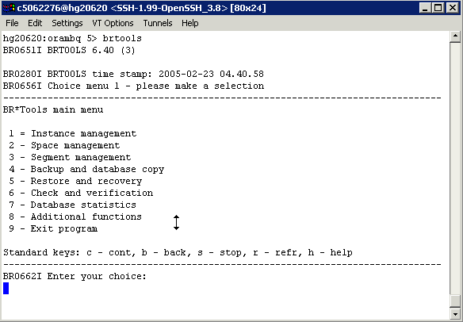

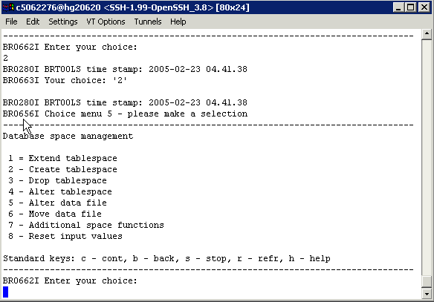

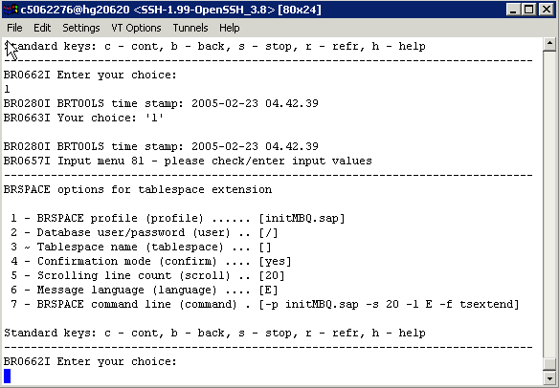

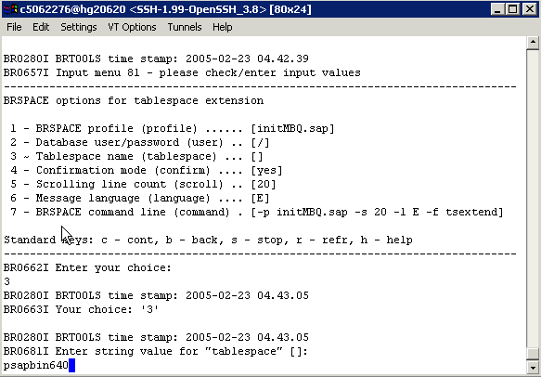

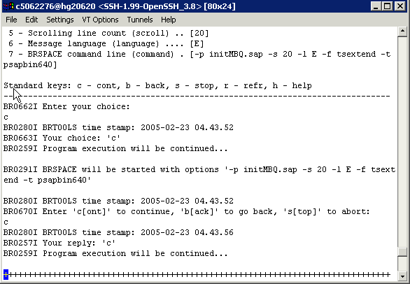

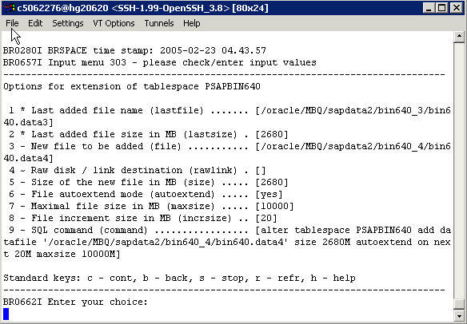

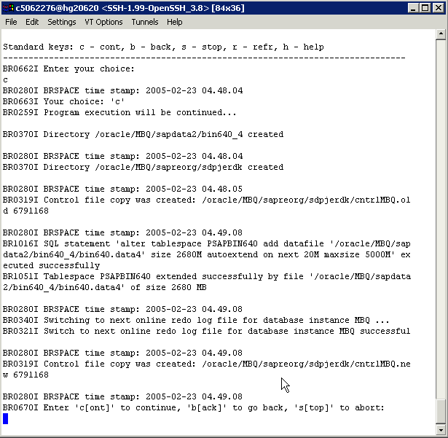
How to extend an Oracle datafile using BRTOOLS

Summary

- Logon to the systems as ora<sid>
- Execute brtools
- Select “2 – Space management”
- Select “4 – Alter data file”
- Select “3 – Alter data file action (action)” and type resize ↵
- Select “4 – Tablespace name (tablespace)” and type the tablespace name
- Select “5 – Data file names (file)” and specify the complete path of the data file
- Check the input data and select continue to launch the BRSPACE interface.
- Confirm the call to “BRSPACE”
- Select “7 ? New data file size in MB (incrsize)” and specify the new size in MB
- Check the input data and select continue (this will actually execute the resizing). Look for any error messages.
- Select continue and confirm the return to BRTOOLS menu.
- Exit from the “Space management” menu using b (back)
- Now it is possible to exit from BRTOOLS using option “9 – Exit program”.

NOTE: Check next page for a detailed procedure

Detailed procedure

- Logon to the systems as ora<sid>
- Execute brtools

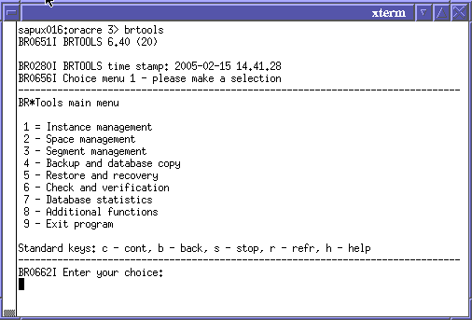

- Select “2 – Space management”

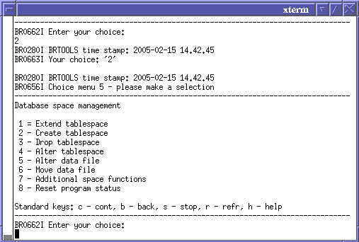

- Select “4 – Alter data file”
It is obligatory to fill items marked with “~”.
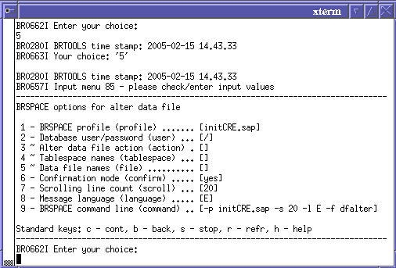

- Select “3 – Alter data file action (action)” and type resize ↵

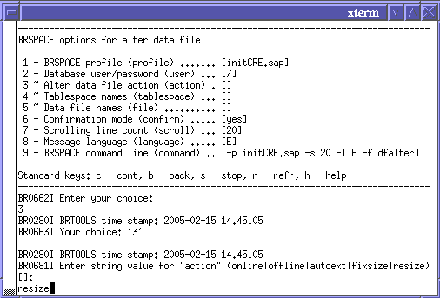

- Select “4 – Tablespace name (tablespace)” and type the tablespace name

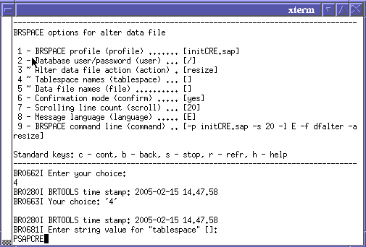

- Select “5 – Data file names (file)” and specify the complete path of the data file

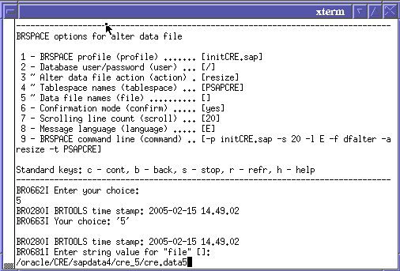

- Check the input data and select c to continue to launch the BRSPACE interface.

Datafiles can be checked within the SAP system with transaction DB02 -> Current sizes -> Select the tablespace -> Data files / Temp files

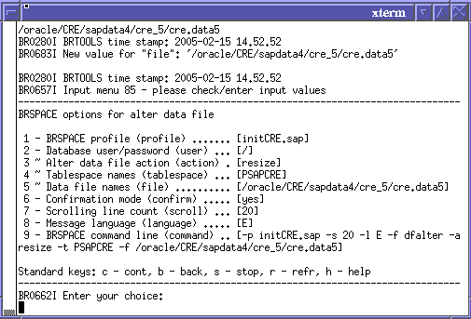

- Confirm the call to “BRSPACE”

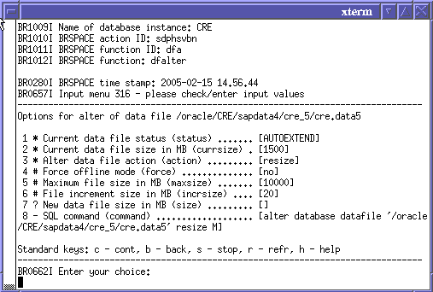

- Select “7 ? New data file size in MB (incrsize)” and specify the new size in MB

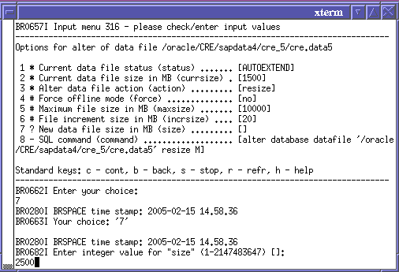

- Check the input data and select continue (this will actually execute the resizing). Look for any error messages.

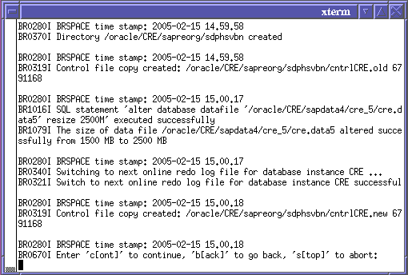

- Select continue and confirm the return to BRTOOLS.
- Exit from the “Space management” menu using b (back)
- Now it is possible to exit from BRTOOLS using option “9 – Exit program”.

