



Table of Contents
1. The Alert Monitor 4
1.1Purpose 4
2. The Monitoring Architecture Concept: 4
2.1 Purpose 4
3. Operating the Alert Monitor 6
3.1Purpose 6
3.2Process Flow 6
4. Elements of the Alert Monitor 8
4.1 Purpose 8
4.2 Operation and Customizing of the Elements of the Alert Monitor 8
5. Creating and Editing Monitor Sets 9
5.1 Use 9
6. Transporting Monitor Sets and Monitor Definitions 11
6.1 Use 11
6.2 Prerequisites 11
7. Creating and Changing Monitors 12
7.1 Use 12
7.2 Prerequisites 12
8. Rule Node: Rule Description and Use 15
8.1 Definition 15
9. Selected Alert Monitor Methods 18
9.1 Use 18
9.2 Features 18
10. Step-by-Step Automatic Alert Notification Configuration 19
10.1 Use 19
10.2 Prerequisites 19
10.3 Procedure 19
11. SAP Connect 22
11.1 Purpose 22
11.4 Send job 24
11.5 Inbound 25
12. Creating Distribution Lists 25
12.1 Procedure 25
12.2 Result 26
13. Address Type 27
13.1 Definition 27
13.2 Use 27
14. Auto-Reaction Method: Execute Operating System Command 28
14.1 Use 28
14.2 Prerequisites 28
14.3 Procedure 29
14.4 Result 30
15. Setting Up Central Auto-Reaction Methods 31
15.1 Use 31
15.2 Prerequisites 31
15.3 Constraints 31
15.4 Procedure 31
15.5 Result 34

1. The Alert Monitor

1.1Purpose

The CCMS provides a variety of monitors to support the SAP environment and its surrounding components. These monitors are critical for understanding and evaluating the behavior of the SAP processing environment. If your SAP System is operating at unacceptable performance levels, they provide the proper tuning insight for making sure your SAP installation is operating at peak efficiency.

With the alert monitor, you can manage and monitor your R/3 System efficiently. The monitor offer you:

- Complete, detailed monitoring of the R/3 System, host systems, and database
- Status indicators (green, yellow, red) for all components
- Alerts if a status indicator is not in the green range
- Easy access to methods for analyzing alerts
- Alert tracking and management

2. The Monitoring Architecture Concept:

2.1 Purpose

The R/3 alert monitor is based on an innovative new monitoring architecture that was introduced
with Release 4.0. This section describes the main parts of the monitoring architecture and how
they work together.

The Monitoring Architecture

Here is how the monitoring architecture and the alert monitor work:

Data Collection Methods: These are programs that gather information on different parts of the R/3 System and its environment. They then register this information with the monitoring infrastructure.

The monitoring architecture comes ready to use with collection methods for all of the most important components of your R/3 System and environment. When you start the alert monitor, you will see that collection methods are already active for reporting on all of the following:

- The host systems on which your R/3 System is running
- The R/3 database
- R/3 instances (application servers) and their services and components
- Components outside the R/3 System

There is nothing that you have to do to prepare or activate the monitoring architecture. All collection methods in your system are started automatically when the system starts or as they are needed.

Monitoring architecture: Data Collection methods pass their information to the monitoring architecture. The monitoring architecture provides an infrastructure for gathering and managing system information.

The infrastructure concept means that collection methods are independent of the monitoring architecture. Data Collection methods "plug into" the monitoring architecture and use its services for displaying and managing system information. But Data collection methods are not programmed directly into the monitoring architecture.

Data Collection methods are independent of the monitoring architecture, and so can be easily added or modified. The monitoring architecture offers ABAP and C interfaces which any R/3 or external programmer can use to create a collection method.

Monitoring objects and attributes: Data Collection methods report their information with respect to one or more monitoring objects (as shown by the arrows in the illustration). A monitoring object represents something in the R/3 System or its environment that should be monitored. A monitoring attribute represents one type of information that is to be reported on a monitoring object.

Example: Monitoring objects include the CPU in your host system, the database, and R/3 services, such as background processing. Monitoring attributes for a CPU object might include the five-minute average CPU load and the CPU utilization.

Monitoring objects and their attributes are displayed to you in the alert monitor. In the alert monitor, objects and their attributes are called nodes or monitoring tree elements (MTEs). Monitoring objects are created by collection methods. All the objects that you can currently monitor in your R/3 System are automatically available when you start the alert monitor.

Data Consumers: This is the layer of the monitoring architecture for displaying alerts and status
data. Data consumers are supplied with the information that collection methods pass to the monitoring architecture. SAP delivers a standard "data consumer" (the alert monitor) with your R/3 System. SAP also provides other, more specialized monitors that use the data provided by the monitoring architecture.

The data consumer layer (the alert monitor) is your workplace for displaying the current state of your system and responding to alerts that are triggered by warnings or problems. The alert monitor displays its information and alerts to you in a hierarchical monitoring tree.

If a data collection method reports a problem, then the monitoring architecture triggers an alert. This is also visible to you in the alert monitor. For example, if the CPU’s five-minute load average is too high, then the alert monitor triggers a "yellow" (warning) or "red" (problem) alert. The color-coding in the alert monitor lets you see an alert fast. And the alert monitor can then provide you with detailed information on the alert as well as access to a method for analyzing the alert.

The following methods exist for analyzing the alerts:

Auto-Reaction Methods
These methods start automatically when an alert is triggered. Almost no assignments are made in the standard SAP system; however, there are several predefined auto-reaction methods in the monitoring architecture that you can assign to any MTE classes:
- Send an E-Mail
- Execute an Operating System Command
- Execute an Auto-Reaction in the Central Monitoring System

Analysis Method

This method allows a detailed analysis of error situations without leaving the Alert Monitor. You start an analysis method manually when you want to display information or investigate an alert.

An analysis method is, for example, an ABAP program for displaying information about a node in the monitoring tree and for collecting information about the problem that triggered an alert in this node.

3. Operating the Alert Monitor

3.1Purpose
The following section contains a short overview of the operation of the Alert Monitor.

3.2Process Flow
To perform a a periodic check of your monitored systems, follow the procedure below:
- Start the alert monitor by calling transaction RZ20.The system displays the CCMS Monitor Sets screen. Every monitor set contains monitors that deliver information for a particular system management topic. Expand a monitor set and choose the required monitor by double clicking it. You can copy, change, and create new monitor sets and monitor. The icons after the monitor sets display whether a monitor set was delivered by SAP () or created by the customer (), and whether you are authorized to change the set () or not ().
- The system displays the tree structure of the desired monitor. The system is displaying the Current Status view in which you can monitor the current values of your monitoring attributes. If you want to analyze an alert, choose the corresponding monitoring tree element (MTE) by double clicking it.
- You can then check what has happened since the last check in the system. Use the Open Alerts monitoring view to see if there have been yellow or red alerts (warnings or problems). If you choose an alert in this view by double clicking it, the system displays the Alert browser. This displays all alerts that have not yet been analyzed in a flat hierarchy.
- After you have analyzed an alert and taken the necessary action, set it to Completed to remove it from the display of open alerts.
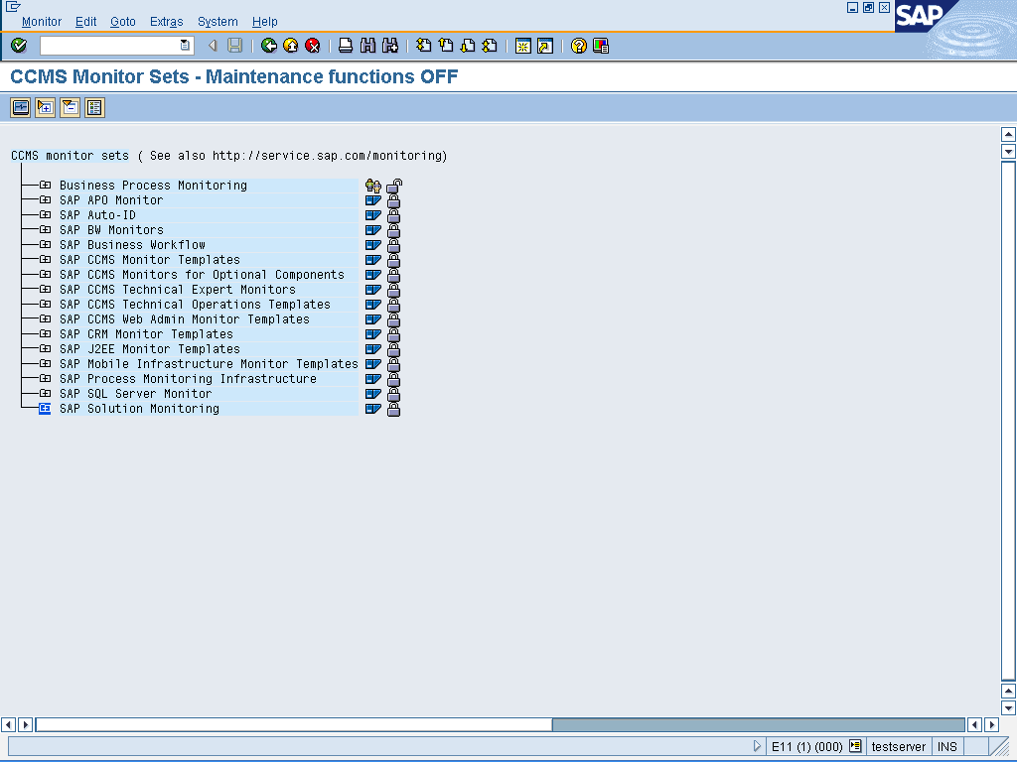

4. Elements of the Alert Monitor
The following section describes the most important elements of the Alert Monitor and their relationships to each other.

4.1 Purpose
When you start transaction RZ20, the system first displays the monitor sets available to you. These monitor sets group the monitors.
A monitor set usually consists of different monitors. A monitor is a collection of monitoring tree elements (MTEs) in a hierarchical structure that deliver information for a particular aspect of system management.
The hierarchical structure of a monitor is the alert monitoring tree. In this tree, you can check the status of your IT system landscape. The MTEs are nodes of this tree, where the root node also has the name of the monitor.
Different MTEs are Elements of the Alert Monitoring Tree: monitoring summary nodes, monitoring objects, and monitoring attributes. Monitoring summary nodes (summary MTEs) provide a better overview in the tree, without performing a monitoring function themselves.
A monitoring object represents a component of your IT environment that you want to monitor (such as the CPU of a server or background processing), while a monitoring attribute displays a value, status, or text that is reported for this object (for example, the CPU utilization during the last 15 minutes).
If a value that deviates from the norm is reported for a monitoring attribute, the Alert Monitor generates an alert. The conditions under which an alert is generated, the criticality of the alert, or which message is assigned to an MTE – all of these are properties of an MTE.
In addition to its properties, an MTE has methods: the data collection method allows the collection of information about the MTE, the auto-reaction method and analysis method are executed as a reaction to an alert.
To simplify Customizing, the properties and methods do not need to be edited for each MTE individually: There are attribute groups for attributes, and MTE classes for objects.

4.2 Operation and Customizing of the Elements of the Alert Monitor

Element | Operation | Customizing
Monitor set |  | Creating and Editing Monitor Sets  Transporting Monitor Sets and Monitor Definitions
Monitor | Starting and Changing Monitors | Copying and Deleting Monitors  Creating and Changing Monitors
Alert Monitoring Tree | Actions in the Alert Monitoring Tree  Selecting Nodes in the Alert Monitoring Tree
Methods | Starting Methods | Defining, Releasing, and Transporting Methods  Selected Alert Monitor Methods
Properties |  | Properties of Performance Attributes  Properties of Status Attributes
Alerts | Handling Alerts
MTE Classes and Attribute Groups | Rule Node: Rule Description and Use

5. Creating and Editing Monitor Sets

5.1 Use
Monitor sets simplify system administration, as they combine monitors. Every SAP R/3 system already contains the standard monitor sets delivered by SAP. These sets can only be changed by SAP. You can also create, edit, copy, and delete your own monitor sets. To be able to edit standard monitor sets, you must first copy them to your own monitor sets.
With your own monitor sets, you can use the attributes of the set to determine who may edit the set and whether the set is to be visible to all users. You can also transport your own monitor sets and monitor definitions.
5.2 Prerequisites
To be able to edit a monitor set or a monitor definition, you must first activate the maintenance functions.
5.3 Procedure
To call the individual functions in the table, choose CCMS → Control/Monitoring → Alert Monitor, or call transaction RZ20. Choose Extras → Activate Maintenance Functions.

Function | Menu Path
Create Monitor Set | Choose Monitor (set) → Create (); choose Create Monitor Set; define the name and the attributes of the set on the Create Monitor Set screen.
Change Monitor Set | Select the desired monitor set; choose Monitor (set) → Change (); on the Edit Attributes of a Monitor Set screen, change the desired attributes.
Copy Monitor Set | Select the desired monitor set; choose Monitor (set) → Copy (); on the Copy Monitor Set screen, enter the name of the copy of the set.
Delete Monitor Set | Select the desired monitor set; choose Monitor (set) → Delete (); confirm the command.
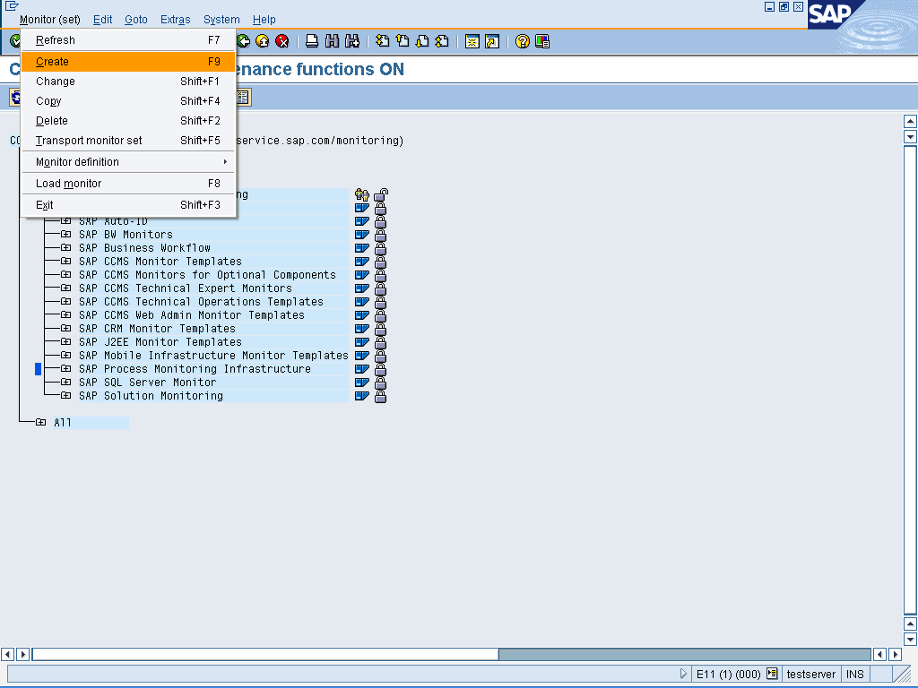

6. Transporting Monitor Sets and Monitor Definitions

6.1 Use
You can transport monitor sets to other systems in your transport landscape. This is only necessary for the monitor sets that you create yourself, as the monitor sets provided by SAP are already available in all SAP systems.
If you want to use the definitions of individual monitors in other SAP systems, we recommend that you export them as an XML file and then import them. To do this, you must store the monitor definition in a file in XML format in the source system; this is then imported into the target system. This exchange is faster, as no SAP transports must be created. You can also distribute existing monitor definitions quickly over the Internet or a file server in XML format.

6.2 Prerequisites
To transport a monitor set or a monitor definition, you must first activate the maintenance functions.
6.3 Procedure
The transport of monitor sets uses the SAP transport mechanism.
- To do this, choose CCMS → Control/Monitoring → Alert Monitor, or call transaction RZ20. The system displays the CCMS Monitor Sets screen.
- Choose Extras → Activate Maintenance Functions.
- Choose the monitor set that you want to transport, and choose Transport Monitor Set (
- Enter a Workbench request with the desired target system.
The transport of a monitor definition uses the export and import of the definition in XML format.
- To do this, choose CCMS → Control/Monitoring → Alert Monitor, or call transaction RZ20. The system displays the CCMS Monitor Sets screen.
- Choose Extras → Activate Maintenance Functions.
- Choose the monitor for which you want to export the definition and then choose Monitor → Display Monitor Definition.
- The system displays the Display Monitor Definition screen. Choose Monitor Definition → Export. Enter a file name and path to which you have access from the target system.
- Switch to the target system, and choose CCMS → Control/Monitoring → Alert Monitor, or call transaction RZ20. The system displays the CCMS Monitor Sets screen.
- Choose Extras → Activate Maintenance Functions.
- Create a new monitor. To do this, select the desired monitor set and choose Create ().
- Choose Monitor Definition → Import and specify the file name and path entered above.
NOTE: If the monitor definition already exists, this is overwritten by the import of a definition

7. Creating and Changing Monitors

7.1 Use
You can quickly and easily create your own monitors that meet your own special requirements. If, for example, you want to monitor the interaction between your CPUs, the operating system paging, and the dialog response time of your SAP R/3 Systems, you can create an Alert Monitor that contains only these monitoring tree elements (MTEs). You can decide whether this monitor covers one or more SAP R/3 Systems.
To be able to create a monitor, you must first create a tree structure. You have the following options for the individual nodes:
- Static MTE Selection
You can explicitly select MTEs for your monitor. Only the selected MTEs are added to the monitor, and the selection of the MTEs is not updated.
- Rule-Based MTE Selection
You can use the rule-based MTE selection (dynamic selection) to create your own monitor. In this case, the Alert Monitor inserts all MTEs that meet a certain rule into your monitor. If the MTEs that meet the rule change, the system automatically updates the monitor. In this way, your monitor is automatically updated if a new SAP R/3 System is added to the Alert Monitor.
Tip: You can combine static and rule-based MTE selection in the same monitor.
- Virtual MTEs
You can define virtual MTEs to structure your monitor. Virtual nodes are used as titles or headings in the Alert Monitor. They have no function other than to group monitoring tree elements visually. For example, you can create virtual MTEs as titles for different groups of actual MTEs in your monitor.

7.2 Prerequisites
To be able to create or change a monitor, you must first activate the maintenance functions.
7.3 Procedure
- Choose CCMS → Control/Monitoring → Alert Monitor, or call transaction RZ20.
- Choose Extras → Activate Maintenance Function.
- Choose one of the functions from the table:

Function | Menu Path
Create monitor | Choose the monitor set in which you want to create the monitor; ensure that it is a monitor set that you can modify (); choose Monitor (set) → Create ().
Change monitor | Expand the monitor set and choose the monitor that you want to change; choose Monitor (set) → Change ().  You can also change a monitor that has already been started by choosing Monitor → Change ().
- The Alert Monitor displays the complete monitoring tree. In the uppermost line of the tree, the system displays the name of the monitor. You can now either add MTEs to your monitor or display or change the properties of existing MTEs. To do this, choose one of the functions from the table:
Function | Procedure
Insert static MTE selection | Choose the required MTEs from the list of Selectable MTEs . Only the selected MTEs are visible in the final monitor. The system displays the list at every point in the monitoring tree where you can insert statically created MTEs.
Insert rule-based MTE selection | Choose the node under which you want to insert a rule-based node; choose Edit → Create Node (), and in the Create Node screen, choose the Rule Node radio button
Insert a virtual MTE | Choose the node under which you want to insert a virtual node; choose Edit → Create Node (), and in the Create Node screen, choose the Virtual Node radio button. Enter a name for the node.
Change node | Select the relevant node; choose Edit → Change Node (). You can change different properties depending on the type of node.
Display node | Select the relevant node; choose Edit → Display Node (). The system displays different properties depending on the type of node.
Delete node | Select the relevant node; choose Edit → Delete Node (). The node is deleted, along with its subnodes.

Tip: The following rules apply to the sequence of nodes in the monitoring tree:
- The root node (uppermost node) of a monitor is always a virtual node. Its name is the name of the monitor.
- You can create as many levels of virtual MTEs as you want. A virtual node can only be placed under a rule node or another virtual node in the tree hierarchy.
- A rule node can only be placed under a virtual node or another rule node in the tree hierarchy.
- A static node can only be placed under a virtual node.
- To save your monitor, choose Monitor definition → Save or Generate Monitor (). If you are creating a new monitor, the system prompts you to enter a name for your monitor.
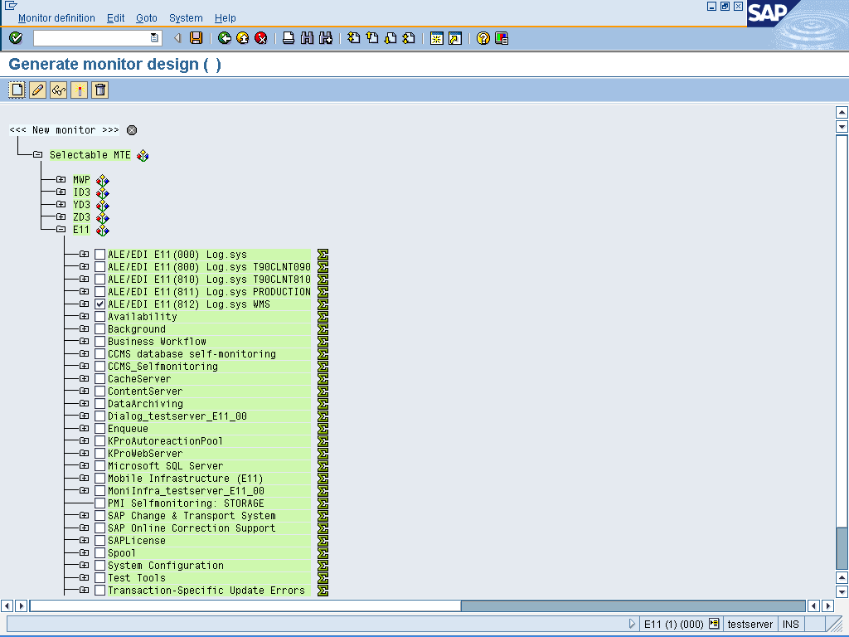

8. Rule Node: Rule Description and Use

8.1 Definition
A rule node or rule monitoring tree element specifies a rule that defines which nodes should be included in a monitor. The monitoring architecture interprets the rule and includes monitoring tree elements in the monitor that match the selection criteria specified in the rule. The rules are regularly reinterpreted, meaning that a monitor of your own automatically matches the current system landscape. A monitor defined with rules will, for example, automatically include a newly started SAP application server. In this way, a monitor that consists of rule MTEs has the following properties:
- The monitor automatically contains different MTEs
- The monitor automatically adjusts to the current status when changes are made to your system landscape
Rules allow the dynamic selection of MTEs using selection criteria. On the other hand, with static selection, you explicitly select individual MTEs. These are not update if changes are made to the system landscape.
8.2 Use
When creating a rule MTE, select a predefined rule for the selection of MTEs for your new monitor. The Alert Monitor interprets this rule and selects the MTEs that match the specified selection criteria.
The available rules are:
- CCMS_DEFINE_R3_SYSTEMS
This rule creates virtual MTEs for SAP R/3 Systems that are included in the monitor. Use this rule to set up rule-based monitoring of one or more SAP R/3 Systems. Rule MTEs that you add under this MTE are created for every selected system. You can add monitoring functions by creating virtual and rule-MTEs under this MTE.
The parameter R3System is the name of the SAP R/3 System that is to be monitored in the corresponding monitor. Additional selection options are <ALL> (all available SAP R/3 Systems), <CURRENT> (SAP R/3 System of the Alert Monitor), and all system groups that you have defined in your system landscape.
- CCMS_GET_MTE_BY_CLASS
This rule inserts MTE classes as real nodes in the monitor. As all monitoring objects and attributes are assigned MTE classes, you can use this rule to monitor certain types of monitoring objects and attributes. For example, the monitoring attribute ResponseTime is assigned the MTE class R3DialogResponseTime. AbortedJobs is assigned the MTE class R3BPServerSpecAbortedJobs.
As all instances of a particular MTE share the same MTE class, even beyond system boundaries, you can select monitoring objects in all SAP instances and systems using the rule.
NOTE: Adding MTEs by class also adds all subordinate MTEs (for example, the subordinate MTEs CPU_Utilization and 5minLoadAverage are inserted with the MTE class CPU, although these MTEs have other MTE classes).
TIP: You can display the available MTE classes using the possible entry help. As the help does not display where an MTE class appears in the monitoring tree, it can be difficult to find the desired MTE class. To find the required MTE class, open a standard monitor for the MTE in which you want to insert the monitor. Then display the MTE class of the MTE by choosing Properties.
- CCMS_GET_MTE_BY_CLASS_AS_VIRTUAL and CCMS_GET_MTE_BY_CLASS_UNDER_CLASS
Use these two rules together. By doing so, you obtain the same results as with the rule CCMS_GET_MTE_BY_CLASS; however, the information that you require is displayed in a more clearly structured format.
If you choose the rule CCMS_GET_MTE_BY_CLASS_AS_VIRTUAL, use the parameter MTEClass, to include the MTE class as a virtual node in the tree. Then choose the rule CCMS_GET_MTE_BY_CLASS_UNDER_CLASS. You then specify the MTE class that you want to monitor as the real node in your monitor in the parameter ChildMTEClass.
The rule uses the parameters MTEClass and R3System from the superordinate rule (CCMS_GET_MTE_BY_CLASS_AS_VIRTUAL).
- CCMS_GET_MTE_BY_CLASS _AND_CLIENT
This rule is largely the same as CCMS_GET_MTE_BY_CLASS; however, you can also restrict the monitoring to particular clients.
- CCMS_GET_MONITORING_SEGMENT_NAMES and CCMS_GET_MONITORING_CONTEXT_NAMES
These rules are for SAP-internal use only. Although you can experiment with them, we recommend that you do not use them in your own monitor definitions.
- CCMS_GET_AVAILABILITY_FOR_SYSTEM
This rule is reserved by SAP for later use. We recommend that you do not use it in your own monitor definitions.

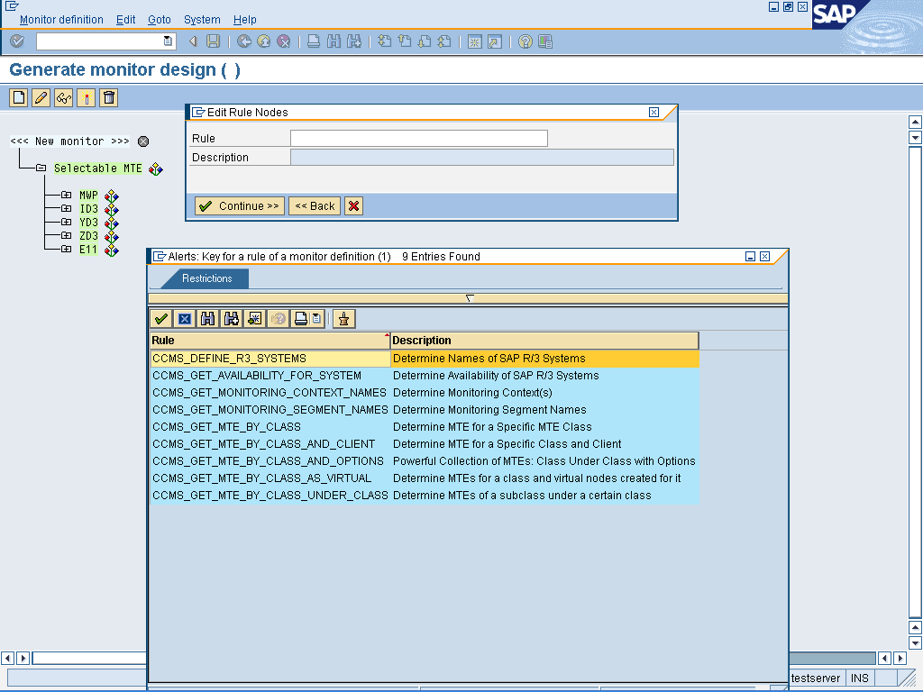

Rule Node

9. Selected Alert Monitor Methods

9.1 Use
You can assign methods to monitoring attributes, and access the method definitions using the Customizing transaction for the Alert Monitor, RZ21. A method can be a report, a function module, an SAP transaction, or a URL that is to executed as a reaction to an alert.
Most methods (especially data collection methods) are already assigned to their MTEs in the standard SAP system and a change to this assignment is not useful. However, there are a number of additional methods available to you that you can assign to certain MTE classes yourself (see Assigning Methods to MTE Classes).

9.2 Features
Analysis Methods
Auto-Reaction Methods
- Define Automatic Alert Notification
You can assign the method CCMS_OnAlert_Email to MTE classes in your system. If an alert occurs in this MTE class, you are informed by e-mail, fax, or pager, even if you are not working in the Alert Monitor.
- Auto-Reaction Method: Execute Operating System Command
You can execute any operating system command as an auto-reaction to a monitoring architecture alert. For security reasons, this does, however, apply only for those commands that have previously been defined in the External Operating System Commands transaction.
- Setting Up Central Auto-Reaction Methods
You can define central auto-reaction methods in the monitoring architecture in the context of central monitoring. The auto-reaction methods are no longer started in the system, in which the alert occurs, but rather in the central monitoring system. In this way, it is possible for reactions to events that occur in monitored components to be performed immediately in a central location.

10. Step-by-Step Automatic Alert Notification Configuration

10.1 Use
With the monitoring architecture, you can define auto-reaction methods that are automatically executed when alerts occur. As of SAP Basis 4.6A, you can assign the method CCMS_OnAlert_Email to MTE classes in your system. If an alert occurs in this MTE class, you are informed by e-mail, fax, or pager, even if you are not working in the Alert Monitor.
CCMS_OnAlert_Email can automatically dial a pager or send an e-mail or a fax to the following addressees:
- A Business Workplace user in client 000
- A distribution list or an external e-mail address
The auto-reaction method for sending the e-mail is started at most five minutes after the alert occurs. However, there can be a delay before the e-mail is sent to external e-mail addresses (that is, addresses of users that are not defined in client 000 of the same SAP R/3 System), depending on the settings in SAP connect. You should therefore set the period for the SAP connect send process to less than an hour.
The message text of the e-mail contains the same information that is displayed in the Alert Monitor:
• What is the problem?
• Where and when did it occur?
• What severity and what color does the alert have?

10.2 Prerequisites
To dial multiple pagers or to send an e-mail or a fax to multiple users (external recipients or recipients in client 000), you must first create a distribution list that contains the required data for the recipients (pager number, name, e-mail address, fax number).
TIP: SAP connect must be configured in client 000, if the message is to be sent to an external address.
In order to use the alert configuration you need to have the following prerequisites
For using the Alert Inbox (BSP based display program of ALM), the corresponding service has to be activated in the service maintenance transaction SICF. Choose Default_host → sap → bc → bsp → sap → alert inbox, and Activate in the context menu. You also have to activate SAP Connect. Choose SAPConnect->activate

10.3 Procedure

10.3.1Tailoring the Auto-Reaction Method
- Call transaction RZ21.
- In the Methods group box, select Method Definitions and choose Display overview.
- Select the method CCMS_OnAlert_Email and choose Edit Data.
- Choose change mode with the Display ↔ Change () pushbutton, and choose the Parameters tab page.
- Fill out the fields as follows:

Parameter | Description
SENDER | SAP username of the person in whose name the e-mail is sent
RECIPIENT | SAP user name of the e-mail recipient, distribution list, or external e-mail address; to automatically send an e-mail to multiple external e-mail addresses, you must create a distribution list in client 000 that contains these external addresses.  If the user is not defined in client 000 you must also specify the system and the client in which the user exists (such as C11:003:PARKERJ).
RECIPIENT-TYPE ID | Indicator for the address type

TIP: Users that are defined in the SAP R/3 System in clients other than 000 cannot be specified in the Business Workplace directly as sender or recipient; they are regarded as external recipients. You should therefore specify the address type R (remote address) for client-specific senders and recipients in the Parameters tab page.

If you want to define different recipients for different alerts, copy the method definition of CCMS_OnAlert_Email. To do this, select the method in the list and choose Copy (). Note that you must release the copied method as a data collection method again

- Save your entries.

10.3.2 Assigning the Method to the Desired Node
- Start the Alert Monitor using transaction RZ20 or choose CCMS →Control/Monitoring → Alert Monitor.
- Start the desired monitor from the list by double clicking it.
- Select the desired node and choose Properties.
- The Monitoring: Properties and Methods screen appears. Choose the Methods tab page and then choose the Method Assignment pushbutton.
- The Monitoring: Methods screen appears. The rest of the procedure depends on whether you want to assign the analysis method only to this node or to the entire MTE class.

10.3.3 Assign Analysis Method to Only this MTE
- Choose change mode with the Display ↔ Change () pushbutton, and choose the Analysis tab page.
- In the Method Assignment group box, choose the Method Name radio button and enter CCMS_OnAlert_Email in the associated field.
- Save your entries.

10.3.4 Assign Analysis Method to the Selected MTE Class
- Choose the name of the MTE class in the header data of the screen by double clicking it, and then choose the change mode with the Display ↔ Change () pushbutton.
- In the Analysis Method group box, choose the Method Name radio button and enter CCMS_OnAlert_Email in the associated field.
Save your entries

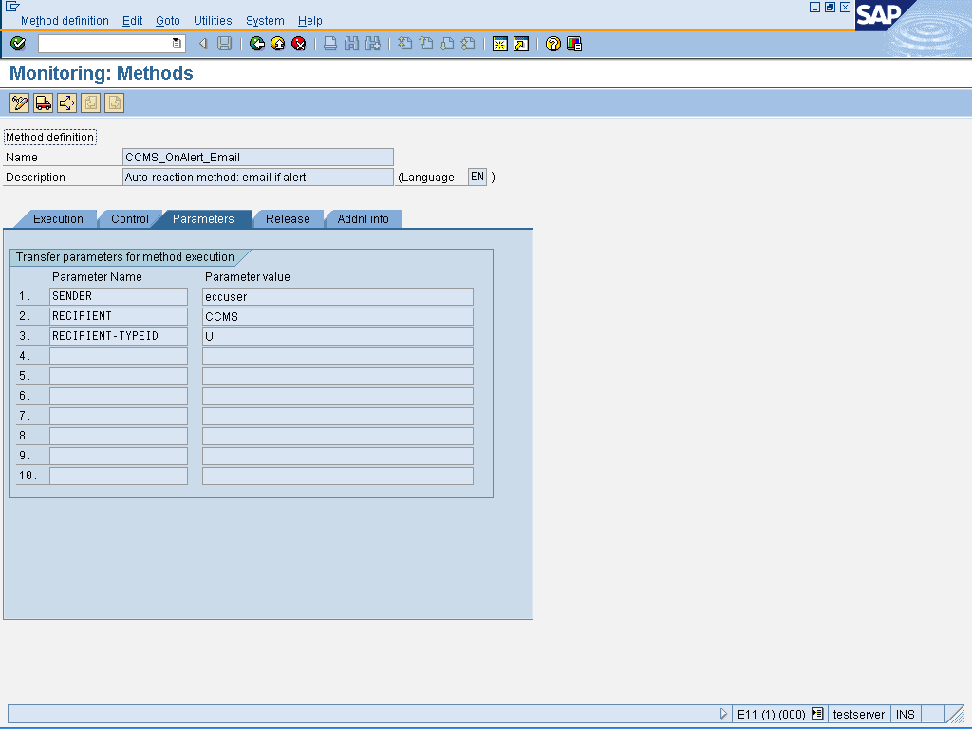

11. SAP Connect

11.1 Purpose
SAPconnect provides a standard interface for external communication, which supports sending with telecommunication services, such as FAX, text message (pager/SMS), Internet mail, and X.400, as well as sending to printers and between different SAP systems. It enables external communication components to be connected to the SAP system.
SAPconnect provides a direct connection to the Internet using the SMTP plug-in of the SAP Web Application Server. This enables you to send and receive Internet mails without the need for an additional external communication system, as well as faxes and text messages (pager/SMS). The SMTP plug-in is available for Internet mail as of SAP Web AS 6.10, and for fax and text messages (pager/SMS) as of SAP Web AS 6.20
11.2 Features
SAPconnect can be used to connect to various communication components and communication systems, such as:
- SMTP plug-in
- HTTP plug-in
- Fax servers, text message (pager/SMS) servers, SMTP gateways, or X.400 gateways, which support the SAPconnect RFC interface (provided by SAP software partners)
- Other SAP systems
- Printers
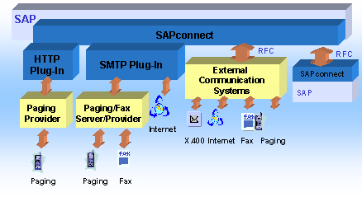

11.3 Procedure to Configure SMTP
To configure the node for sending Internet mail, you:
- Double click on SMTP using transaction code SCOT.
- Give description . Specify the mail server to which outbound mails are to be passed in Mail Host and Mail Port.
- Choose Set adjacent to Internet.
- Specify the address areas of recipient addresses that are to be reached via this node. This is usually * if all e-mails are to be sent using SMTP.
- Enter output formats for SAP documents. The following settings are recommended here:
SAPscript/Smart Forms | PDF
ABAP List | HTM
Business Object/Link | HTM
RAW Text | TXT
- Confirm.
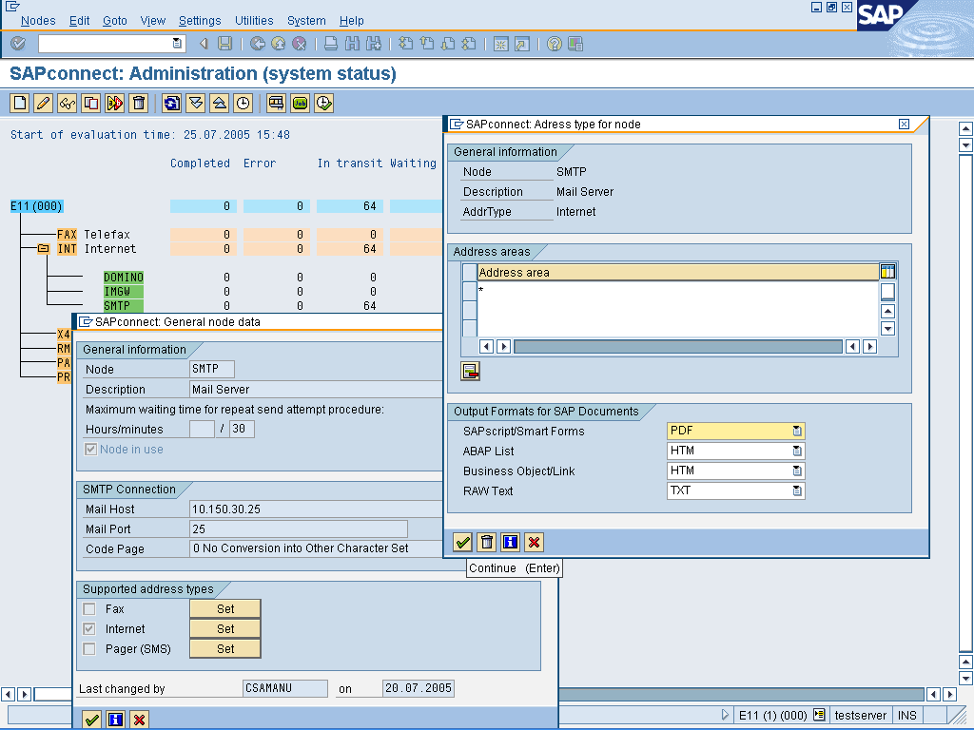

If you want to configure the node for sending faxes as well, you:
- Choose Set adjacent to Fax.
SAPscript/Smart Forms | PDF
ABAP List | PDF
Business Object/Link | TXT
RAW Text | TXT
- Specify the address areas of recipient addresses that are to be reached via this node. This is usually * if all faxes are to be sent using SMTP.
- Enter output formats for SAP documents. The following settings are recommended here:
- Enter the domain of the fax server or fax provider under Conversion into Internet Address. The system generates the local part of the Internet address automatically. The address then has the format FAX=+RecipientNumber@Domain.
- Confirm.
If you want to configure the node for sending text messages (pager/SMS) as well, you:
- Choose Set adjacent to Pager (SMS).
- Specify the address areas of recipient addresses that are to be reached via this node. This is usually * if all text messages (pager/SMS) are to be sent using SMTP.
- Enter the domain of the text message (pager/SMS) server or provider under Conversion into Internet Address. The system generates the local part of the Internet address automatically. The address then has the format SMS=+RecipientNumber@Domain.
- Confirm.

11.4 Send job
E-mails sent from an SAP application are merely put into a queue. A periodic background process, known as the SAPconnect send job, takes the e-mails from this queue and sends them via the Internet. To schedule this job from SAPconnect administration, you:
- Choose View → Jobs.
- If there is not already a job scheduled, choose Job → Create.
- Enter a job name and confirm.
- Select the variant SAP&CONNECTALL by placing the cursor on it.
- Choose Schedule Job.
- Choose Schedule Periodically.
- Enter an appropriate time period, such as 10 minutes.
- Choose Create.

11.5 Inbound
If you want inbound e-mails to a specific address or with a specific content to automatically start a program that processes these e-mails, you can configure this under Settings → Inbound Processing.
If you want inbound e-mails to a specific address or from a specific sender to be automatically redirected to another recipient or distribution list, you can configure this under Settings → Inbound Distribution.

12. Creating Distribution Lists

12.1 Procedure

12.1.1 Creating a Distribution List in the Distribution List Search
- Go to Business Workplace using transaction SBWP, choose Distribution lists.
- The distribution list search screen is displayed.
In the frame Find distribution lists, select whether you want to create a private or a shared distribution list.
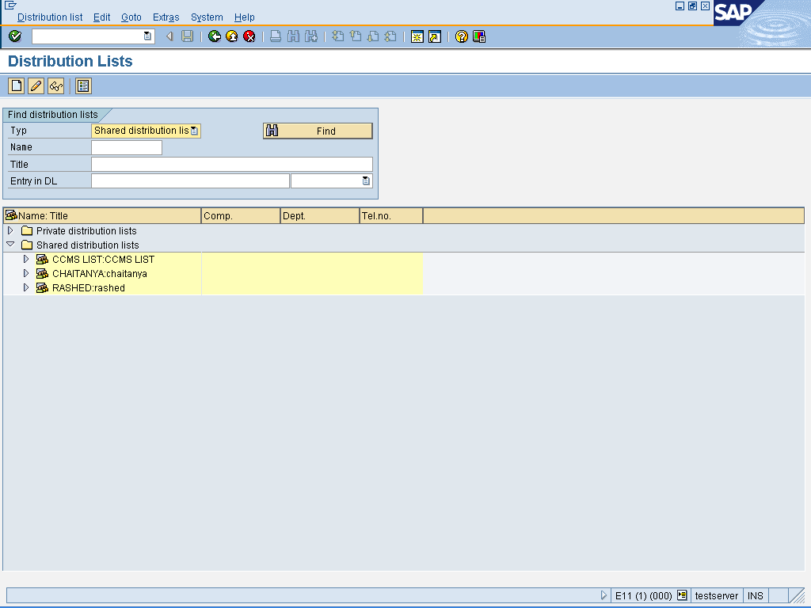
- Choose .
The distribution list maintenance screen appears on the tab page Attributes.
- Specify the attributes of the distribution list.
- Switch to the tab page Distribution list content.
- Specify the recipient addresses and for each one the corresponding recipient type.
- In addition, you can assign the send attributes Express, Copy and Blind copy to each recipient. When sending to an external address, you can also specify that documents are to be sent to another address from the address management rather than to the standard address.
- Choose .

12.2 Result
The distribution list is created and can be used on the send screen, for example, or in other places in the R/3 System where a specific user group has to be specified.
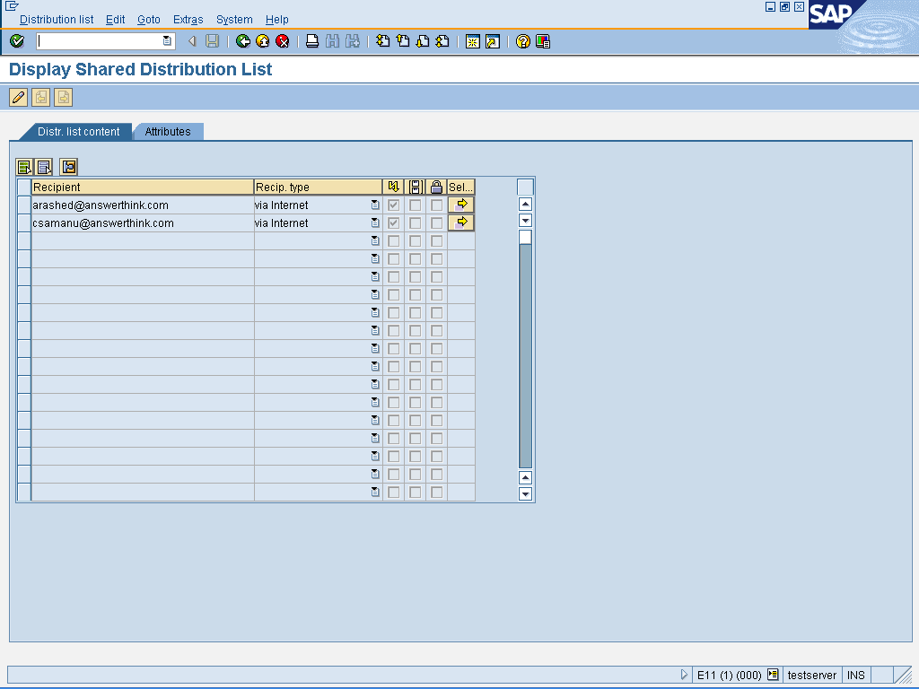

13. Address Type

13.1 Definition
Type of recipient address or sender address. An address type can be one unit (for example, address name) or several units (for example, shared distribution list). Some address types determine the communication method by which the document is sent (for example, an Internet address or a fax number).

13.2 Use
When an address is specified, for example on the send screen, the corresponding address type must be assigned. The address type can be entered automatically. The following recipient types are available in the Business Workplace:
Recipient Type | Example | Indicator
Address name | Anna Wilson
SAP user name | Wilsona | B
External address | Edward Miller | A
Private distribution list | Favorite colleagues | P
Shared distribution list | Archiving project | C
Fax number | USA 123 456 7890 ( <country code - fax number>) | F
Internet address | anna.wilson@our.company.com | U
Organizational object | Purchasing (Organizational unit) | H
Business object | Office folder | J
Remote SAP name: | C11:000:wilson ( <System name:Client:Name>) | R
X.400 address | g=anna;s=wilson;o=c11;ou1=m000;p=company;a=dbp;c=us | X
LDAP address | C=usa/o=c11/ou=m000/cn=… | D

14. Auto-Reaction Method: Execute Operating System Command

14.1 Use
You can execute any operating system command as an auto-reaction to a monitoring architecture alert. For security reasons, this does, however, apply only for those commands that have previously been defined in the External Operating System Commands (SM69) transaction.

14.2 Prerequisites
If an auto-reaction method calls the operating system command, the following parameters are transferred to the command; ensure that the command can process these parameters in the following sequence:
Parameter | Description
<PARAM1> | Fixed parameter that is defined in transaction SM69 in the Parameter for Operating System Command field (optional)
<PARAM2> | Additional parameter, that is defined in the definition of the auto-reaction method under PARAMETERS (see below) (optional)
<SYSID> | System ID of the system in which the alert occurred
<DATE> | Date and time of the alert
<TIME> | Date and time of the alert
<SEVERITY> | Severity and color of the alert that triggered the auto-reaction.
<COLOR>
<SHORTNAME> | Short name of the monitoring attribute and the name of the monitoring object in which the alert was triggered
<OBJECT>
<MESSAGE> | Message that is assigned to the alert
You must now define the desired operating system command in the External Operating System Commands transaction. To do this, follow the procedure below:
1. Choose CCMS → Configuration → External Commands, or call transaction SM69.
2. Choose change mode with the Display ↔ Change () pushbutton, and choose Create ().
3. Now enter the details for the desired operating system command and save your entries.
TIP:
- Note that during the definition of the auto-reaction method, you must no longer enter the name of the operating system command, but rather the name of the (logical) command.
- In the Parameter for Operating System Command, enter the fixed parameter <PARAM1> that is to be transferred to the command (optional).
- Ensure that the Additional parameters allowed indicator is activated.

14.3 Procedure

14.3.1 Copy Method
We recommend that you leave the original method CCMS_AUTO_REACT_OP_COMMAND unchanged and use it only as a template for your methods. In this way, you can set up as many logical commands as you wish as auto-reactions.
1. Choose CCMS → Configuration → Alert Monitor, or call transaction RZ21.
2. In the Methods group box, select Method Definitions and choose Display Overview.
3. Select the method CCMS_AUTO_REACT_OP_COMMAND and choose Copy ().
4. Enter the desired name and save your entries.

14.3.2 Adjust Method Parameters and Release Method
You must now specify the desired logical command in the method that you have created and release the method as an auto-reaction method.
1. Select the copy of the method that you have just created and choose Edit Data ().
2. The Monitoring: Methods screen appears. Choose change mode with the Display ↔ Change () pushbutton.
3. Choose the Parameters tab page. You can set the following parameters here:

Parameter | Description | Default
COMMAND | Logical command that is to be executed in the case of an alert
PARAMETERS | Additional parameter <PARAM2> that you want to transfer to the command (see above)
REACT_ON_ALERTS | Color of the alert at which the auto-reaction method is to be started: for red and yellow alerts (YELLOW) or only for red alerts (RED) | RED

TIP: The COMMAND parameter is required, all other parameters are optional.
4. Choose the Release tab page and in the Execute Method as group box, select Auto-Reaction Method.
5. Save your entries.
TIP:
By default, the operating system command is executed on the local server of the MTE that generated the alert. If the command is to be executed on a different server, change the execution location on the Execution tab page in the Execute Method On group box.

14.3.3 Assign Method to Desired MTE Classes
You must now assign the method to the desired MTEs or MTE classes. You can use either transaction RZ20 (only for the active properties variant) or transaction. Assignment using transaction RZ20 is described below:
1. Start the Alert Monitor using transaction RZ20 or choose CCMS → Control/Monitoring → Alert Monitor.
2. Start the desired monitor from the list by double clicking it.
3. Select the desired node and choose Properties.
4. The Monitoring: Properties and Methods screen appears. Choose the Methods tab page and then choose the Method Assignment pushbutton.
5. The Monitoring: Methods screen appears. The rest of the procedure depends on whether you want to assign the analysis method only to this node or to the entire MTE class.

14.3.4 Assign Analysis Method to Only this MTE
1. Choose change mode with the Display ↔ Change () pushbutton, and choose the Auto-Reaction tab page.
2. In the Method Assignment group box, choose Method Name and, in the associated field, enter the method that you created as described above.
3. Save your entries.

14.3.5 Assign Analysis Method to the Selected MTE Class
1. Choose the name of the MTE class in the header data of the screen by double clicking it, and then choose the change mode with the Display ↔ Change () pushbutton.
2. In the Auto-Reaction Method group box, choose Method Name and, in the associated field, enter the method that you created as described above.
3. Save your entries.

14.4 Result
If an alert is triggered for one of the MTEs to which you have assigned this auto-reaction method, the monitoring architecture automatically calls the logical command with the parameters [<PARAM1>] [<PARAM2>] <SYSID> <DATE> <TIME> <SEVERITY> <COLOR> <SHORTNAME> <OBJECT> <MESSAGE>.

15. Setting Up Central Auto-Reaction Methods

15.1 Use
In the monitoring architecture, you can react automatically to an alert using auto-reaction methods. These methods are automatically started in the case of an alert and by default are executed in the system in which the alert occurs.
As of SAP Web Application Server 6.10, you can define central auto-reaction methods in the monitoring architecture in the context of the central monitoring of mySAP.com components. The auto-reaction methods are not started in the system, in which the alert occurs, but rather in the central monitoring system. In this way, it is possible for reactions to events that occur in monitored components to be performed immediately in a central location.

15.2 Prerequisites
- The central monitoring system (abbreviated to CEN in the following) has a release status of at least SAP Web Application Server 6.10.
- The monitored mySAP.com components with SAP Basis have at least SAP Basis 4.6B with a kernel as of 4.6D AKK patch level 692.
- The monitored mySAP.com components with SAP Basis are linked with CEN using the CCMS agent SAPCCM4X. The agent must have a release status of at least version 6.10.
You can determine the version of the CCMS agent by calling it with the option -v (such as: sapccm4x -v). The version is the number after the term kernel (Such as: 20010110, compiled at Aug 19 2001, kernel 6100_0_104 platform 00230_32bit).
TIP:
Monitored mySAP.com components with SAP Basis 3.1 and systems and components that are centrally linked using the SAPCCMSR agent (such as values in the Operating System Monitor) formally belong to CEN (see Monitoring SAP R/3 3.x Systems). Therefore, auto-reaction methods can always be started centrally here. You can therefore find the relevant MTE classes in the list of the MTE classes of CEN.

15.3 Constraints
You cannot assign any central auto-reaction methods to the MTE classes that belong to the application servers of CEN as described below. In this case, use the conventional assignment using a local auto-reaction method.

15.4 Procedure

15.4.1 Perform all configuration steps for the central auto-reaction method only in CEN.
- Choose CCMS → Configuration → Alert Monitor, or call transaction RZ21.
- The Monitoring: Properties and Methods screen appears. Choose Technical Infrastructure → Assign Central Auto-Reactions.
- The system displays the Maintain Central Auto-Reactions screen. On this screen, you can perform all work steps to define, assign, and edit central auto-reaction methods. A normal first step is to create a central auto-reaction method from an existing (local) auto-reaction method and to then assign this to the desired MTE class in the desired system. You can make the following settings:

15.4.2 Creating, Editing, or Deleting a Central Auto-Reaction Method
You can execute any auto-reaction method centrally that is defined as an auto-reaction method in the central system. The method does not need to be known in the monitored system.
You can also use the predefined auto-reaction methods of the monitoring architecture for this. These are, for example:
• Automatic Alert Notification
• Automatic Execution of Operating System Commands
To have an existing auto-reaction method executed centrally, follow the procedure below:
1. In the subwindow Defined Central Auto-Reactions, choose Create (). On the following dialog screen, enter the desired auto-reaction method in the input field next to the Create with Template pushbutton, or use the input help, which provides a list of all released auto-reaction methods. Choose Create with Template.

TIP: You can also use an existing central auto-reaction method as a template for a new auto-reaction method. To do this, select the desired method in the Defined Central Auto-Reaction subscreen and choose Copy ().

2. The Monitoring: Methods screen appears. The settings are copied from the template, with the exception that the indicator Only in central system, triggered by CCMS agent is activated in the Execute Method group box of the Control tab page.Therefore, you do not usually need to change the settings, other than to enter a name for the central auto-reaction method.

3. Save your entries. The system then displays the method immediately in the Defined Central Auto-Reactions subscreen.
To create a new central auto-reaction method, follow the procedure below:
1. In the subwindow Defined Central Auto-Reactions, choose Create (). In the following dialog screen, enter the desired name for the method in the input field next to the Create pushbutton and choose Create.
2. The Monitoring: Methods screen appears. Enter the desired settings for the method (for more information about creating auto-reaction methods, see Defining, Releasing, and Transporting Methods), and ensure that you activate the radio button Only in central system, triggered by CCMS agent.
3. Save your entries. The system then displays the method immediately in the Defined Central Auto-Reactions subscreen.

To edit a central auto-reaction method, follow the procedure below:
1. In the Defined Central Auto-Reaction Methods subscreen, select the desired method and choose Edit.
2. The Monitoring: Methods screen appears. Make the desired changes to the method definition and ensure that the selection field Only in central system, triggered by CCMS agent is activated.
3. Save your changes.
To delete a central auto-reaction method, follow the procedure below
1. In the Defined Central Auto-Reaction Methods subscreen, select the desired method and choose Delete ().
2. Confirm that you want to delete the method. If the method is used in an assignment, the system will also inform you of this, and ask whether you want to delete the method and all of its assignments.

15.4.3 Assigning a Central Auto-Reaction Method
Enter the MTE classes and system to which you want to assign a central auto-reaction method. The system checks the assignment regularly.
1. In the System ID subscreen, select the desired systems, and the desired MTE classes in the MTE Class subscreen, to which you want to assign a central auto-reaction method. You can always select multiple systems and MTE classes.
TIP: Different systems usually have different MTE classes. After calling the function, the MTE classes of the local system are displayed first. To include the MTE classes of other systems in the list, select the desired systems and choose MTE Classes of System (). The system then displays the MTE classes of the selected system in the list of MTE classes.

2. In the Defined Central Auto-Reactions subscreen, select the desired method that you want to assign to the selected MTE classes of the selected systems.
3. Choose Assign Central Auto-Reaction Method (₎. The system then immediately displays the corresponding assignments in the lower subscreen.
Perform these steps for all desired central auto-reaction methods.

15.4.4 Assigning a Central Auto-Reaction Method from the Alert Monitor
In practice, of the procedures described here, you will use the assignment of MTE classes to a central auto-reaction method most frequently. To make this procedure simpler, you can also call it directly from the Alert Monitor (transaction RZ20).
  - Start the Alert Monitor by calling transaction RZ20.
  - Activate maintenance functions by choosing Extras → Activate Maintenance Functions.
  - Expand the monitor set that contains the monitor that you require, and choose Load Monitor, or double click the desired monitor.
4. Select the MTEs to whose MTE classes you want to assign a central auto-reaction method, and choose Edit → Node(MTE) → Assignment → Central Auto-Reaction Method.
TIP:
In this way, you can also very quickly assign a central auto-reaction to all MTE classes of performance attributes in a monitor. To do this, select all nodes by choosing Edit → Selections → Select → All nodes (MTE), before switching to the administration of central auto-reactions.
5. The Central Auto-Reactions screen appears. The desired systems and MTE classes are selected, meaning that you now only need to select the desired method.
6. Choose Assign Central Auto-Reaction Method (₎. The system then immediately displays the corresponding assignments in the lower subscreen.

15.4.5 Deleting an Assignment of a Central Auto-Reaction Method
In the lower subscreen, the system displays the existing assignments of central auto-reaction methods. To delete assignments, select one or more rows of this table and choose Delete Assignment ().
NOTE:
The central auto-reaction methods are always started under the user in the client that activated the central method dispatcher (to do this, choose Technical Infrastructure → Method Execution → Activate Central System Dispatching in transaction RZ21). As the client is also of great importance for automatic alert notification, ensure that you are in the client from which the mails are to be sent when you activate the central system dispatching.

If you have activated the central system dispatching using the wrong user or in the wrong client, first deactivate it by deleting the job SAP_CCMS_CENSYS_DISPATCHER in transaction SM37. The job is controlled by the event SAP_CSM_TRIGGER_CENSYS_DISPATCH. Then reactivate the central system dispatching using the correct user in the desired client.

15.5 Result
Alerts in the assigned MTE classes of the monitored systems now trigger an auto-reaction in the central monitoring system.

