Creation of Organizational Model

PATH : IMG > CRM > MASTER DATA > ORGANIZATIONAL MODEL > CREATE ORGANIZATIONL MODEL

( GIVE THE ORGANIZATION DATE)

EG : 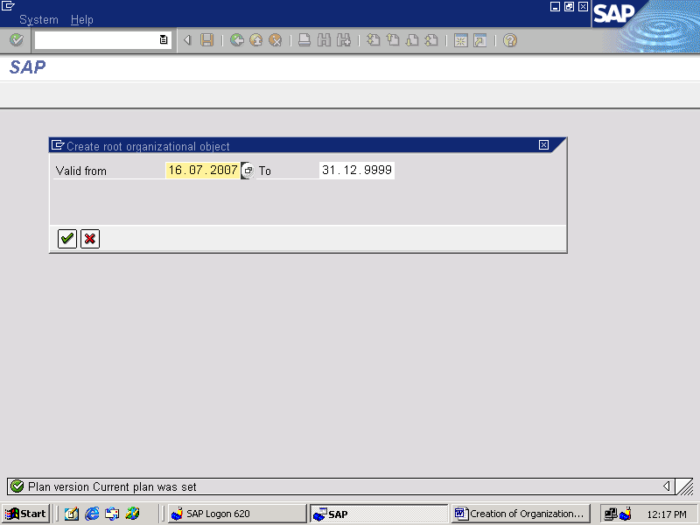

CLICK ON “ CONTINUE “

( COMPANY )

CLICK ON “BASIC DATA TAB”
ENTER THE ORGANIZATION UNIT NAME (COMPANY NAME)
EG : SATYAM LTD

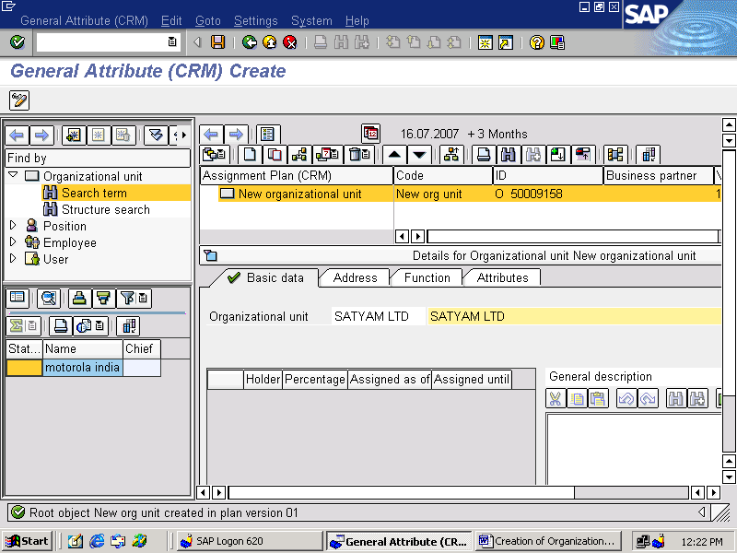

GO FOR THE “ADDRESS TAB”
ENTER THE REQUIRED FIELDS DATA
EG:

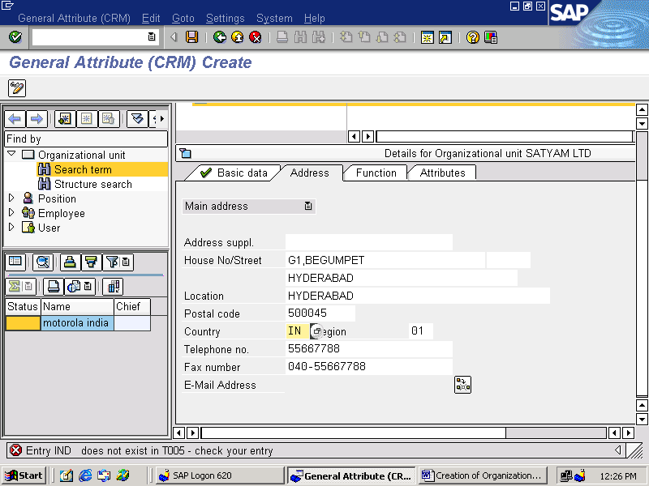

GO FOR THE “FUNCTION TAB”
SELECT WHETHER IT IS SALES / SERVICE ORGANIZATION
EG:

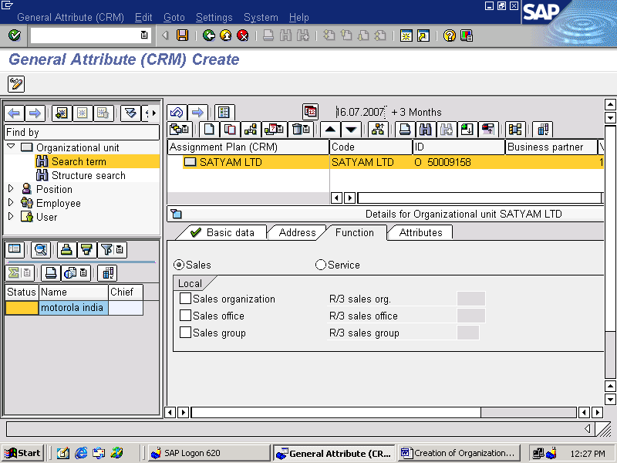

CLICK ON “ATTRIBUTES TAB”
ENTER THE REQUIRED ATTRIBUTES
EG:

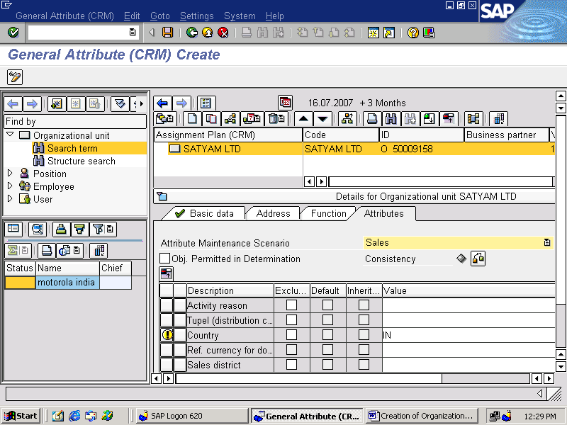

CLICK ON
CONSISTENCY BUTTON FOR CONSISTENCY CHECK

CLICK ON SAVE

RIGHT CLICK ON THE COMPANY NAME ( EG: SATYAM LTD)
CLICK ON CREATE
EG:

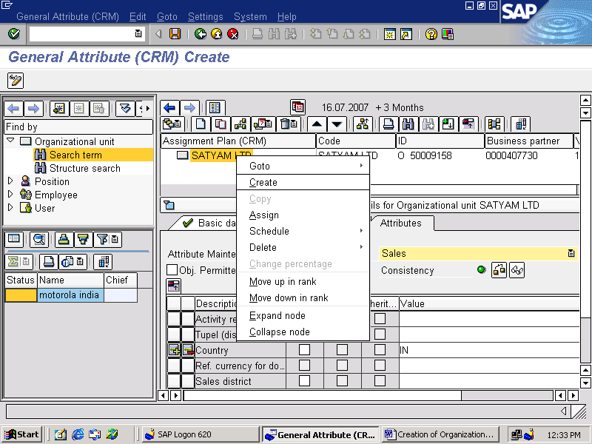

SELECT THE ORGANIZATIONAL UNIT FROM THE TWO OPTIONS
CLICK ON CONTINUE
EG:

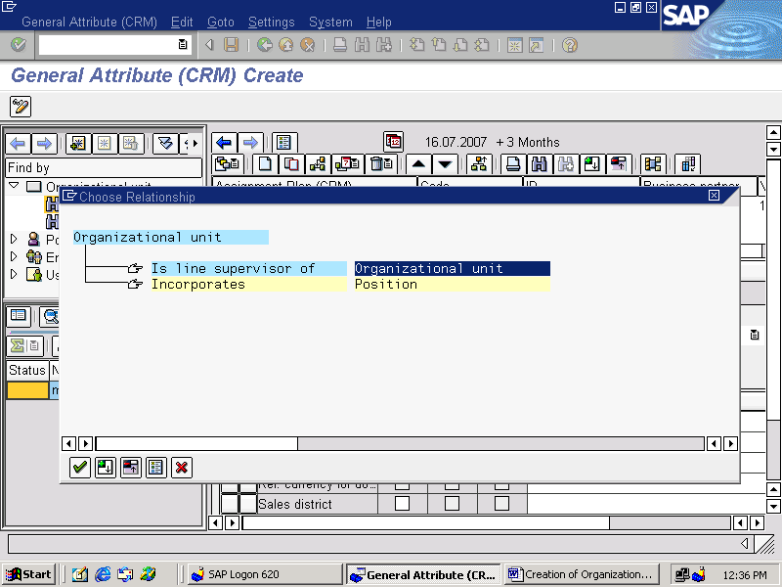

(SALES ORGANIZATION)

CLICK ON BASIC DATA TAB
GIVE THE ORGANIZATIONAL UNIT NAME
EG: SATYAMSORG (SATYAM SALES ORGANIZATION)

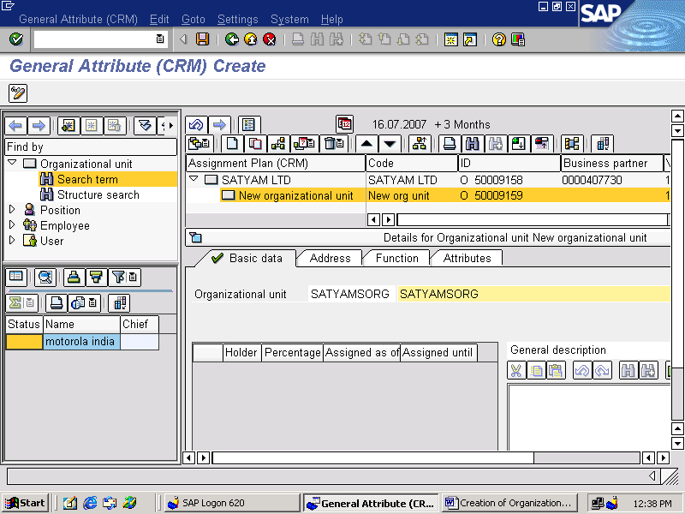

CLICK ON ADDRESS TAB
ENTER THE DATA IN REQUIRED FIELDS
EG:
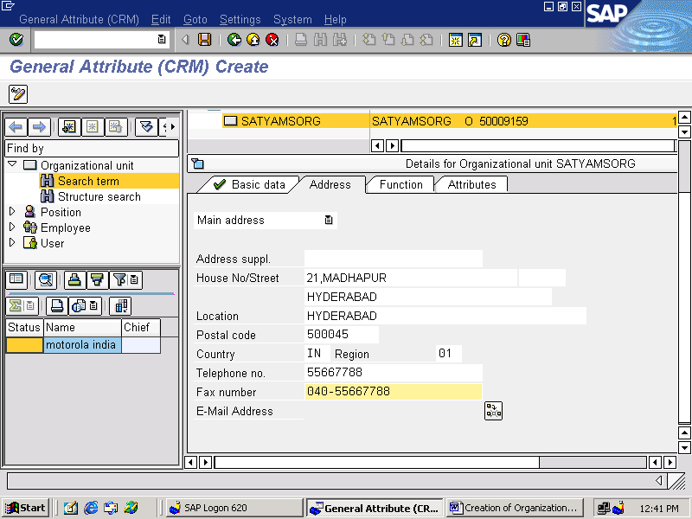

CLICK ON FUNCTION TAB
CHECK THE BOX FOR SALES ORGANIZATION
EG:
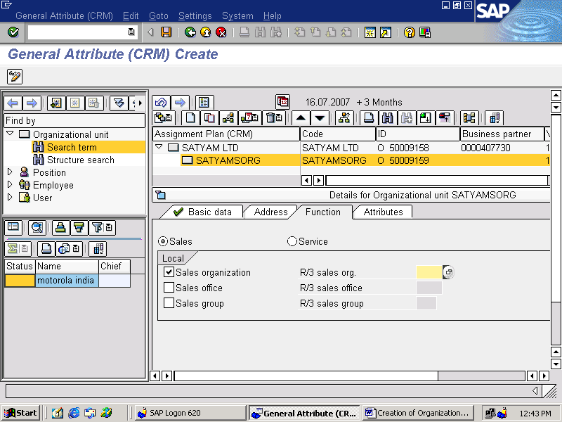

( R/3 SALES ORG : TAB IS FOR MAPPING THE CRM SALES ORGANIZATION WITH THE R/3 SALES ORGANIZATION )

CLICK ON ATTRIBUTES TAB
ENTER THE REQUIRED ATTRIBUTES FOR SALES ORGANIZATION
EG: REGION 01

( THE ATTRIBUTES WHICH ARE GIVEN FOR COMPANY / SALES ORGANIZATION / DIST CHANNEL AND DIVISION WILL INHERIT DOWN THE LINE )

AND

CHECK THE BOX OBJECTS PERMITTED IN DATA DETERMINATION FOR DEFINING THE DETERMINATION RULE

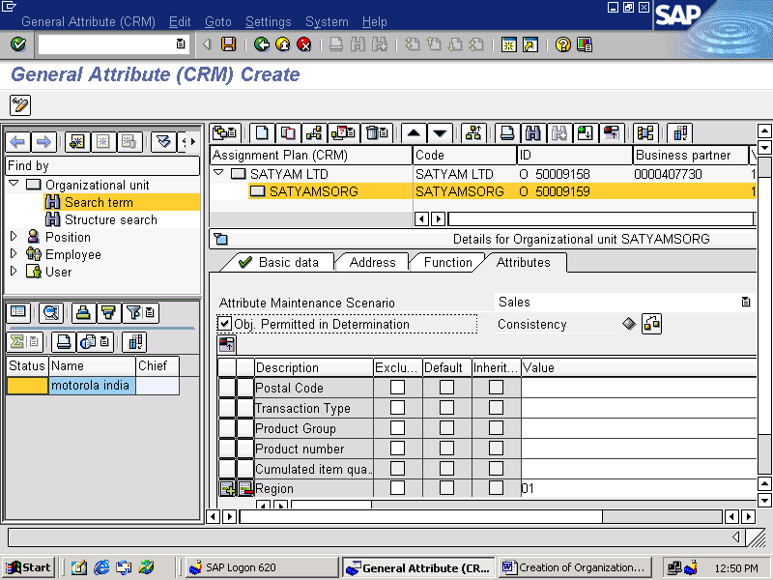

CLICK ON CONSISTENCY CHECK
CLICK ON CONTINUE
CLICK ON SAVE

RIGHT CLICK ON SALES ORGANIZATION
EG : SATYAMSORG ( SATYAM SALES ORGANIZATION)
CLICK ON CREATE

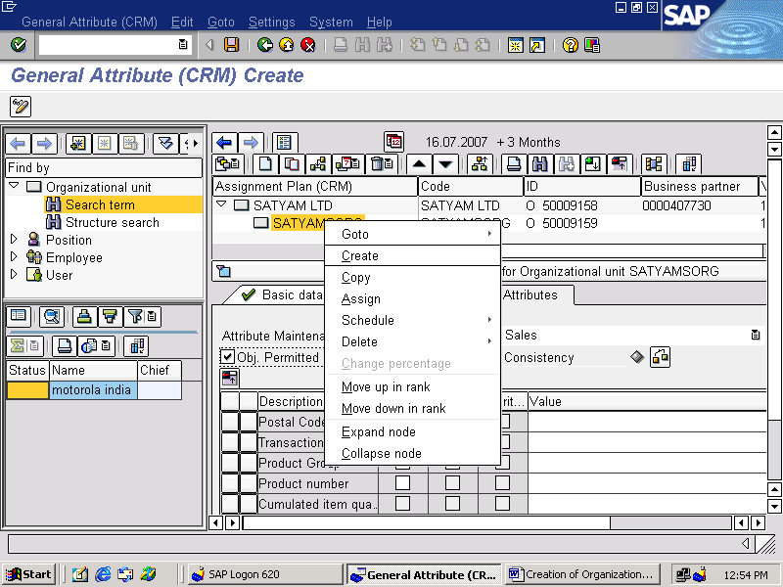

SELECT THE ORGANIZATIONAL UNIT FROM THE TWO OPTIONS
CLICK ON CONTINUE
EG:

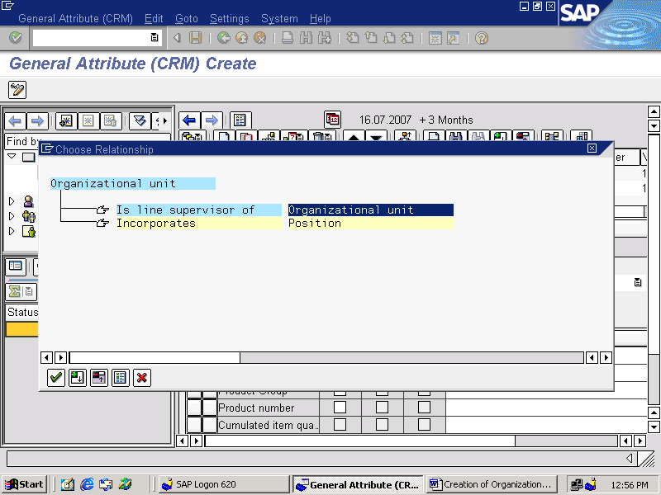

(DISTRIBUTION CHANNEL AND DIVISION)

GO FOR BASIC DATA TAB
ENTER THE DISTRIBUTION CHANNEL AND DIVISION
EG: SATYAMDCDIV ( SATYAM DISTRIBUTION CHANNEL AND DIVISION

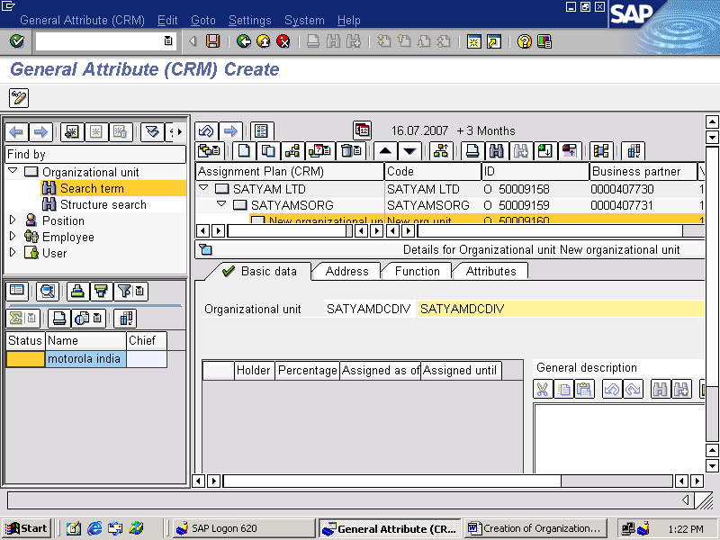

CLICK ON ADDRESS TAB
ENTER THE DATA IN REQUIRED FIELDS
EG:

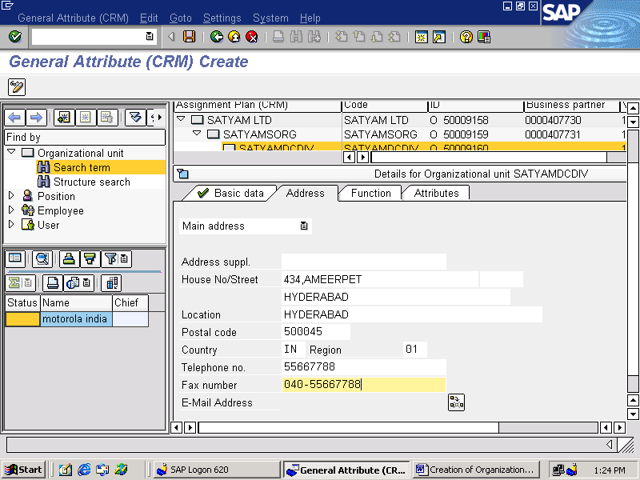

CLICK ON THE ATTRIBUTES TAB
ENTER THE DISTRIBUTION CHANNEL AND DIVISION WHICH ARE CREATED
EG:

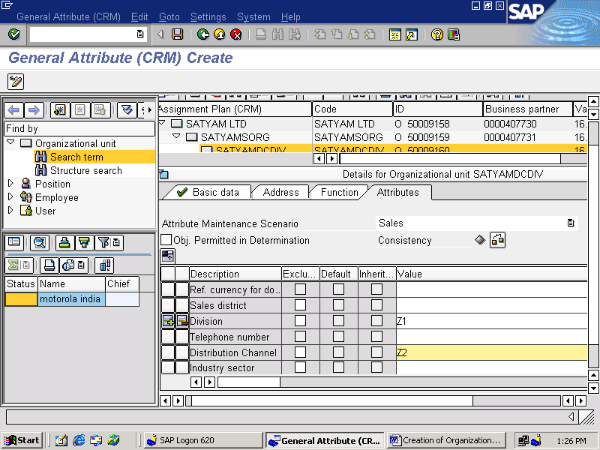

CLICK ON CONSISTENCY CHECK
CLICK ON CONTINUE
CLICK ON SAVE

RIGHT CLICK ON DISTRIBUTION CHANNEL AND DIVISION (SATYAMDCDIV)
CLICK ON CREATE
EG:

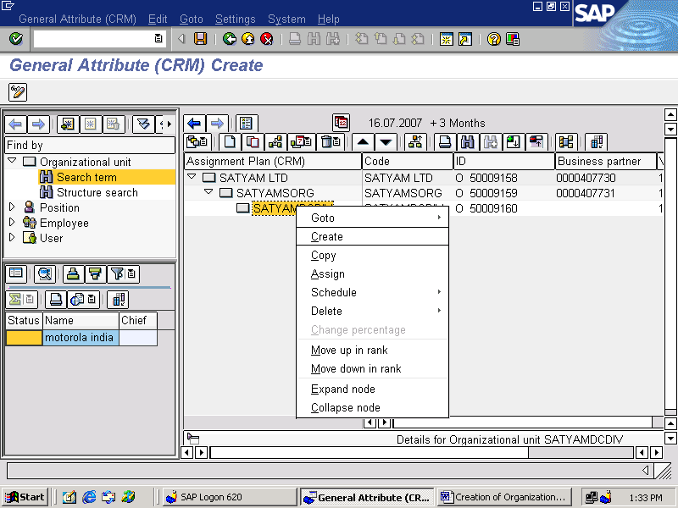

SELECT THE ORGANIZATION UNIT FROM THE TWO OPTIONS
CLICK ON CONTINUE
EG:

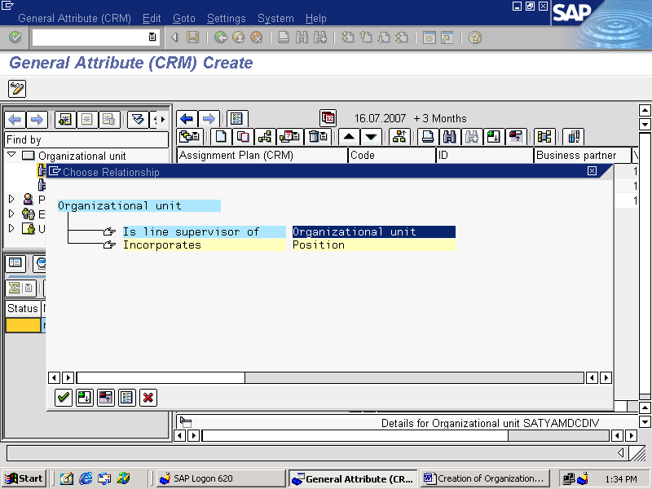

(SALES OFFICE )

CLICK ON BASIC DATA TAB
ENTER THE SALES OFFICE OF THE SALES ORGANIZATION (SATYAMSORG)
EG: SATYAMSOFF

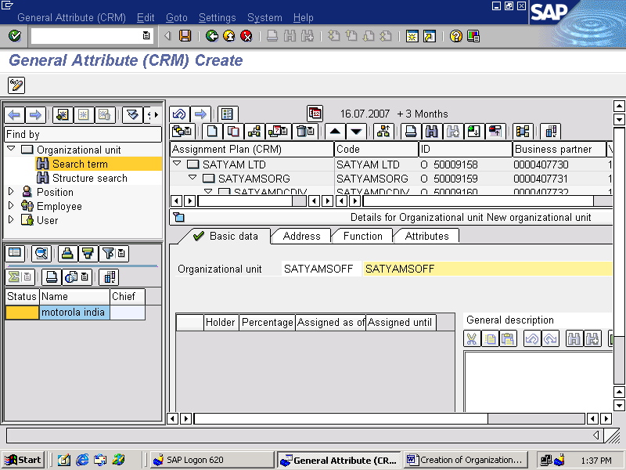

CLICK ON ADDRESS TAB
ENTER THE REQUIRED FIELDS DATA
EG:

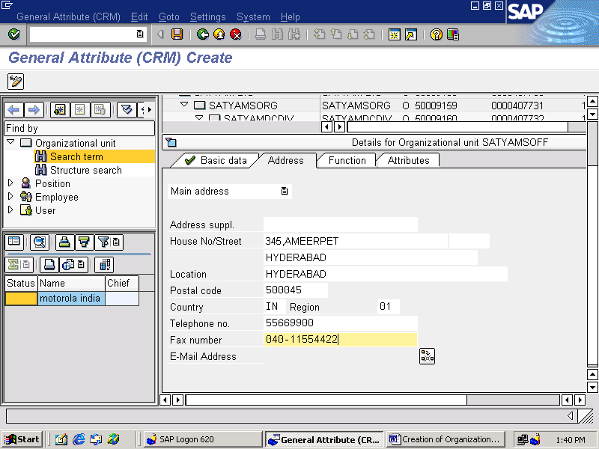

CLICK ON THE FUNCTION TAB
CHECK THE BOX FOR SALES OFFICE
EG:
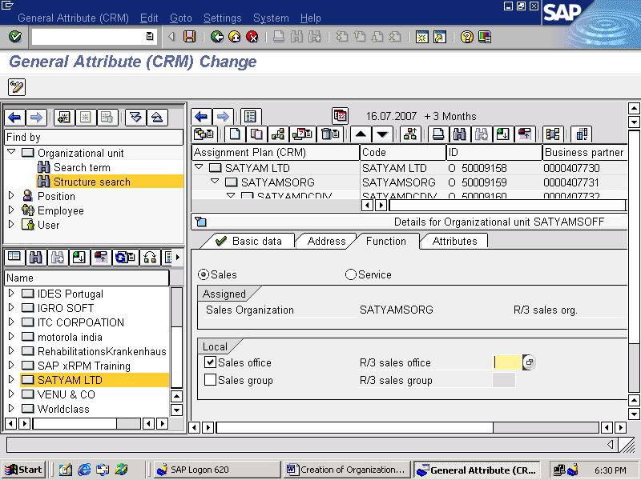

CLICK ON ATTRIBUTES TAB
CHECK THE BOX OBJECTS PERMITTED IN DATA DETERMINATION

EG:

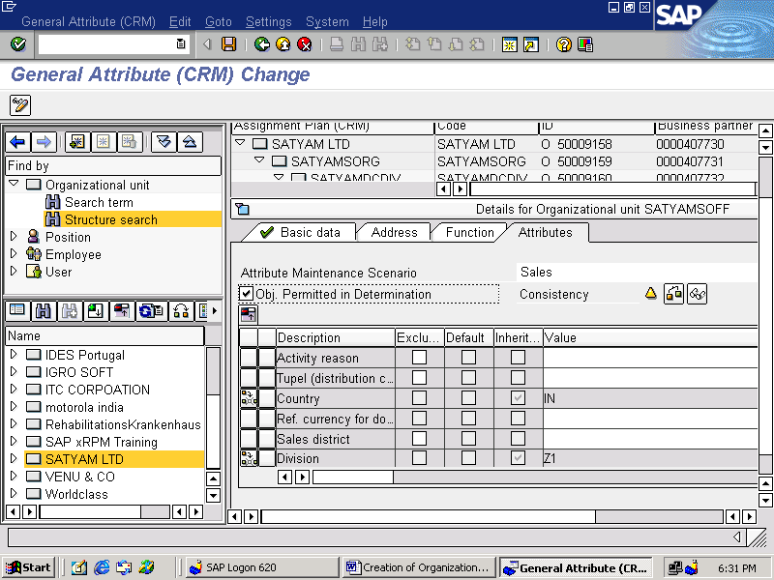

RIGHT CLICK ON SALES OFFICE (EG: SATYAMOFF)
CLICK ON CREATE
EG:

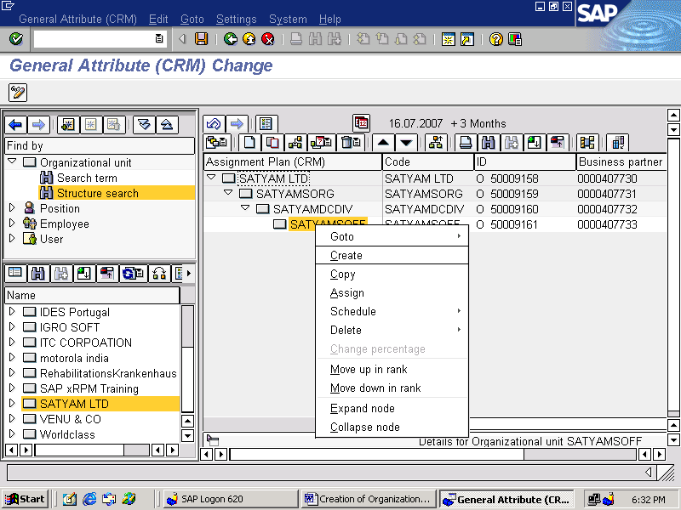

SELECT THE ORGANIZATIONAL UNIT FROM THE TWO OPTIONS
CLICK ON CONTINUE
EG:

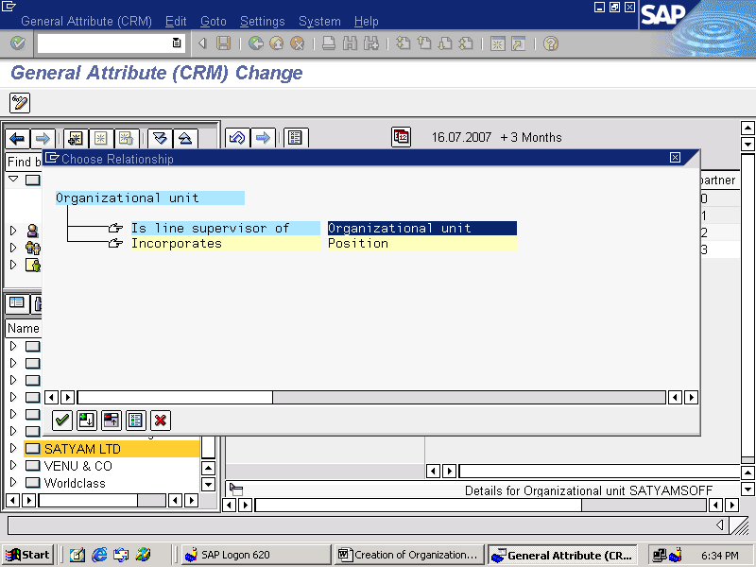

(SALES GROUP)

CLICK ON BASIC DATA TAB
ENTER THE ORGANIZATIONAL UNIT SALES GROUP
EG: SSGROUP (SATYAM SALES GROUP)
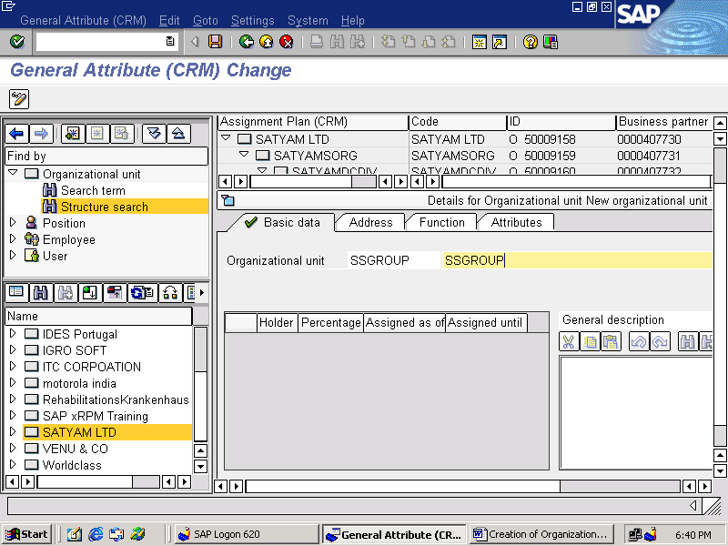

CLICK ON ADDRESS TAB
ENTER THE REQUIRED FIELD DATA
EG:

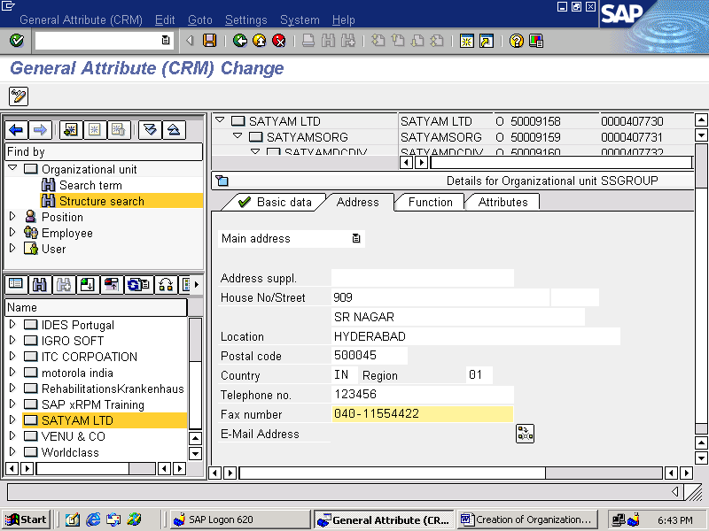

CLICK ON FUNCTION TAB
CHECK THE BOX SALES GROUP
EG:

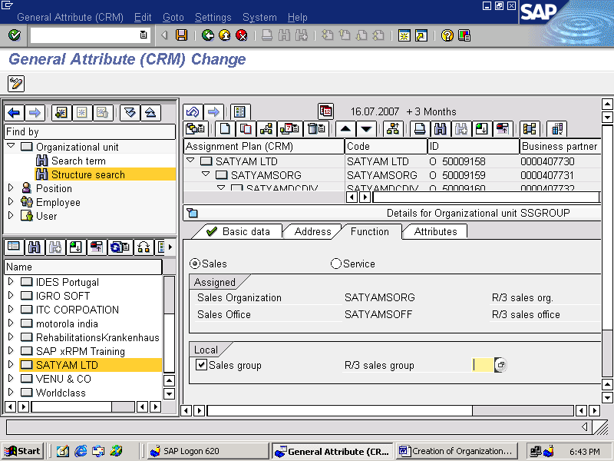

CLICK ON ATTRIBUTES TAB
ENTER THE REQUIRED ATTRIBUTES
EG:

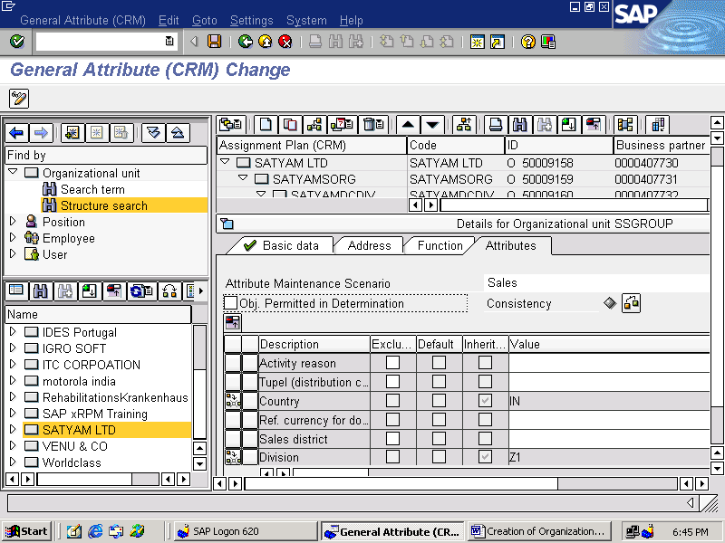

CLICK ON SAVE

RIGHT CLICK ON SALES GROUP ( EG: SSGROUP)
CLICK ON CREATE
EG:

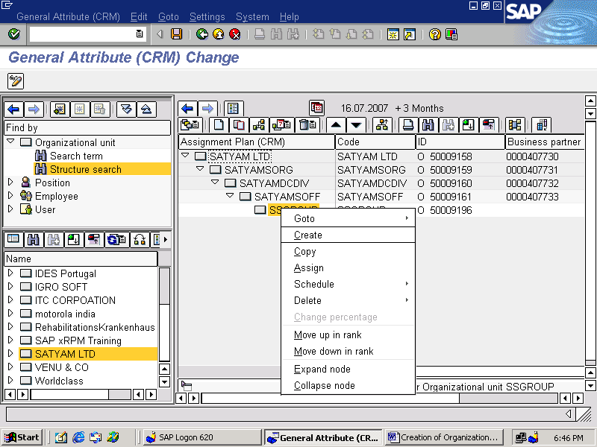

SELECT “POSITION” FROM THE TWO OPTIONS
CLICK ON CONTINUE
EG:

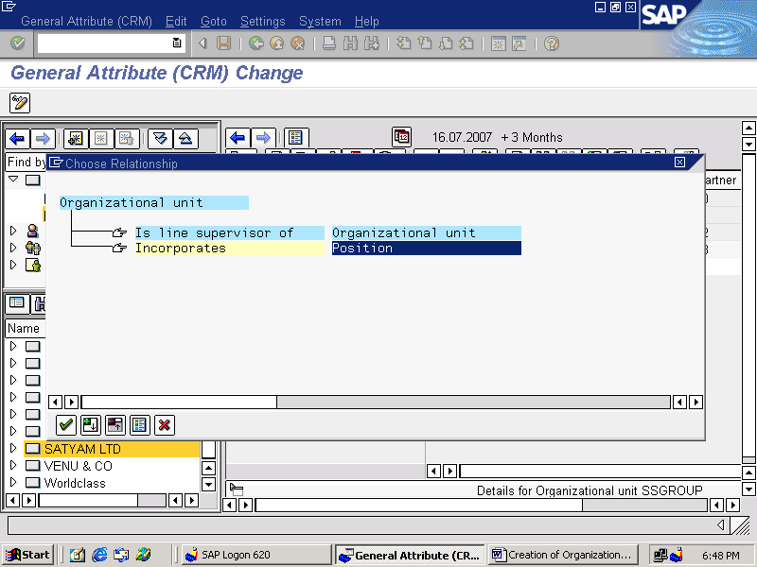

(SALES MANAGER)

CLICK ON BASIC DATA TAB
ENTER THE POSITION SALES MANAGER
CHECK THE BOX “HEAD OF OWN ORGANIZATIONAL UNIT”
EG: SSMGR ( SATYAM SALES MANAGER)

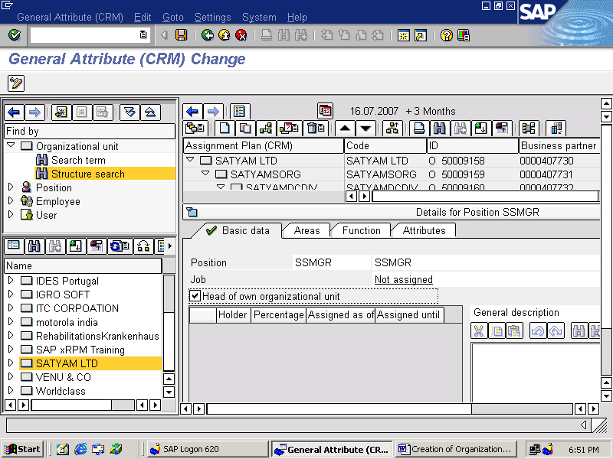

CLICK ON AREAS TAB
CLICK ON CREATE BUTTON
ASSIGN THE TERRITORY ID FOR SALES MANAGER
EG:

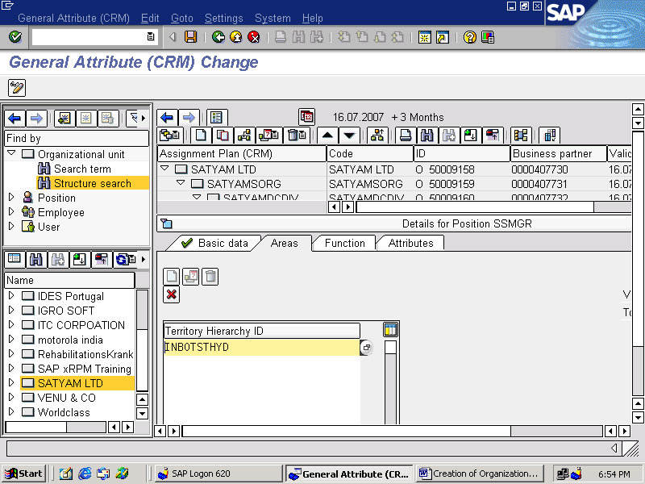

( WE ARE NOT TAKING ANY DATA IN FUNCTION AND ATTRIBUTES TABS FOR SALES MANAGER)

CHECK THE CONSISTENCY
CLICK ON SAVE

RIGHT CLICK ON SALES MANAGER ( EG: SSMGR)
CLICK ON ASSIGN FOR ASSIGNING A BUSINESS PARTNER/ USER

EG:

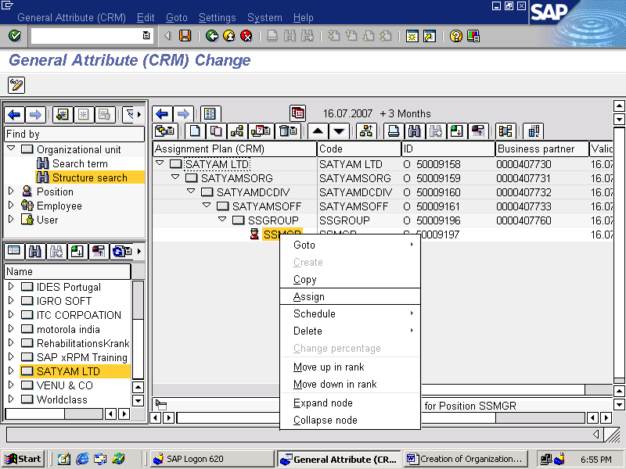

SELECT THE “BUSINESS PARTNER” FROM THE TWO OPTIONS
CLICK ON CONTINUE
EG:

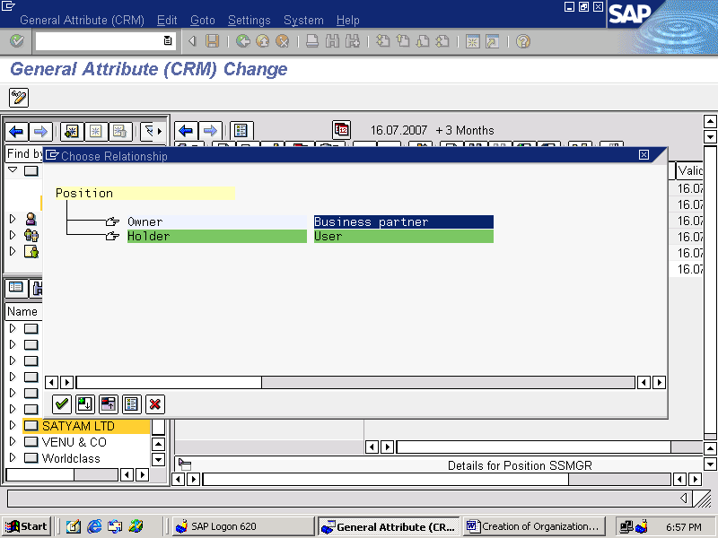

(BUSINESS PARTNER)

SELECT / CREATE A BUSINESS PARTNER WITH ROLE “EMPLOYEE”
EG: VASANTH
CLICK ON CONTINUE
THE BUSINESS PARTNER WILL BE ASSIGNED TO SALES MANAGER

EG:

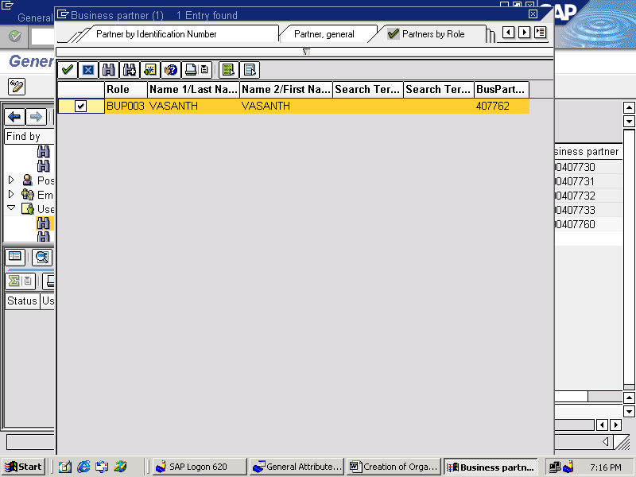

AGAIN RIGHT CLICK ON SALES MANAGER ( EG: SSMGR)
CLICK ON ASSIGN FOR ASSIGNING A USER TO THE SALES MANAGER
EG:

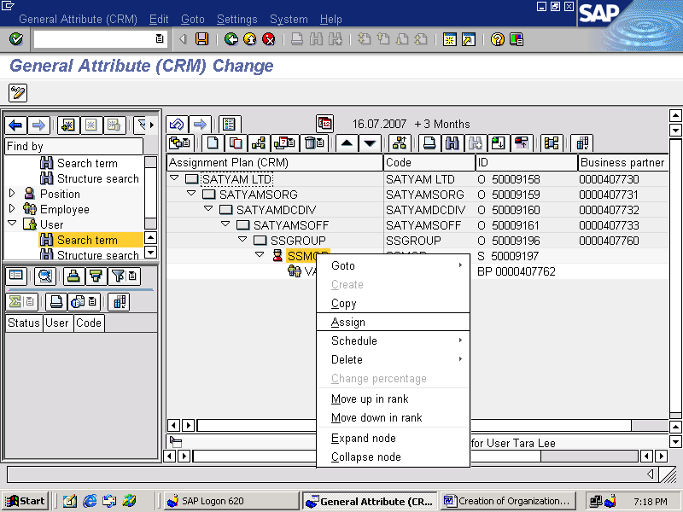

SELECT THE OPTION “USER “ FROM THE TWO OPTIONS
CLICK ON CONTINUE
EG:

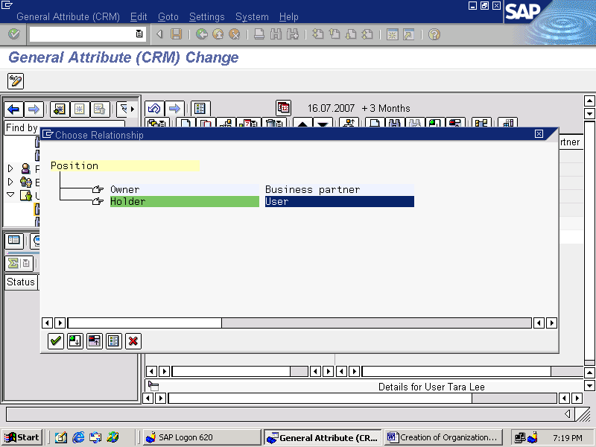

( USER)

SELECT THE EXISTING USER
CLICK ON CONTINUE
(THE USER WILL BE ASSIGNED TO THE SALES MANAGER)
EG:

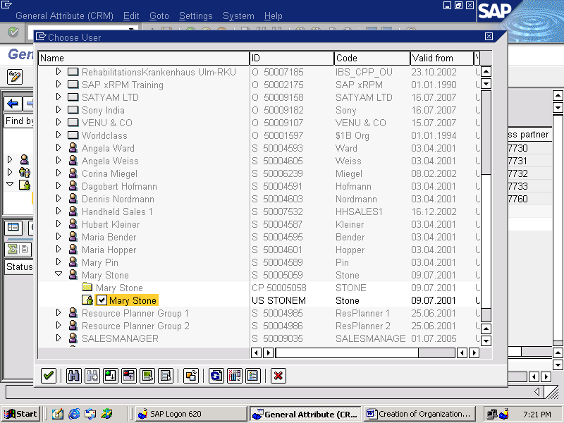

STRUCTURE OF THE ORGANIZATIONAL MODEL

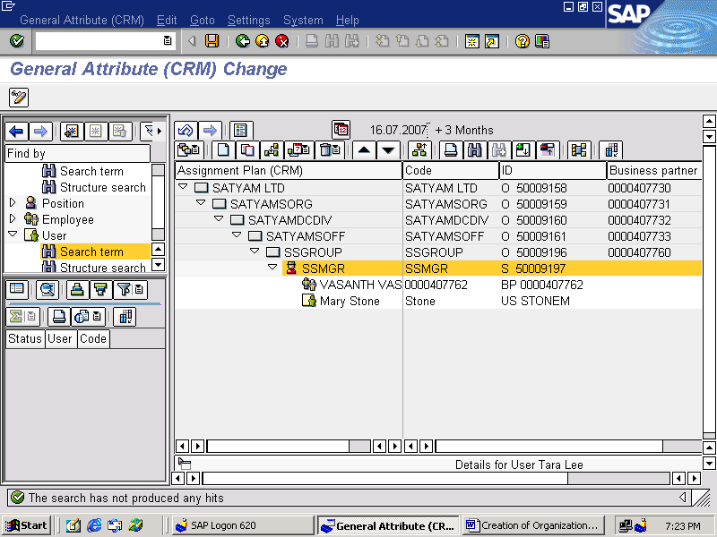

SATYAMLTD : COMPANY NAME
SATYAMSORG : SALES ORGANIZATION
SATYAMDCDIV : DISTRIBUTION CHANNEL AND DIVISION
SATYAMOFF : SALES OFFICE
SSGROUP : SALES GROUP
SSMGR : SALES MANAGER
VASANTH : BUSINESS PARTER WITH ROLE EMPLOYEE
MARY STONE : USER

