 Displaying Lists of Trace Records

Prerequisites
You must have switched off the Performance Trace, set the display parameters in the Display Filter and displayed the basic or extended list.

Lists
You can display trace records in either a basic list or an extended list.
The extended list contains everything from the basic list, along with three extra display columns. There is a range of analysis functions that you can use both on the basic list and on the extended list. The functions are the same in both lists. You can switch between the two list displays using a pushbutton in the application toolbar.

Basic List
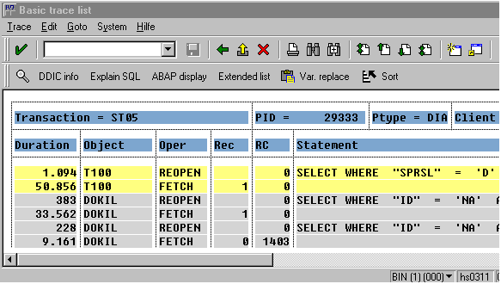
The first line of the list contains a subheader, which remains unchanged for all trace records of a program to be analyzed. It contains the following information:
- Name of the transaction, process identification number, process type, client, and user name.
The next line contains the following headers:
Duration - Runtime for the statement in the format milliseconds.microseconds.
Object
- SQL trace record: Name of the database table
- Enqueue trace record: Name of the lock object
- RFC trace record: Shortened name of the instance on which the function module was executed
Oper
- SQL trace record: Name of the operation to be performed on the database. See also: Measured Database Operations
- Enqueue trace record: Name of the lock operation
- RFC trace record: Client | Server (client means that a remote function was called, server means that the function was made available and executed)
Rec – Number of records
- SQL Trace: Number of records retrieved or processed and passed between the SAP System and the database.
- Enqueue trace: Number of granules
- RFC Trace: Not used
RC - Return code of the logged statement
Statement - Short form of the logged statement
- Depends on the trace type.
The runtime (duration) is highlighted in the list if it exceeds a given threshold value (100000 microseconds). This is declared in the type group “SQLT” as the constant “SQLT_DURATION_NEG”. You can change this value by changing the constant accordingly.
Note that the duration can only be as precise as clock of your hardware platform. If the execution time of the statement is less than the smallest unit of time supported by the hardware clock, the duration will be zero.

Extended List
To switch from the basic list to the extended list, choose Extended list. The extended list contains three extra display columns:
hh:mm:ss.ms - The time at which the record was executed (in the form hours: minutes: seconds: milliseconds).
Program - Name of the program that executed the logged statement.
Curs
- SQL trace record: Number of the cursor (link to cursor cache) used to find the database entries.
- Enqueue and RFC trace records: Not used.

Additional Functions

Analyzing Trace Records
Sort list
Display formatted logged statements
Definition of the corresponding ABAP Dictionary object for SQL and Enqueue trace
Display the logged statement in the source code
Display the access plan for a logged SQL statement
Format identical select statements in the trace list
Summarize the trace list
Switch between the two lists
For more information, refer to Analyzing Trace Records

Different Trace Types
The system displays different trace types in different colors.

Standard Functions
A range of standard SAP list functions is also available to help you print the list, navigate and search in the list, or save the list to an operating system file. These functions can be called via the corresponding menu entries, buttons, or function keys.
See also Saving Lists Locally

