

SAP Basis Training

28/02/00 – 03/03/00
Avon USA

SAP Architecture 4
R/2 vs R/3 Architecture: 4
R/3 Landscape Reebok: 5
PRD Layout: 5
SAP Application Layer 6
SAP Communication: 6
SAP Basis 7
System Monitoring From SAP: 7
AL08 7
DB01 7
SM12 8
SM21 9
SM36 10
SM37 10
SM50 11
SM51 11
SM66 12
ST04 12
System Monitoring From Unix: 13
Glance Plus 13
Onstat 14
Sar 14
Reporting Performance Issues: 15
Issues Affecting The Whole System: 15
Issues Affecting Only One User: 15
Heads Up: 15
Daily Status Report: 16
Informix 17
Informix Architecture: 17
Informix Information 17
Onstat: 17
SAPdba: 18
Onmode & Oninit: 18
Informix Information From SAP: 18
SAP Users And Security 19
Security Overview 19
Transaction Codes 19
SU01 19
SU53 20
System Support Menu (unknown transaction code) 20
ZAUT 21
Correction In Transport System (CTS) 22
Transport Layout 22
Transports From SAP 22
Manual Transports 22

SAP Architecture

R/2 vs R/3 Architecture:

R/2 (host based) R/3 (client/server 3 tier)

R/3 Landscape Reebok:

PRD Layout:

SAP Application Layer

SAP Communication:

SAP Basis

System Monitoring From SAP:

AL08
This transaction code shows a list off all user currently logged on to the SAP system (all app servers).
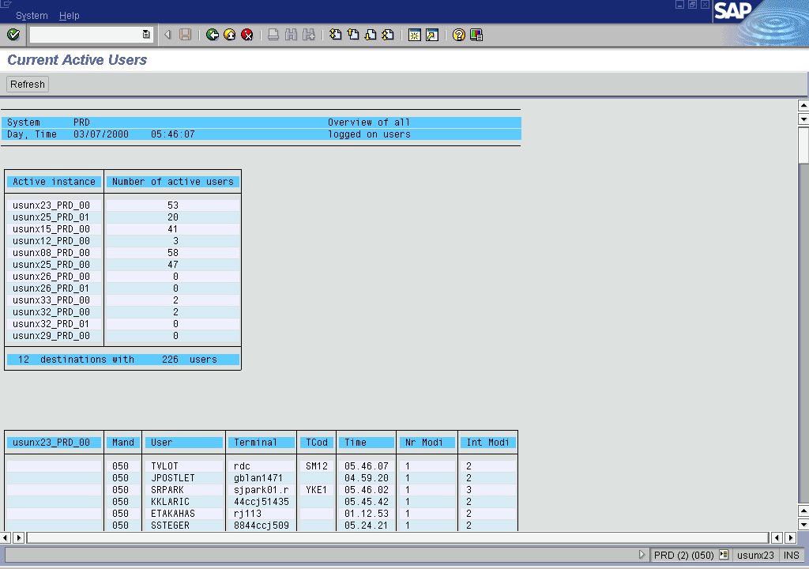

DB01
This transaction codes will display table locks.
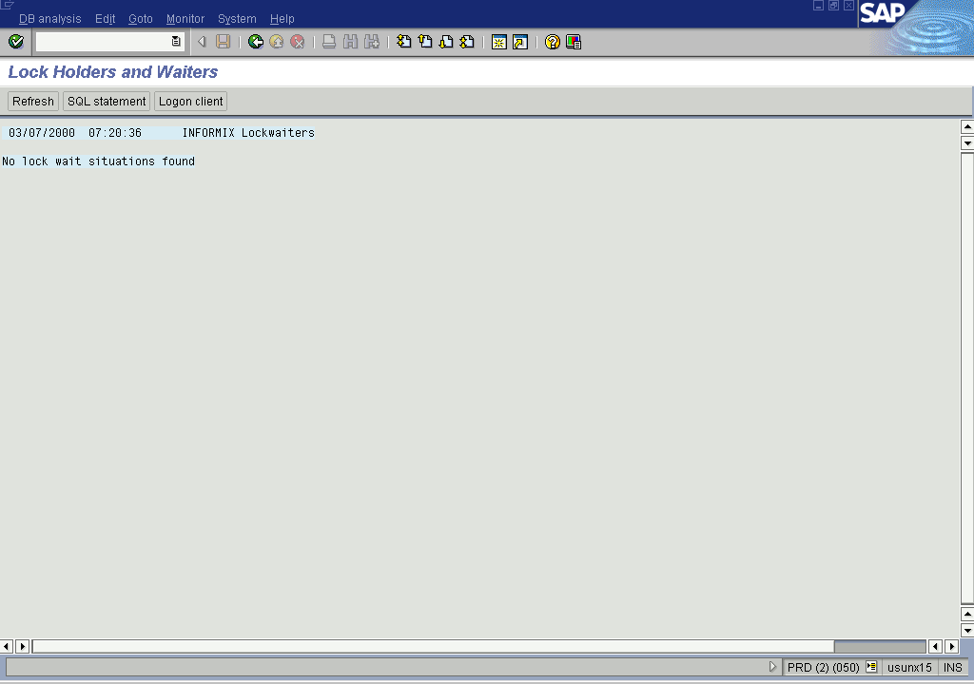

SM12
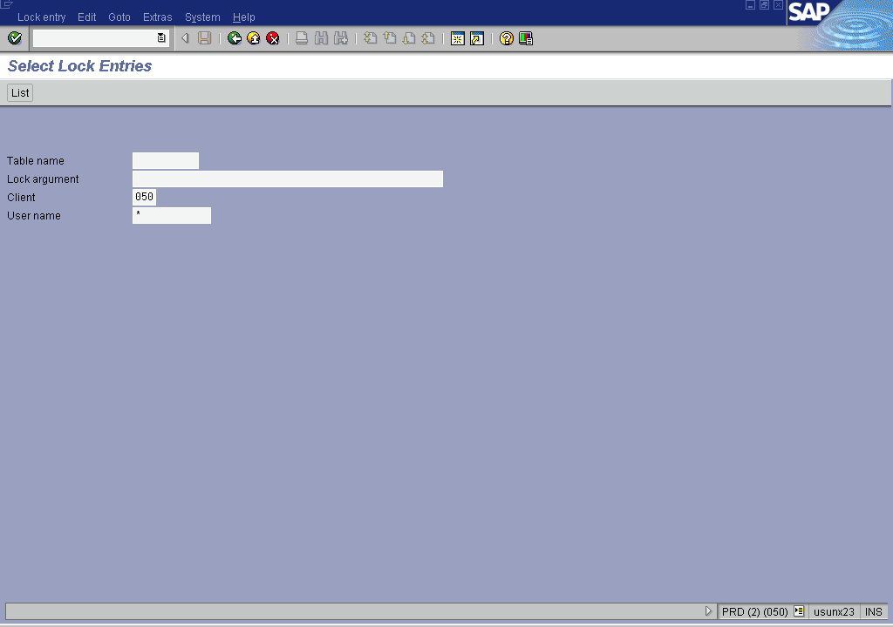
This transaction code will display the enqueue locks.

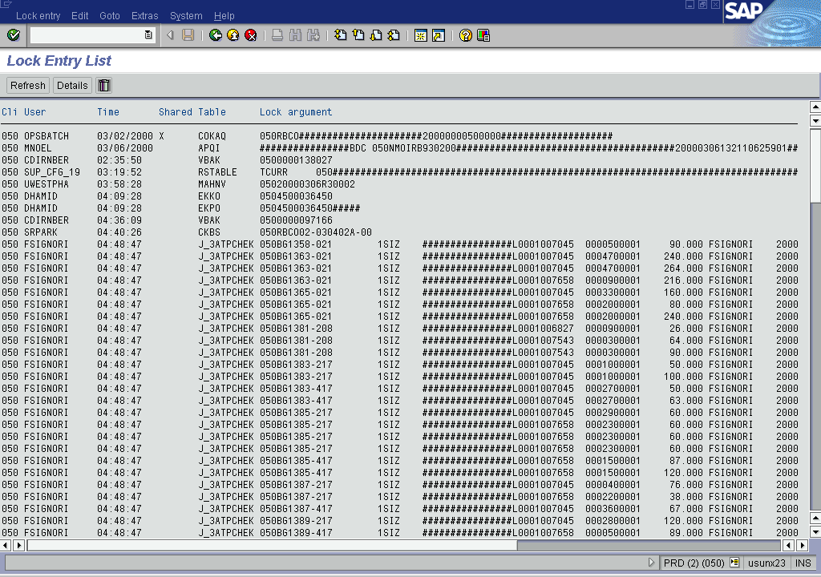
Fill in the selection criteria as you want them and hit the list button at the top.

SM21
This transaction code is used to see the system log files.
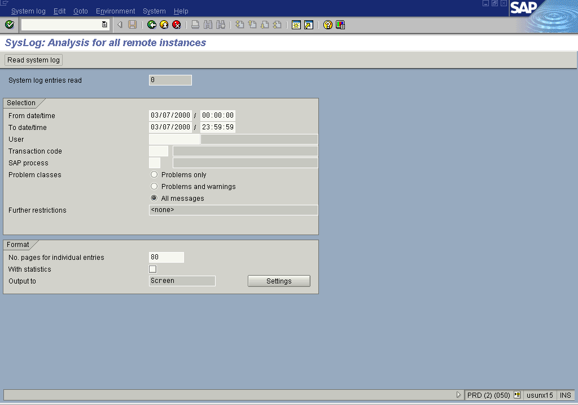
After you have filled in your selection make sure to choose system log, choose, all remote system logs before you hit the read log button.
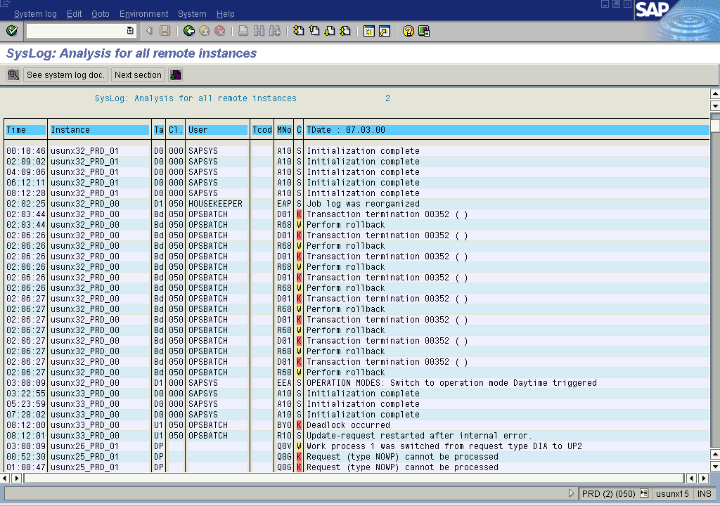

SM36
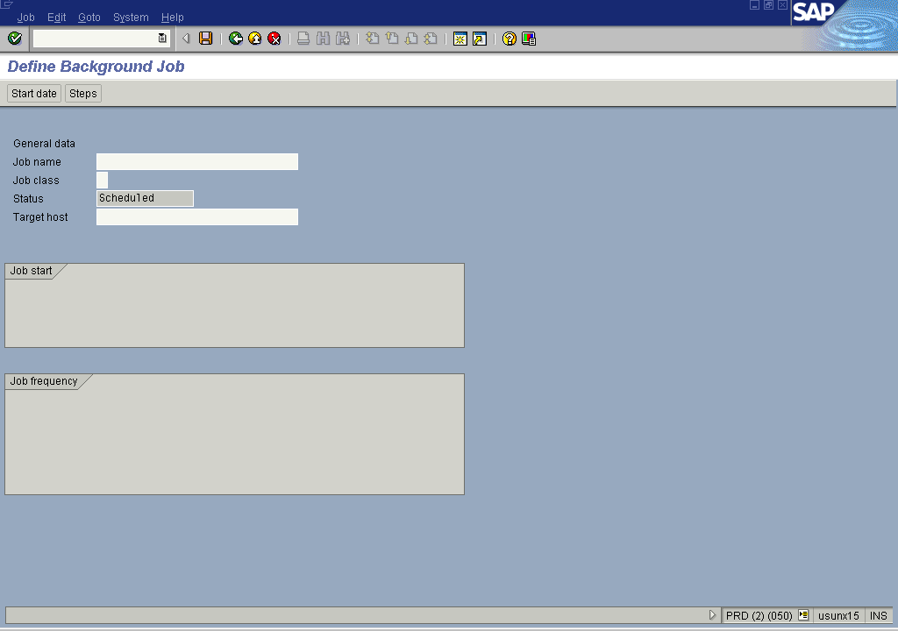
This transaction is used to schedule a background job.

SM37
This transaction code is used to display background (or batch) jobs submitted by users.

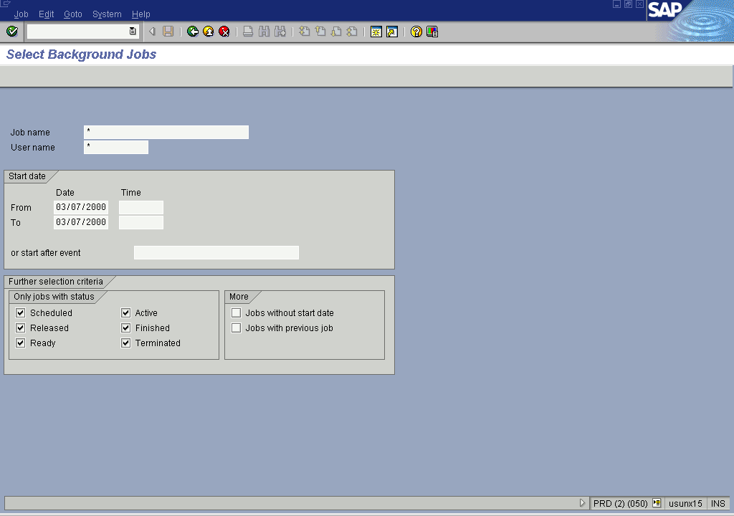
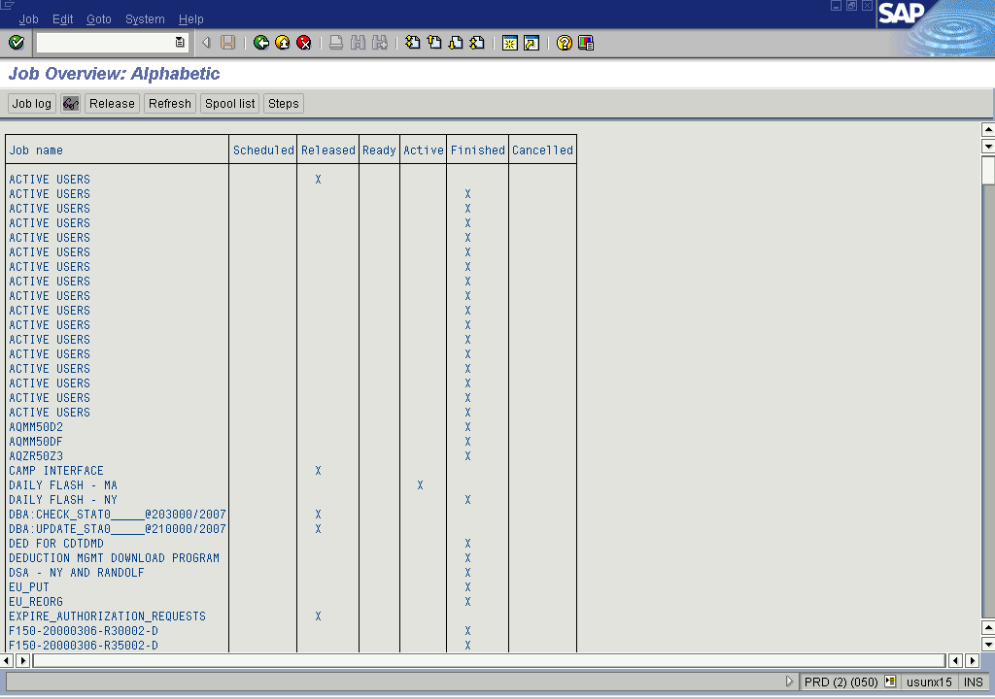
After making your selection hit enter.

SM50
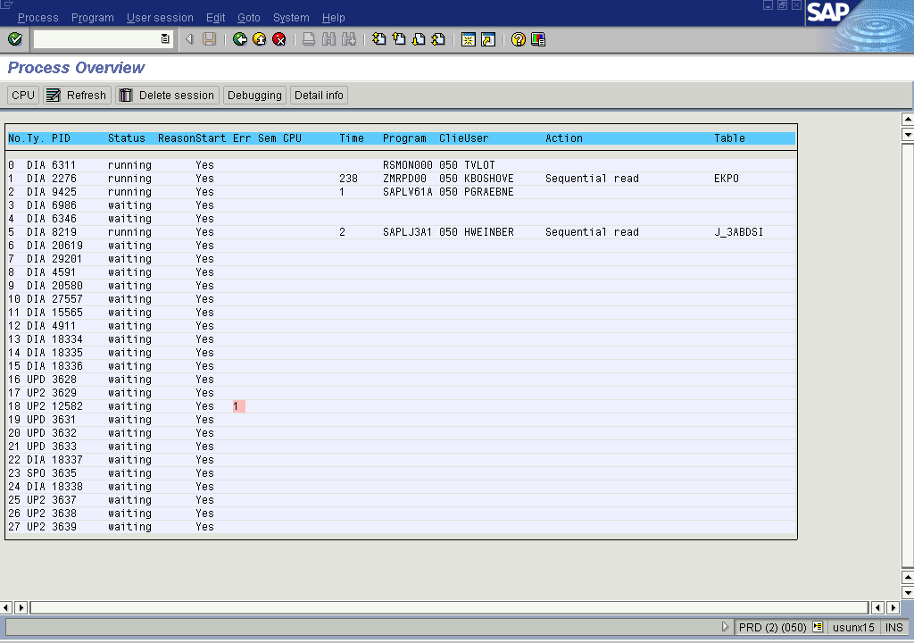
This transaction code is used to display all the work processes on the current apps server.

SM51
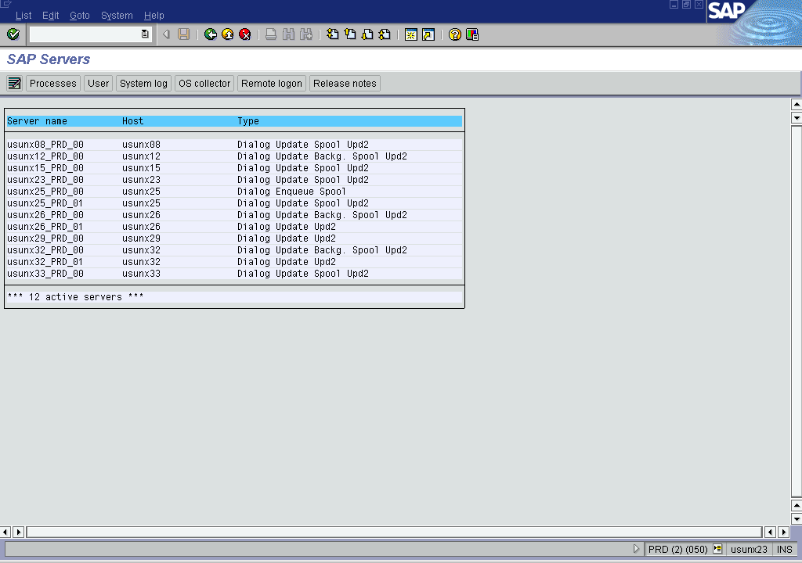
This transaction code is used to display a list off all the running apps servers. There should be 12 apps servers running at all times.

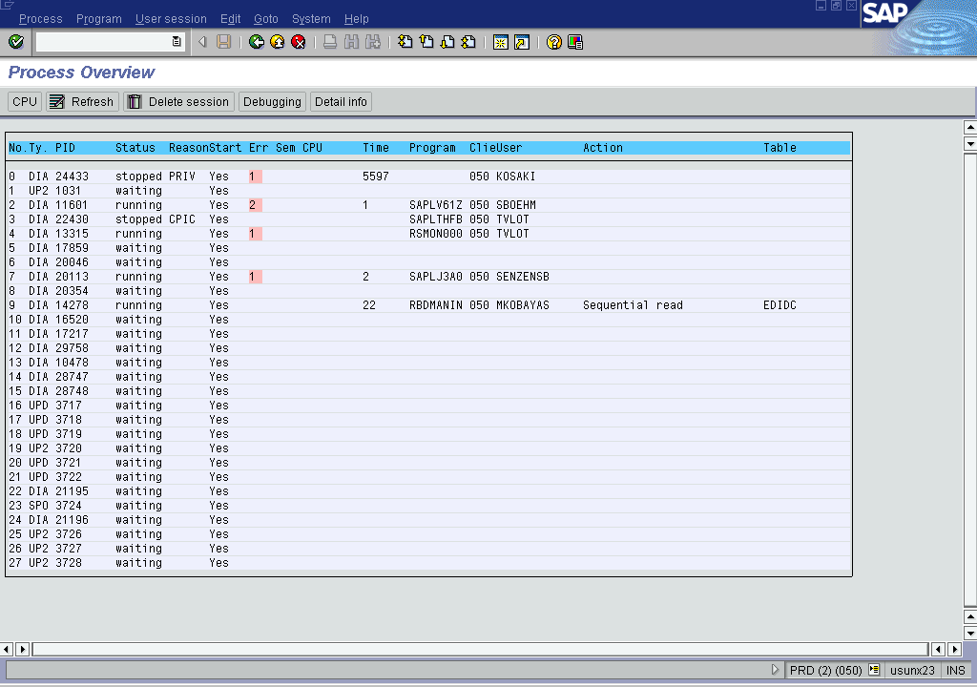
By double clicking on one off the servers in the list you will then see a listing off all the workprocesses on that server (same as using sm50). Note: you will also connect to that server.

SM66
This transaction code will display a list off all current running work processes on all the apps servers. It doesn’t refresh itself automatically so hit <enter> or select the refresh button located at the top.
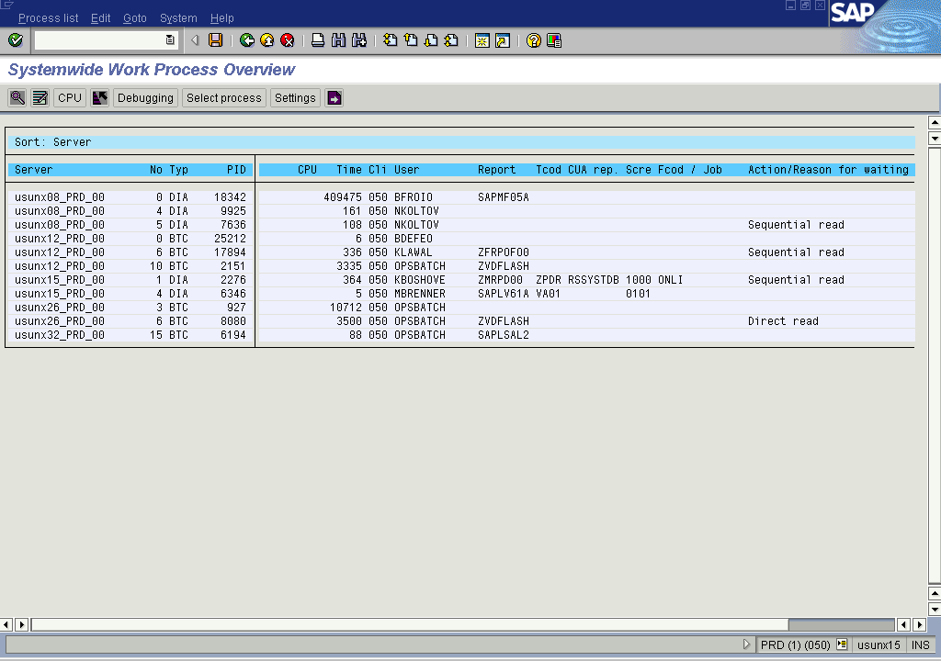
The list can be sorted by selecting a colum and hitting the sort button located at the top.

ST04
This transaction code will bring up the Informix database overview. It displays information about the current use of the database
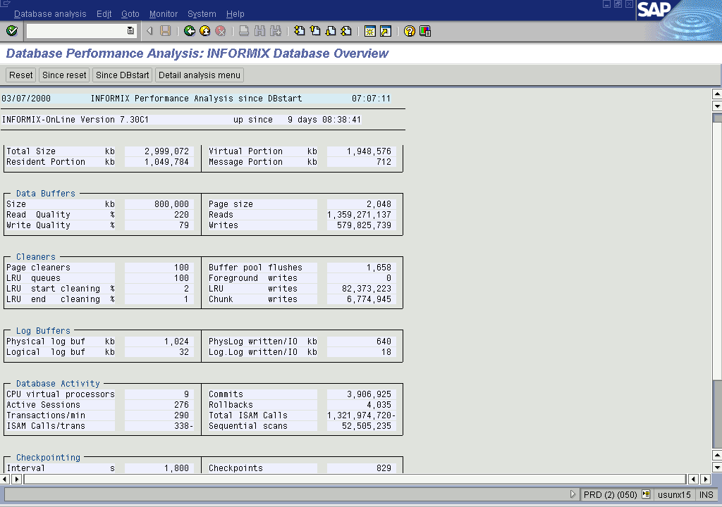
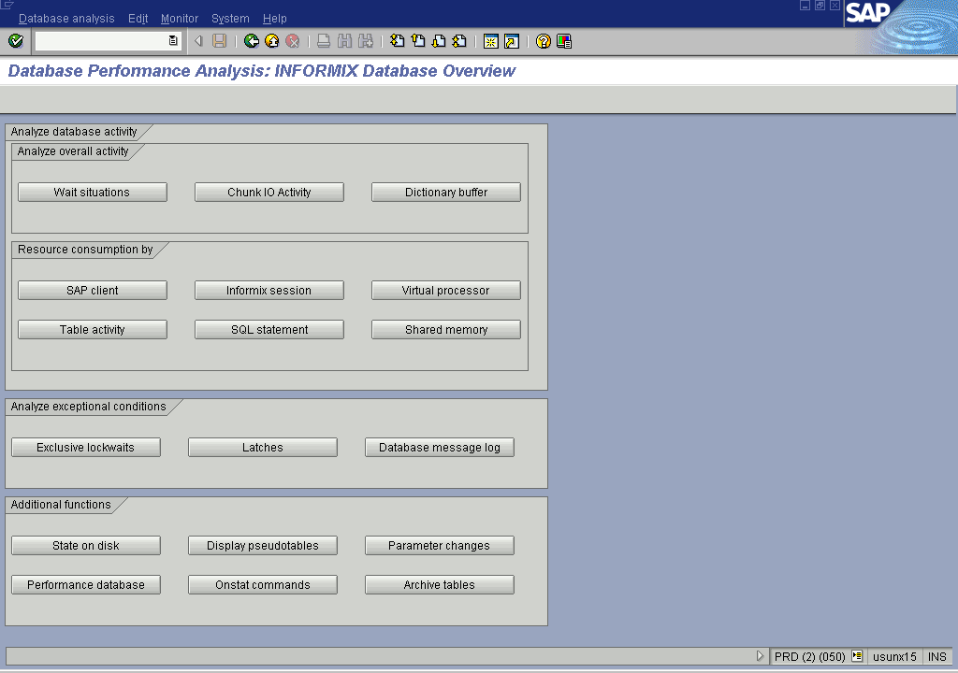
If you select the detail analysis menu using the button in the top bar you will see the screen shown below.

Here the button informix session is very usefull because the screen it brings up will help you map the PID to the SID.
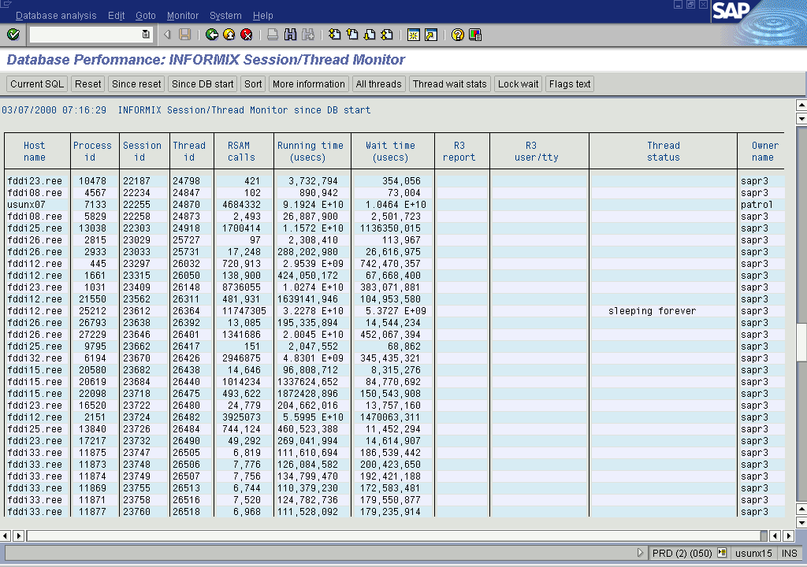

System Monitoring From Unix:

Glance Plus
Glance is an unix command used to show system usage. It must be run as root or superuser.

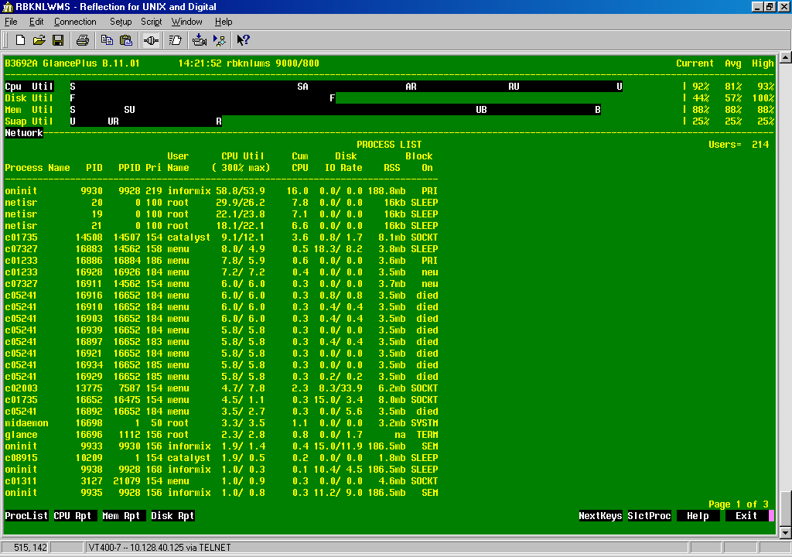
Onstat
Onstat is an informix status command. It must be run on the informix database server as user informix. There are a few possible options:

$ onstat -l
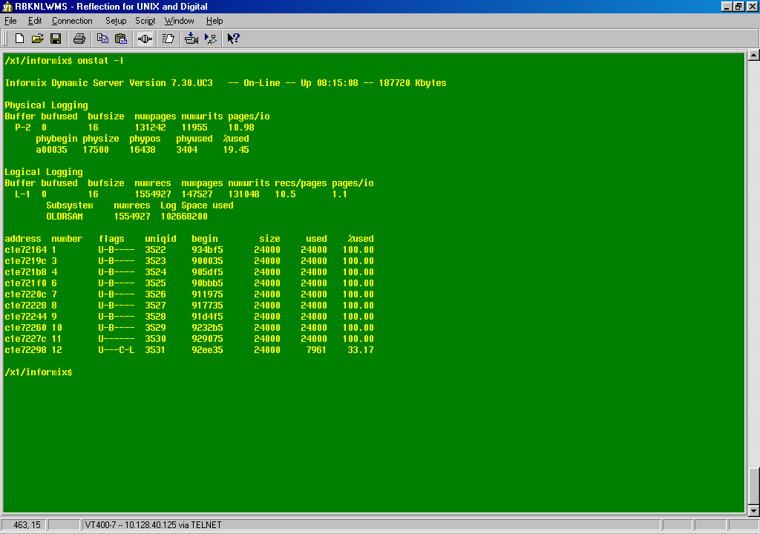
$ onstat –m (shows the tail off the informix log)
$ onstat –g sql SID
$ onstat –u –r |grep SID

Sar
Sar is used to display disk activity on the unix box.
#sar –g 5 5

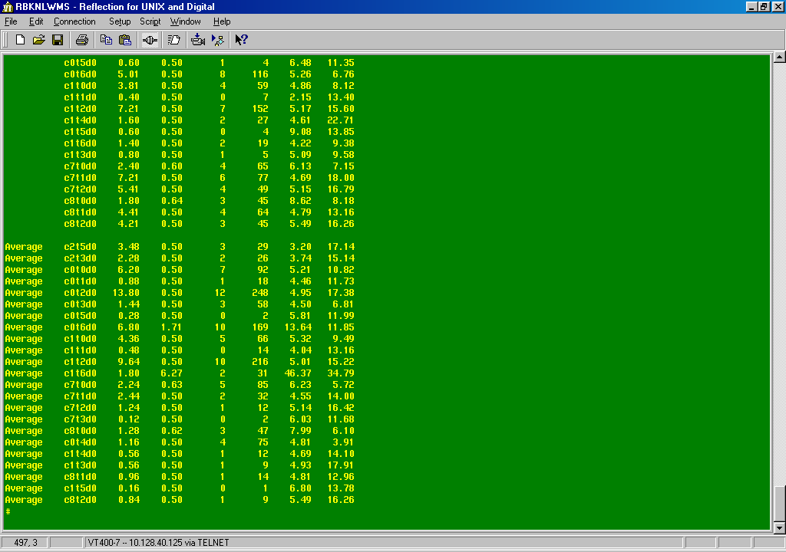
Reporting Performance Issues:

Issues Affecting The Whole System:
If there are system wide problems makes screenshots off the following transactions and send them to SAP Basis in the US.
- sm66
- al08
- sm12
- db01
- sm51
- # glance
- # sar –d 5 5
- # onstat -l

Issues Affecting Only One User:
If there are user specific problems make captures off the following transactions:
- sm50
- st04
- sm37
- # onstat –u –r |grep SID

Heads Up:
If you do find anything in the list below pass on a general heads up to the Basis team so they have an idea where to look.
- sm21
- st22
- sm13
- OSS notes
- ST11
- Informix log (onstat –m)

Daily Status Report:
For the daily report send a mail message with:
- Short dumps (st22)
- System Log (sm21)
- Update errors (sm13)
- Reported user problems

Informix

Informix Architecture:

A database is made up off database records. These are made up of chunks (of raw disk space) which comprise pages of data. A data page will be loaded into RAM. At that time an entry will be made in the physical log. Changes are then made to the page in RAM and an entry added to the logical log. If the database should crash, the physical and logical logs can be used to restore database integraty.

Informix Information
All informix commands are run on the database server as user informix.

Onstat:
Onstat is used for a number off things.
- onstat - : will show if informix is up and running
- onstat –m : tail of the informix message log (located in: /informix/<SID>/online.<machinename>.<sid>.log). Checkpoint shold be ≤ 7 secs
- onstat -- |more : help on onstat

SAPdba:
This displays information about the database for SAP. More than you can get from SAP but without the SAP protection of itself!

Onmode & Oninit:
- onmode -- : help on onmode
- onmode –yuck : SHUTDOWN informix db
- oninit : start informix db

Informix Information From SAP:
- db02
- st04
- dpspace should be < 95%

SAP Users And Security

Security Overview
There are 2 levels of security in SAP
- Transaction Code
- Authorisation

Transaction Codes

SU01
This lets you lock and unlock users.

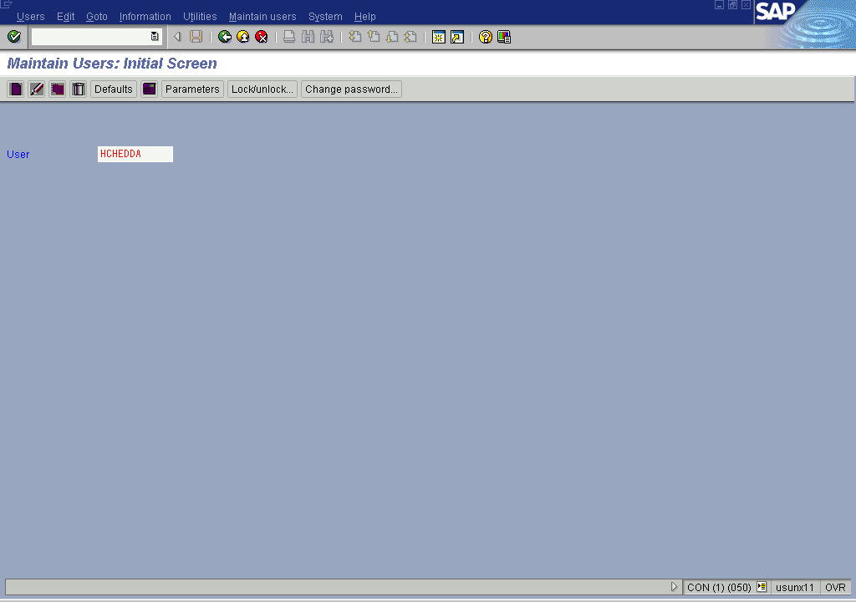

SU53
This transaction code is used for displaying authorisation problems. If a user has an authorisation issue this screen can tell you why.
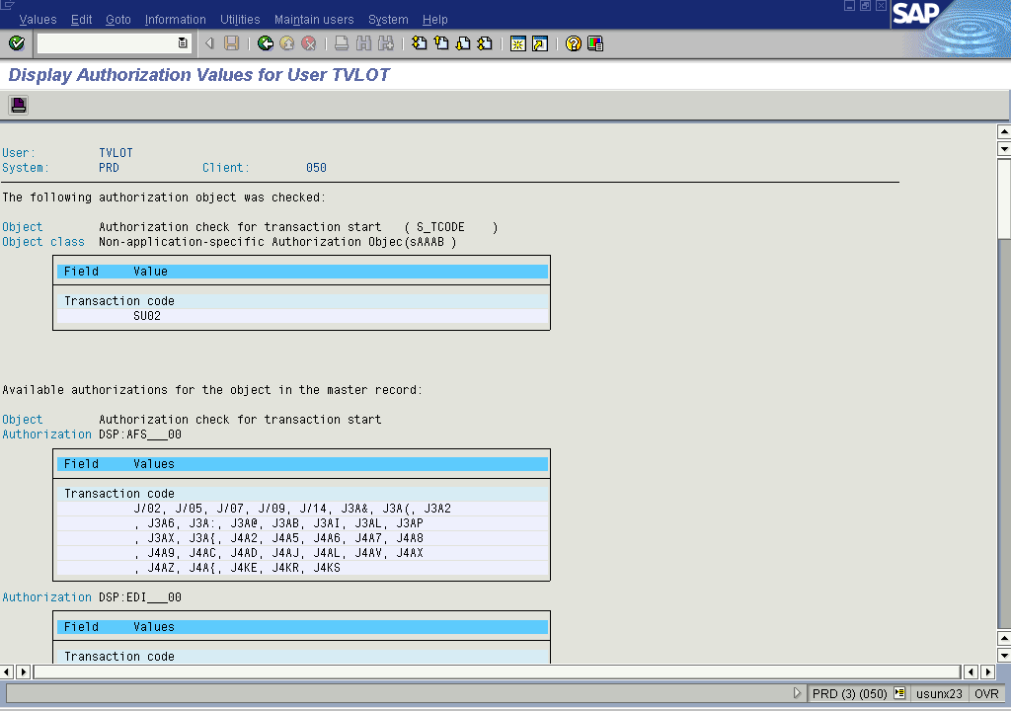

System Support Menu (unknown transaction code)
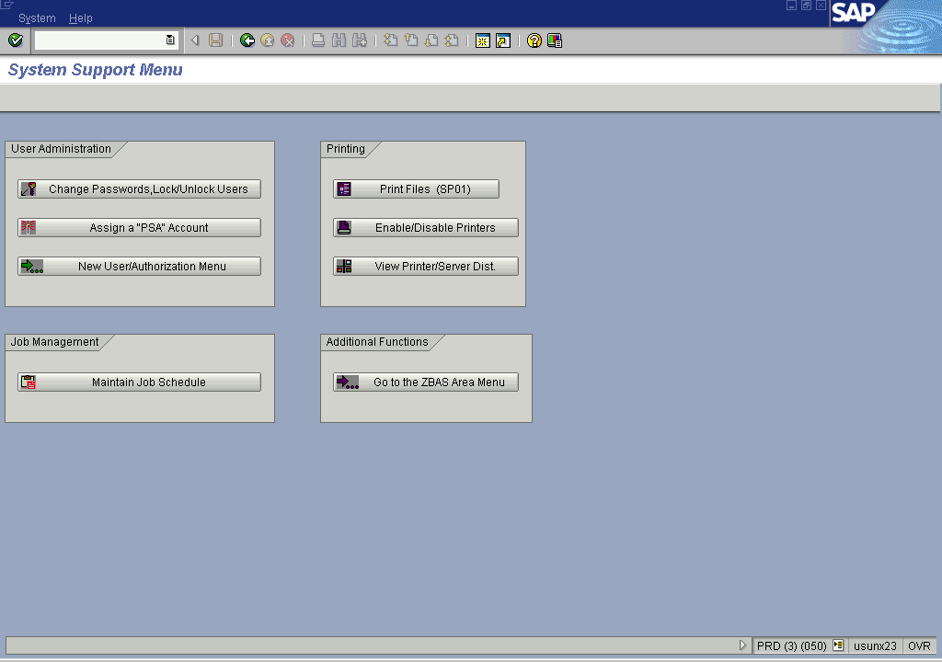
This is a handy menu that has a few off the essentials close at hand, such as locking/unlocking users, assigning “PSA” accounts (temporary accounts for testing purposes should not be active for more than 5 days, 3 is prefferable to 5), printers, etc.

ZAUT
This is “the” tools for user maintenance. Requesting new users, changing authorisation, etc.
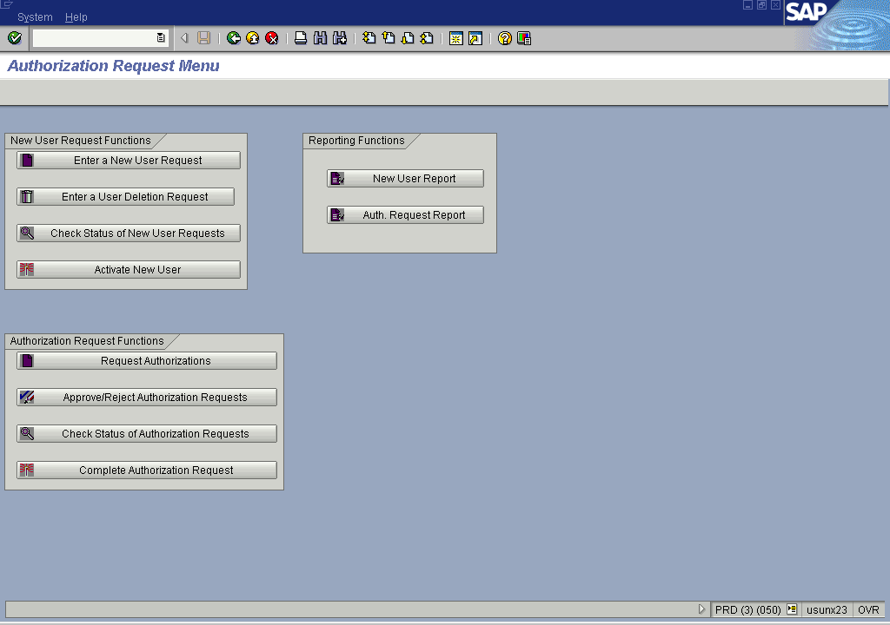

Correction In Transport System (CTS)

Transport Layout

Transports From SAP
Use transaction ztms to view the transports and if they have been approved. If you need to do transports look at the “cheat sheet” Bill made.

Manual Transports
For a few systems you have to do manual transports (like ARC). To do this:
- rlogin to the box
- su – <sid>adm
- cd /usr/sap/trans/bin
- tp addtobuffer RET<transportnumber> SID
- tp import RET<transportnumber> SID client050

