

SAP Training

Canton Feb/Mar 2001

SAP Training Canton Feb/Mar 2001
Three Tier Client/Server Model 3
Overview 3
Flow 4
Application Server 4
Database Server 5
Performance Troubleshooting 6
Performance Bottlenecks 6
Performance problems and troubleshooting techniques 6
Dialog response 6
Bottom-Up Troubleshooting 7
Unix 7
Database 10
Basis Layer 14
Dialog (per process) 17
Batch (per process) 17
Top-Down Troubleshooting 19
Acute Problems 19
Qualitative Data 19
Quantitative Data 19
Transaction overview 23

Three Tier Client/Server Model

Pro: Distribution of workload
Con: Lots of moving parts

Overview

Flow

- Check with Central Instance which server is least loaded
- Servers check with each other, one responds to CI
- Make a straight connection to that server

Application Server

- Dialog = Interactive communication (client/server communication)
- Update = Communication with database
- Spool = Formatting spool requests and passing it on to the host.
- Reebok Environment ≈ 330 work processes ≈ 330 Informix logons (threads)

Database Server

Performance Troubleshooting

Performance Bottlenecks

Performance problems and troubleshooting techniques
- Chronic/Widespread – Bottom-up
- Acute – Top-down

Dialog response
- Measured from Dispatcher to Dispatcher
- CPU (ABAP time on the Apps server)
- DB (CPU and IO on USUNX07)
- Roll (context swapping of user data)
- Wait
- Load/Gen (compiling of ABAP code)
- Processing

Bottom-Up Troubleshooting

Unix
- OSS Collector
- Basic, generalized data of the Operating System
- ST06 runs OSS Collector for the instance you’re logged on to
- Collector runs hourly
- Has an option to compare all servers
- On the USUNX07
- Idle time not less then 20%
- Not to much swap action
- Paging must be < 20% of main memory
- Disk utilization should be < 50%
- Disk queue should be low
- Disk wait time should be < 50/100 ms
- On an Apps server
- Dialog instances have low CPU usage
- Batch instances use more CPU (max should be < 20%)

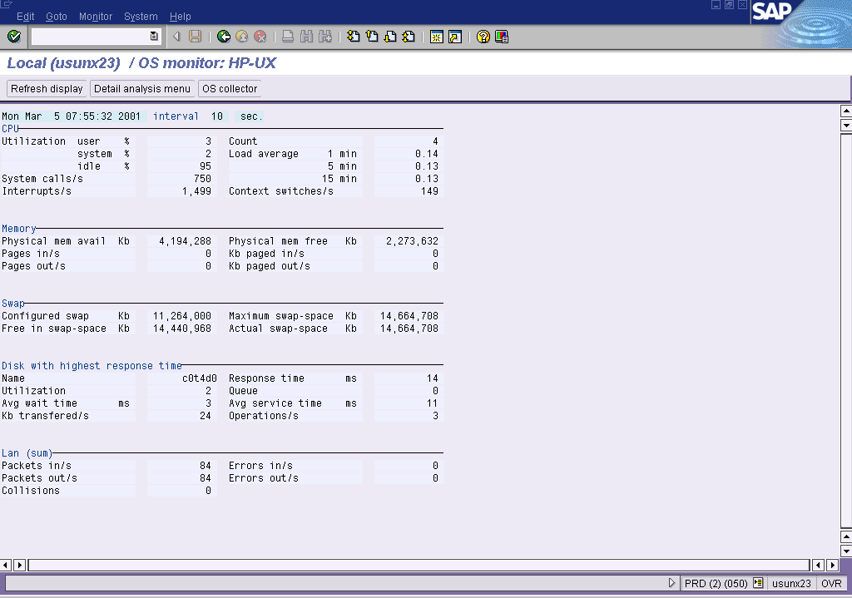

- Perview (pv)
- Glance plus (gpm)
- Disk 80%
- CPU 80%
- MEM 90%
- Swap 20%/main mem (no reactivations or deactivations)

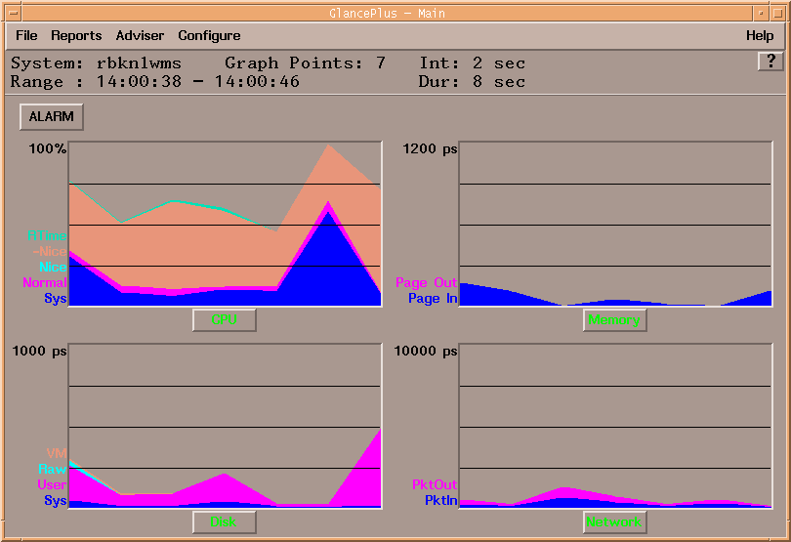

- SAR (sar –d 5 5) – Will show hot disks
HP-UX usunx07 B.11.00 U 9000/800 03/05/01

08:01:43 device %busy avque r+w/s blks/s avwait avserv
Average c0t6d0 10.32 0.56 9 145 5.03 27.44
Average c3t10d0 6.40 0.56 7 137 4.88 19.55
Average c13t0d0 3.12 0.50 9 38 4.69 4.18
Average c9t0d0 2.56 0.50 9 40 5.31 3.15
Average c15t0d0 3.16 0.50 8 34 5.46 3.74
Average c19t0d0 3.04 0.50 9 38 5.00 3.25
Average c17t0d5 23.99 0.50 76 704 5.08 4.23
Average c7t0d5 27.15 0.50 76 714 5.12 4.79
Average c11t0d5 25.63 0.50 76 706 5.14 4.73
Average c5t0d5 25.75 0.50 75 704 5.05 4.81
Average c15t0d1 0.24 0.50 0 2 4.31 8.36
Average c19t0d1 0.16 0.50 0 1 6.34 4.84
Average c17t0d4 0.88 0.50 2 7 5.61 4.75
Average c7t0d4 1.12 0.50 2 9 5.06 4.93
Average c11t0d4 0.96 0.50 2 7 4.96 4.88
Average c5t0d4 0.56 0.50 1 4 5.87 5.15
Average c9t0d2 0.04 0.50 0 0 3.01 8.41
Average c15t0d2 0.04 0.50 0 0 4.22 5.97
Average c19t0d2 0.04 0.50 0 0 3.59 8.37
Average c17t0d3 0.12 0.50 0 2 4.57 3.71
Average c7t0d3 0.36 0.50 1 2 5.24 6.74
Average c11t0d3 0.20 0.50 0 1 4.34 8.88
Average c5t0d3 0.16 0.50 0 2 5.49 4.61
Average c13t0d3 1.08 0.50 4 24 5.81 3.25
Average c9t0d3 1.52 0.50 12 70 5.09 1.57
Average c15t0d3 4.52 0.50 9 38 5.20 4.88
Average c19t0d3 0.44 0.50 1 4 4.69 5.39
Average c17t0d2 0.08 0.50 0 0 6.13 7.12
Average c7t0d2 0.52 0.50 2 6 5.15 2.50
Average c13t0d4 4.68 0.55 25 746 5.54 4.69
Average c17t0d1 6.00 0.50 35 141 5.00 1.68
Average c5t0d1 3.64 0.50 15 60 4.89 2.26
Average c13t0d5 0.52 0.50 1 4 6.11 5.00
Average c9t0d5 0.84 0.63 2 11 6.39 8.48
Average c15t0d5 0.04 0.50 0 0 3.72 7.95
Average c19t0d5 7.76 0.50 37 149 4.96 1.92
- Dmesg – Shows system messages

btlan6: Initializing 10/100BASE-TX card at 0/0/0....
HP PCI Mux Device Driver, FILESET PCI-MUX-KRN Version B.11.00.02
Copyright (c) 1997 Hewlett-Packard Company
pci_mux0: Driver Enabled for board 1 at HW path (3/1/0).
fddi4: INITIALIZING: 0150 PCI FDDI card in slot 4/1/0
fddi4: INITIALIZING: 0150 PCI FDDI card in slot 5/1/0
btlan6: Initializing 10/100BASE-TX card at 7/2/0....

System Console is on SPP DUART0 Interface
Logical volume 64, 0x3 configured as ROOT
Logical volume 64, 0x2 configured as SWAP
Logical volume 64, 0x2 configured as DUMP
Swap device table: (start & size given in 512-byte blocks)
entry 0 - major is 64, minor is 0x2; start = 0, size = 4194304
Dump device table: (start & size given in 1-Kbyte blocks)
entry 0 - major is 31, minor is 0x6000; start = 207712, size = 2097152
Starting the STREAMS daemons-phase 1
Create STCP device files
Starting the STREAMS daemons-phase 2
B2352B/9245XB HP-UX (B.11.00) #1: Wed Nov 5 22:38:19 PST 1997

Memory Information:
physical page size = 4096 bytes, logical page size = 4096 bytes
Physical: 8384512 Kbytes, lockable: 7267600 Kbytes, available: 7412892 Kbytes

- /var/adm/syslog/syslog.log – System log

Mar 5 05:35:18 usunx07 ftpd[26592]: FTP session closed
Mar 5 05:35:20 usunx07 ftpd[26476]: FTP session closed
Mar 5 05:45:11 usunx07 ftpd[27540]: FTP LOGIN FROM rbkusibmmf.reebok.com [10.101.226.250], prdftp
Mar 5 05:45:12 usunx07 ftpd[27540]: FTP session closed
Mar 5 06:10:00 usunx07 : su : + tty?? root-informix
Mar 5 06:10:06 usunx07 ftpd[29417]: FTP LOGIN FROM usunx24.reebok.com [10.101.202.124], mrcadm
Mar 5 06:10:06 usunx07 ftpd[29417]: FTP session closed
Mar 5 06:11:56 usunx07 ftpd[26470]: FTP session closed
Mar 5 06:20:09 usunx07 ftpd[397]: FTP LOGIN FROM usunx24.reebok.com [10.101.202.124], mrcadm
Mar 5 06:20:09 usunx07 ftpd[397]: FTP session closed
Mar 5 06:30:10 usunx07 ftpd[974]: FTP LOGIN FROM usunx24.reebok.com [10.101.202.124], mrcadm
Mar 5 06:30:10 usunx07 ftpd[974]: FTP session closed
Mar 5 07:00:15 usunx07 ftpd[2858]: FTP LOGIN FROM rbkusibmmf.reebok.com [10.101.226.250], prdftp
Mar 5 07:00:22 usunx07 ftpd[2858]: FTP session closed
Mar 5 07:10:00 usunx07 : su : + tty?? root-informix
Mar 5 07:10:05 usunx07 ftpd[3461]: FTP LOGIN FROM usunx24.reebok.com [10.101.202.124], mrcadm
Mar 5 07:10:06 usunx07 ftpd[3461]: FTP session closed
Mar 5 07:16:57 usunx07 : su : + td bderzhav-informix
Mar 5 07:20:07 usunx07 ftpd[4909]: FTP LOGIN FROM usunx24.reebok.com [10.101.202.124], mrcadm
Mar 5 07:20:08 usunx07 ftpd[4909]: FTP session closed
Mar 5 08:01:36 usunx07 : su : + tc tvlot-informix

Database
- ST04
- Unfortunatly this transaction is pretty useless because the numbers are squed due to 64/32 bit limitations

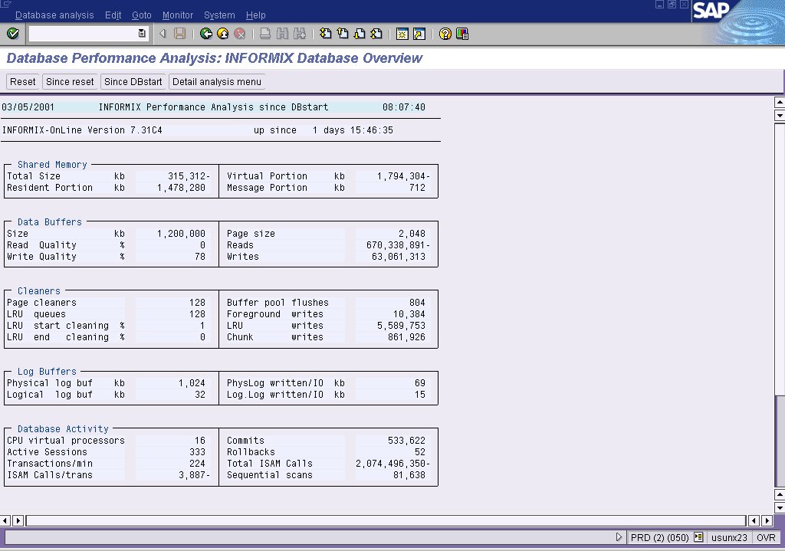

- Onstat –p
- Read quality > 95% (% cached reads)
- Write quality > 82% (% cached writes)
- Buffers shouldn’t be to big because the flush point will take to long (see checkpoint duration in the logs). During a flush point the system halts.

Informix Dynamic Server Version 7.31.FC7X8 -- On-Line -- Up 1 days 15:47:41 -- 3878280 Kbytes

Profile
dskreads pagreads bufreads %cached dskwrits pagwrits bufwrits %cached
503518339 555131625 7922394078 93.64 13790707 12327788 63066879 78.13

isamtot open start read write rewrite delete commit rollbk
6517994423 31894184 148483570 5618257153 4541512 1474594 4032022 533747 52

gp_read gp_write gp_rewrt gp_del gp_alloc gp_free gp_curs
0 0 0 0 0 0 0

ovlock ovuserthread ovbuff usercpu syscpu numckpts flushes
0 0 10391 230004.69 173810.34 403 806

bufwaits lokwaits lockreqs deadlks dltouts ckpwaits compress seqscans
49301821 3608 3967053865 0 0 3039 1409042 81640

ixda-RA idx-RA da-RA RA-pgsused lchwaits
178228743 4854740 1054788 183924904 2789177
- Onstat –m
- Last 20 lines of the informix message log

Informix Dynamic Server Version 7.31.FC7X8 -- On-Line -- Up 1 days 15:48:12 -- 3878280 Kbytes

Message Log File: /informix/PRD/online.usunx07.prd.log
05:56:16 Checkpoint Completed: duration was 2 seconds.
06:03:19 Logical Log 101488 Complete.
06:03:20 Logical Log 101488 - Backup Started
06:05:33 Logical Log 101488 - Backup Completed
06:06:27 Checkpoint Completed: duration was 2 seconds.
06:16:37 Checkpoint Completed: duration was 2 seconds.
06:26:47 Checkpoint Completed: duration was 1 seconds.
06:30:56 Logical Log 101489 Complete.
06:30:58 Logical Log 101489 - Backup Started
06:33:33 Logical Log 101489 - Backup Completed
06:36:55 Checkpoint Completed: duration was 2 seconds.
06:47:05 Checkpoint Completed: duration was 1 seconds.
06:57:12 Checkpoint Completed: duration was 1 seconds.
07:07:22 Checkpoint Completed: duration was 1 seconds.
07:17:29 Checkpoint Completed: duration was 1 seconds.
07:27:36 Checkpoint Completed: duration was 1 seconds.
07:37:45 Checkpoint Completed: duration was 1 seconds.
07:47:53 Checkpoint Completed: duration was 1 seconds.
07:58:01 Checkpoint Completed: duration was 0 seconds.
08:08:09 Checkpoint Completed: duration was 1 seconds.

- Onstat –g seg
- Shared memory segments
- Only 1 pool per type, otherwise you will get fragmentation
- Resident buffers (general buffer) > 95% read quality
- Virtual area
- If a pool fills up it will add 128mb of extra space in a new pool

Informix Dynamic Server Version 7.31.FC7X8 -- On-Line -- Up 1 days 15:48:42 -- 3878280 Kbytes

Segment Summary:
id key addr size ovhd class blkused blkfree
1545 1381386241 c000000000476000 1513758720 24168 R* 184778 7
6666 1381386242 c00000005a818000 2457600000 38144 V 153899 146101
6155 1381386243 c0000000ecfd8000 729088 656 M 82 7
Total: - - 3972087808 - - 338759 146115

(* segment locked in memory)

- Onstat –g ioq
- IO for database
- Queue length should be < 100
- KIO = asynchronous (calling app doesn’t for response, better performance)
- IO = synchronous

Informix Dynamic Server Version 7.31.FC7X8 -- On-Line -- Up 1 days 15:52:10 -- 3878280 Kbytes

AIO I/O queues:
q name/id len maxlen totalops dskread dskwrite dskcopy
kio 0 0 0 0 0 0 0
kio 1 0 32 49501754 47534265 1967489 0
kio 2 0 0 0 0 0 0
kio 3 0 32 25865984 25264772 601212 0
kio 4 0 32 61937290 60343519 1593771 0
kio 5 0 33 53681692 52282090 1399602 0
kio 6 0 43 48397660 47118610 1279050 0
kio 7 0 32 41979379 40857936 1121443 0
kio 8 0 33 34843228 33945581 897647 0
kio 9 0 33 57211174 55717065 1494109 0
kio 10 0 32 20870483 20362210 508273 0
kio 11 1 32 29032632 28288494 744138 0
kio 12 0 32 24411901 23817826 594075 0
kio 13 0 32 17870690 17440026 430664 0
kio 14 0 32 15686702 15311974 374728 0
kio 15 0 32 13798308 13466504 331804 0
kio 16 0 32 12355706 12079671 276035 0
kio 17 0 32 10977899 10731187 246712 0
adt 0 0 0 0 0 0 0
msc 0 0 1 17471 0 0 0
aio 0 0 2 7364 3306 2 0
pio 0 0 0 0 0 0 0
lio 0 0 0 0 0 0 0
gfd 3 0 0 0 0 0 0
gfd 4 0 0 0 0 0 0
gfd 5 0 0 0 0 0 0
gfd 6 0 0 0 0 0 0
gfd 7 0 0 0 0 0 0
gfd 8 0 0 0 0 0 0
gfd 9 0 0 0 0 0 0
gfd 10 0 0 0 0 0 0
gfd 11 0 0 0 0 0 0

- Onstat –g rea
- Ready threads (waiting for processes)
- Informix WP’s which are ready but are not doing anything at the moment
- No more then 8

Informix Dynamic Server Version 7.31.FC7X8 -- On-Line -- Up 1 days 15:53:00 -- 3878280 Kbytes

Ready threads:
tid tcb rstcb prty status vp-class name
144 c00000005b914ca8 0 4 ready 1cpu kaio

- Onstat –g act
- Active informix threads

Informix Dynamic Server Version 7.31.FC7X8 -- On-Line -- Up 1 days 15:53:31 -- 3878280 Kbytes

Running threads:
tid tcb rstcb prty status vp-class name
8 c00000005a898ca0 0 2 running 1cpu soctcppoll
142 c00000005b799d08 0 4 running 3cpu kaio
161 c00000005c068028 0 4 running 4cpu kaio
165 c00000005be5a028 0 4 running 6cpu kaio
186 c00000005ba29c18 0 4 running 5cpu kaio
1815 c000000067cbadb0 c0000000622db3d8 2 running 3cpu sqlexec
4493 c0000000927b1a90 c0000000622b9558 2 running 9cpu sqlexec
4649 c00000006cbf30c0 c000000066ef8648 2 running 7cpu sqlexec

- Onstat –g ath
- All informix threads

Informix Dynamic Server Version 7.31.FC7X8 -- On-Line -- Up 1 days 15:54:17 -- 3878280 Kbytes

Threads:
tid tcb rstcb prty status vp-class name
2 c00000005a8389e0 0 2 yield forever 18lio lio vp 0
3 c00000005a8391a0 0 2 yield forever 19pio pio vp 0
4 c00000005a839960 0 2 yield forever 20aio aio vp 0
5 c00000005a877100 0 2 yield forever 21msc msc vp 0
6 c00000005a8777e0 0 2 yield forever 22aio aio vp 1
7 c00000005a898540 c00000005a89c028 4 sleeping secs: 1 4cpu main_loop()
8 c00000005a898ca0 0 2 yield forever 1cpu soctcppoll
9 c00000005a899460 0 2 running 3cpu sm_poll
10 c00000005a899c60 0 3 yield forever 1cpu soctcplst
11 c00000005a9f06a0 0 3 yield forever 3cpu sm_listen
12 c00000005a9f0e48 0 2 sleeping secs: 1 5cpu sm_discon
13 c00000005a9f1608 c00000005a89c6f0 2 yield forever 6cpu flush_sub(0)
14 c00000005a9f1dc8 c00000005a89cdb8 2 yield forever 4cpu flush_sub(1)
15 c00000005a9f6780 c00000005a89d480 2 yield forever 6cpu flush_sub(2)
16 c00000005a9f6f40 c00000005a89db48 2 yield forever 5cpu flush_sub(3)
17 c00000005a9f7700 c00000005a89e210 2 yield forever 6cpu flush_sub(4)
18 c00000005a9fc1e0 c00000005a89e8d8 2 yield forever 14cpu flush_sub(5)
19 c00000005a9fc8c0 c00000005a89efa0 2 yield forever 3cpu flush_sub(6)
20 c00000005a9fd020 c00000005a89f668 2 yield forever 10cpu flush_sub(7)
21 c00000005a9fd7e0 c00000005a89fd30 2 yield forever 3cpu flush_sub(8)

- Onstat –l
- Shows logical logs usage
- U = Used
- B = Backup-ed
- Used to roll the database back or forward

Informix Dynamic Server Version 7.31.FC7X8 -- On-Line -- Up 1 days 15:54:45 -- 3878280 Kbytes

Physical Logging
Buffer bufused bufsize numpages numwrits pages/io
P-2 13 512 2990072 86452 34.59
phybegin physize phypos phyused %used
4500035 70000 7132 2243 3.20

Logical Logging
Buffer bufused bufsize numrecs numpages numwrits recs/pages pages/io
L-3 14 16 41136289 3978892 527379 10.3 7.5
Subsystem numrecs Log Space used
OLDRSAM 41136289 7592216904

address number flags uniqid begin size used %used
c00000000a562568 1 U-B---- 101418 b1c3503 50000 50000 100.00
c00000000a562588 2 U-B---- 101419 b1cf853 50000 50000 100.00
c00000000a5625a8 3 U-B---- 101420 b1dbba3 50000 39025 78.05
c00000000a5625c8 4 U-B---- 101421 b1e7ef3 50000 2367 4.73
c00000000a5625e8 5 U-B---- 101422 15300003 50000 50000 100.00
c00000000a562608 6 U-B---- 101423 1530c353 50000 50000 100.00
c00000000a562628 7 U-B---- 101424 153186a3 50000 50000 100.00
c00000000a562648 8 U-B---- 101425 153249f3 50000 50000 100.00
c00000000a562668 9 U-B---- 101426 15330d43 50000 50000 100.00
c00000000a562688 10 U-B---- 101427 1533d093 50000 50000 100.00
c00000000a5626a8 11 U-B---- 101428 153493e3 50000 50000 100.00
c00000000a5626c8 12 U-B---- 101429 5100035 50000 50000 100.00
c00000000a5626e8 13 U-B---- 101430 510c385 50000 50000 100.00
c00000000a562708 14 U-B---- 101431 51186d5 50000 50000 100.00
c00000000a562728 15 U-B---- 101432 5124a25 50000 50000 100.00
c00000000a562748 16 U-B---- 101433 5130d75 50000 50000 100.00
c00000000a562768 17 U-B---- 101434 513d0c5 50000 50000 100.00
c00000000a562788 18 U-B---- 101435 5149415 50000 50000 100.00

- Sapdba
- Db space reports (b, a)
- Never < 1% free (except for logdbs & physdbs)
- 0% free will cause that table to be shut down

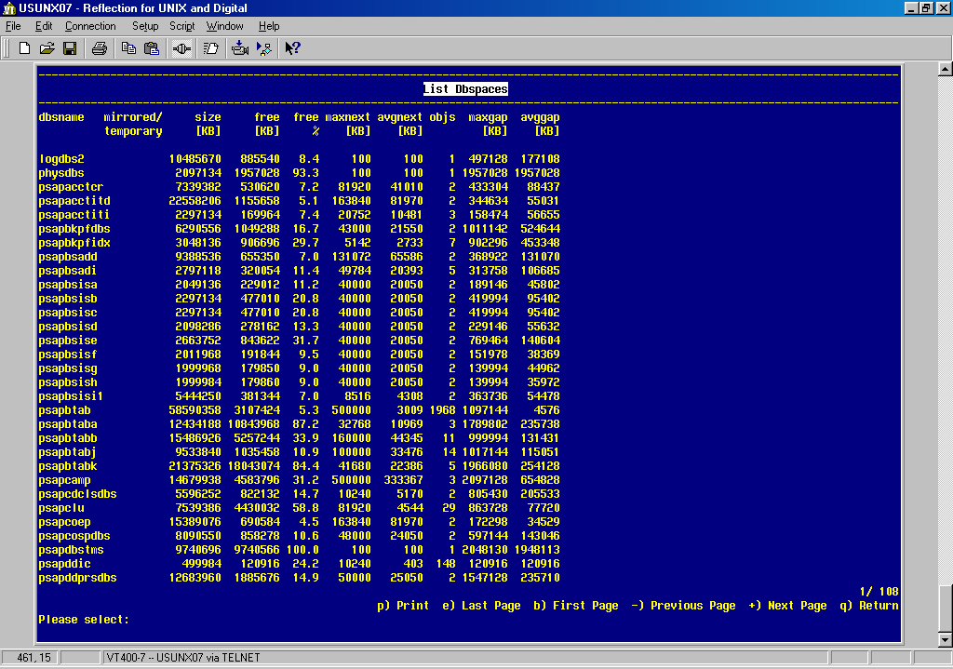

Basis Layer
- ST02
- Tune Summary
- Hit ratio +/- 99%
- No swaps except for program
- Generic Key -> buffered tables (customizing)

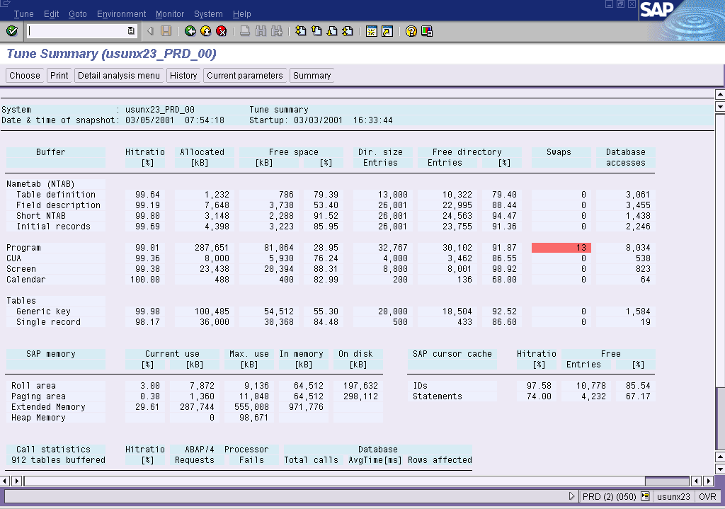

- ST10
- Table call statistics

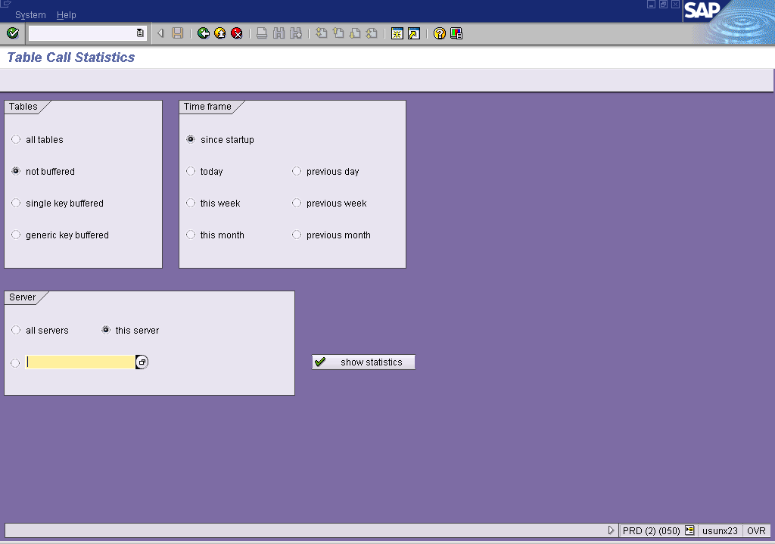

- SM12
- Lock entries shouldn’t be more then 6 hours old. If there are old locks, the user must save or back out of the transaction

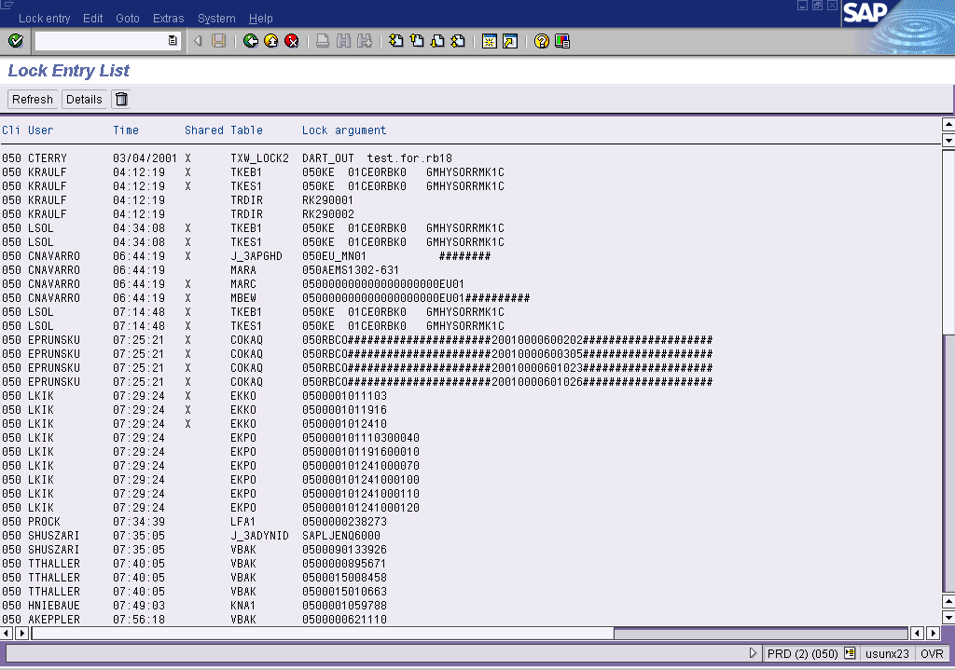

- ST03
- DB request time should be 50% of total request time
- CPU 40%
- Other 10%

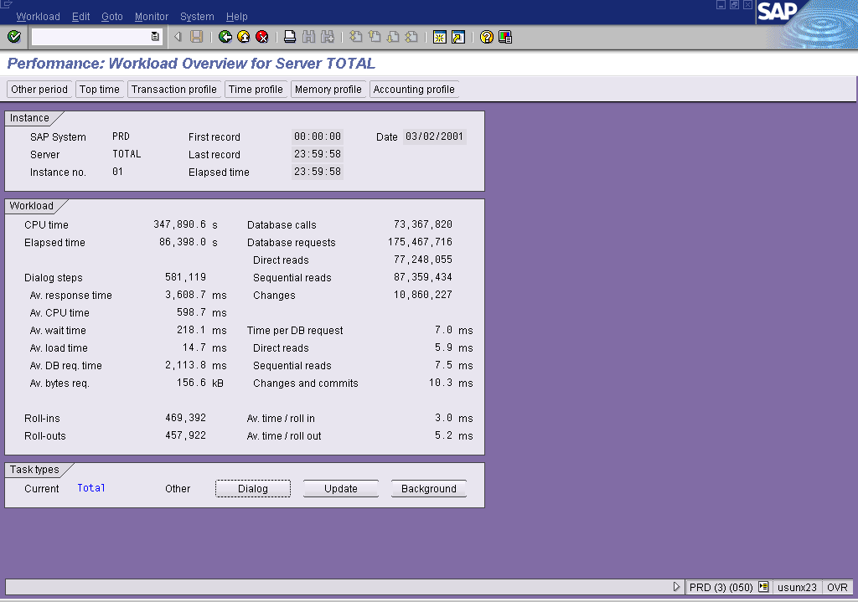

- SM37
- Check for Terminated Jobs

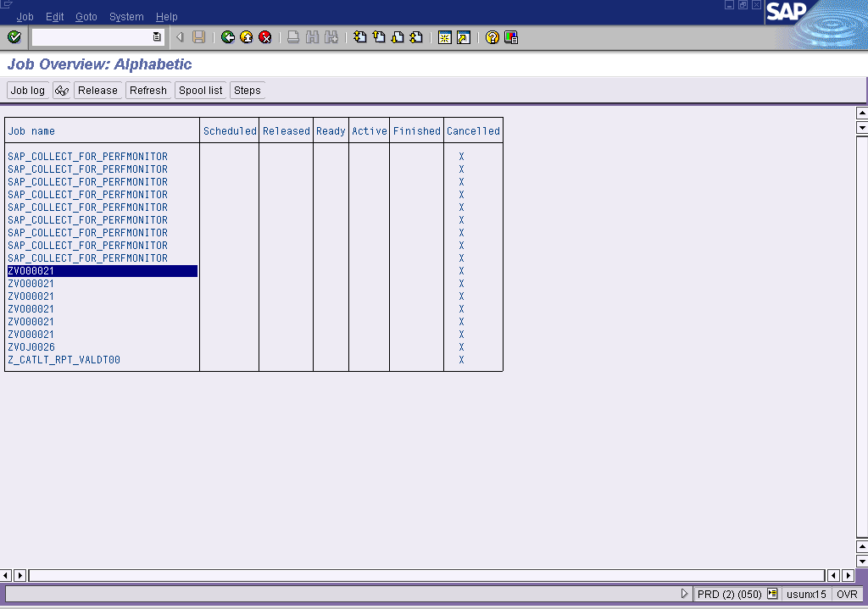

- SM50
- Make sure there are not too many processes in “private” mode

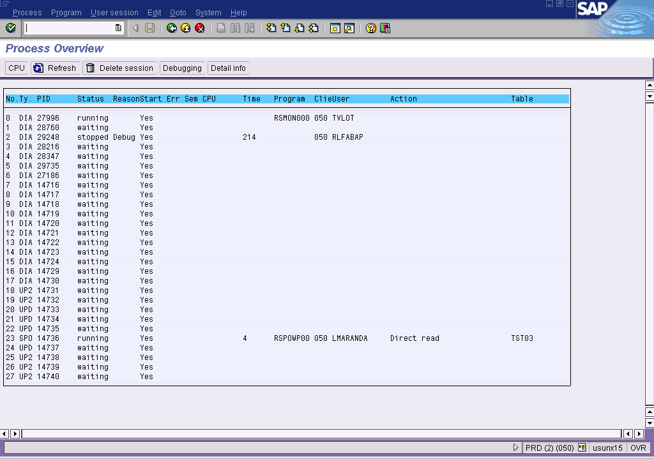

Dialog (per process)

- Roll 1 byte (zta/roll_first)
- EM 200 MB (zta/roll_extension)
- Heap/Private 600 MB (abap/heap_area)

When this amount of memory is exceeded by a WP you get an ABAP dump: tsv_tnew_page_alloc_failed

Batch (per process)

- Heap 600 MB
- EM 200 MB
- Roll 6.5 MB

When this limit is exceded you get the short dump: tsv_no_roll_memory.

Top-Down Troubleshooting

Acute Problems

- Abnormal system situation
- Specific problem
- CPU on the Apps server (poor ABAP)
- Database (everything on USUNX07
- This data can be reviewed by using /STAT
- Main problems lay in:
- Expensive SQL, indexes
- IO Bottlenecks
- Exclusive lock waits/locking situations (2000000 locks available)

Qualitative Data

Data received/asked from user when they report an issue
- What runtimes are you seeing?
- What runtimes do you usually have/need?
- Which server?
- Selection criteria/circumstances
- Time of day
- Anything else they can tell us for context

Quantitative Data

What changed (code, customizing, business process)?

- /SE38 (in DEV)
- ABAP editor
- In program attributes you can then see who touched the program last (developer)

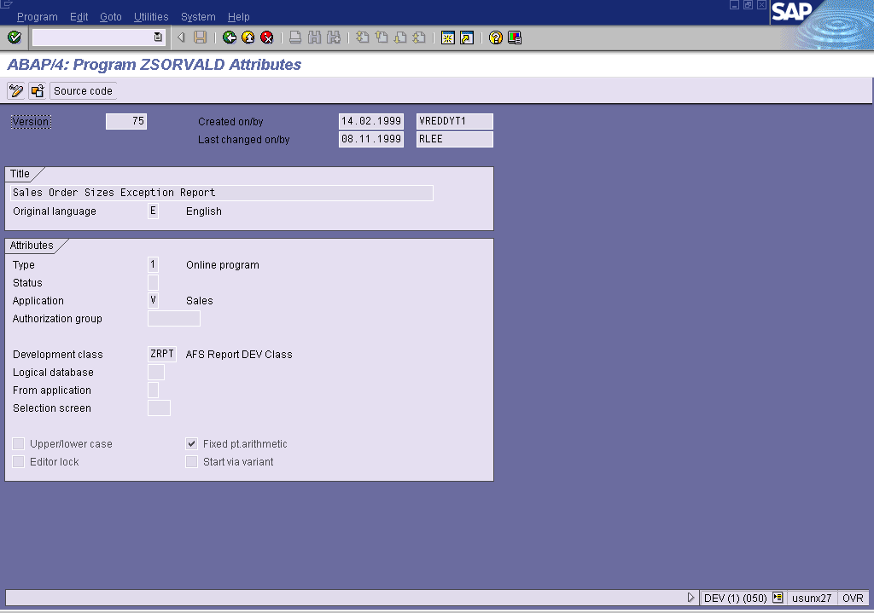

- In Utils, Version Management you can see when the last version was transported.

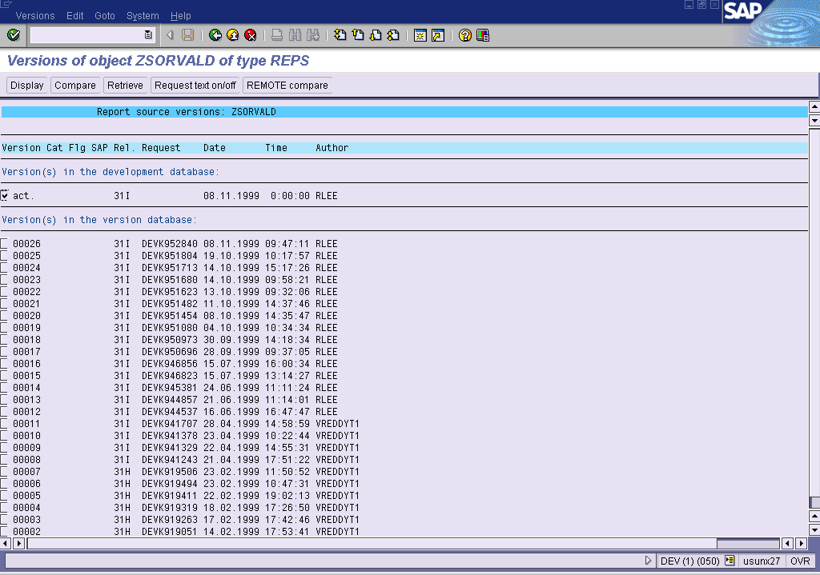

- Locks
- There are 2 types of locks:
- Database locks. Maintained by IDS for database integrity.
- Enqueue locks. Arbitrated by SAP to maintain application integrity (follows business logic). Enqueue locks should be released by killing the user session from /SM04.
- /SM12: Enqueue Lock entries. Blue are updates, black are user busy.

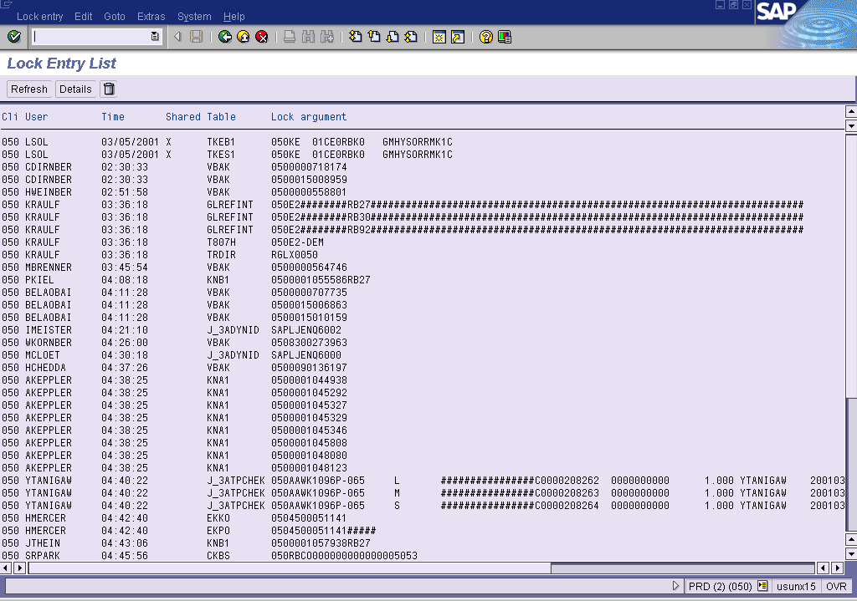

- Locks can cause the following problems:
- Performance
- Deadlocks. Because a process won’t release it’s current lock until it gets it’s new lock, deadlocks can occur. Deadlocks occur when:
- Process A wants a lock on field 1 while it has a lock on field 2.
- Process B has a lock on field 2 and wants a lock on field 1.
- Both processes won’t give up their lock until they have the new lock. Eventually SAP will kill of one of the processes so the system can run on.

- Expensive SQL
- /ST05: SQL Trace. Traces everything the ABAP processor does on a specified server. This has the option to Explain SQL. The Estimated Cost (derived by the Informix optimizer) shows how “heavy” the SQL is. A cost > 1000 is bad.

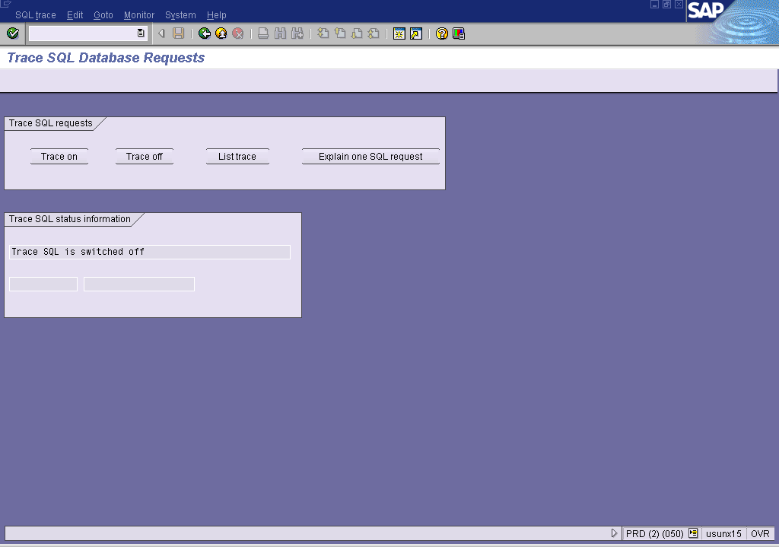

- /ST04: database analysis. The detail analysis shows lots of useful data for the database

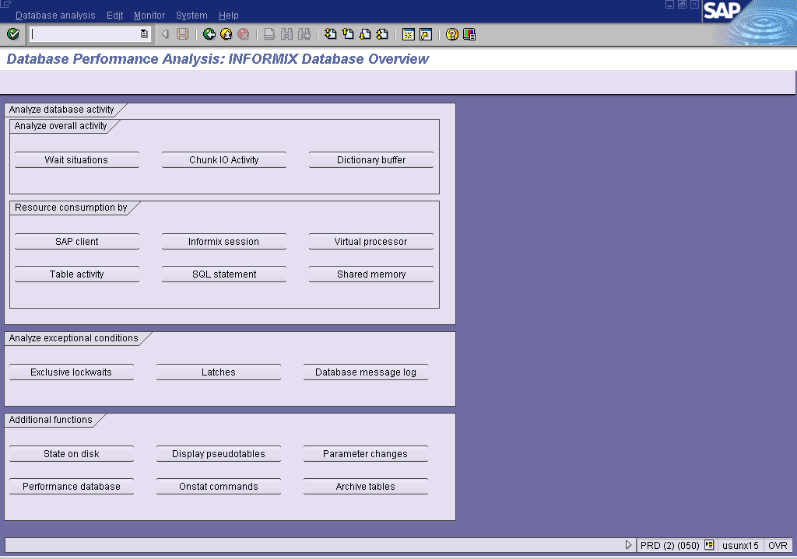

Transaction overview

- /SE11 – Database Dictionary

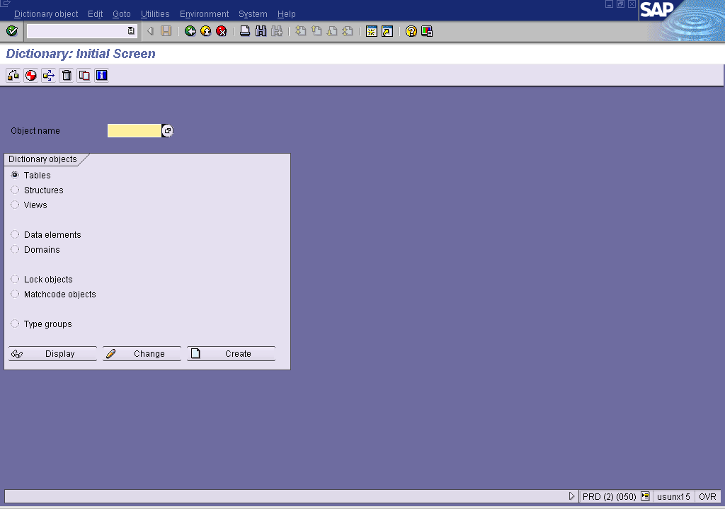

- /SE16 – Data browser. Will show how big a table is

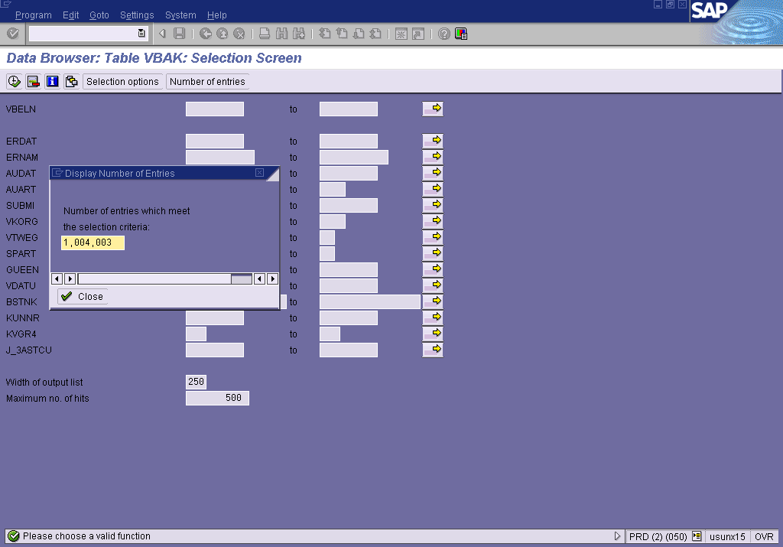

- /ST04 – Can also be used to calculate the cost of SQL for running processes. In Detail Analysis, go to Informix Session.

