<Company_Name>
SAP Basic Operations Manual
For Oracle/Windows NT

Servers and Databases Overview 4
Servers: Basic Information 4
STANDBY 4
DEVELOPMENT 4
PRODUCTIVE 4
Server/Client Landscape 4
Development Process 5
Administration of Change Requests 5
Transporting Client-Dependent vs. Client-Independent Changes 5
Transporting Changes 5
Starting/Stopping SAP and Oracle 6
Starting/Stopping the Oracle Services 6
Logging onto Oracle with SVRMGR23 6
Starting up/Shutting Down the Oracle Database 6
Stopping Oracle (emergency) 6
Starting SAP 6
Stopping SAP (normal) 7
Backup 7
Using DLT vs. DAT 7
Initialize the backup tapes 7
Check tape header information 8
Full Backup from SAPDBA 8
Scheduling a Backup Job from SAP GUI front end 8
Changing a Scheduled Backup job from SAP GUI front end 9
Checking the Volumes Needed from the SAP GUI front end 9
Database Restore/Recovery from Backup Tape 10
Full Restore from Offline or Online SAPDBA backup 10
Performing Database Recovery 10
Restore a Single File or Tablespace (Using SAPDBA) 11
RAID Management 12
View, Test, Change RAID Configuration 12
Boot System Tools from the Internal Hard Drive 12
Standby Server With Oracle Standby Functions 13
Set Up the Standby Server 13
Refresh the Standby Database Control File 13
Maintain the Standby Database 13
Switchover to Standby Server (Productive Server Crash) 13
Standby Server Without Standby Function 14
Set Up the Standby Server 14
Maintain the Standby Database 14
Switchover to Standby Server (Productive Server Crash) 14
Weekly/Monthly Administrative Tasks 15
Test Restores 15
Cleanup: Backup and Delete 15
Check File Systems 15
Check Boot from Backup Partition 15
Update Backup Boot Partition 15
Client Copy and Deletion 16
General 16
Adjusting the Rollspace 16
Local Client Copy 16
Remote Client Copy 16
Copying the Productive Client to the Development System (with Client Export/Import) 17
Deleting Client 17
Common Problems with Client Copy or Deletion 17

Servers and Databases Overview

Servers: Basic Information


Server | PRODUCTIVE | DEVELOPMENT |  | STANDBY
Hostname | PROD | DEV | STBY
System ID | PRO | DEV | PRO
Changes | Locked | Allowed | Locked
Primary Services | Oracle  SAP |  | recovery
Secondary Services | PC Anywhere | Oracle  SAP (Dev)  SAP (Productive)  PC Anywhere | PC Anywhere

The overall landscape is a two-system development/test server and productive server. The third server is s standby server that can be kept in a remote location. If the productive server fails, the development server can be used for recovery (requiring several hours of downtime while the development server is restored to the productive database), or the standby server can be used (requiring almost no downtime). The standby server is a copy of the productive server database, and is periodically synchronized with the productive server using the archived logs.

Server/Client Landscape
P
R
O
D

D
E
V

Server
270
200
250
100
Training
300
Development/Customizing
User Testing/Training
Reference
Productive
The DEV server provides three clients:
- Consultant/User Practice: for new users to learn basic SAP skills
- Development/Customizing: for consultants and key users, to make development and customization changes. After approval by the consulting team, these changes are released and then transported to the testing client. This client contains application data periodically copied from the productive client, in order to make the testing environment as close to the productive environment as possible. Security must be enforced on this client
- User Testing/Training: For users and consultants to conduct thorough testing of changes before transport to the productive system. This client contains application data periodically copied from the productive client, in order to make the testing environment as close to the productive environment as possible. Security must be enforced on this client
The PROD server provides two clients:
- Reference: for experienced users to have another client as reference. This client does not contain any application data
- Productive: client for productive use

Development Process
The development process is designed to make sure that
Consultant and key users test and implement changes on DEV 200. After approval, team leader releases request
MIS executes import to DEV 250, if change is client-dependent
Users thoroughly test changes on DEV 250 and accept or reject
Change is rejected
MIS executes import to PROD 300 and 270 for all related change requests (including previously rejected changes) in the order in which they were released. Changes are also imported to DEV 100 for training.
Change is accepted
- changes are thoroughly tested before being transported to the productive system, and
- the development and productive server are kept in a consistent state

Administration of Change Requests
The following procedures should be observed:
- Release of tasks and change requests require the approval of a team leader
- Release of change requests is accompanied by paperwork describing change request
- If a change is rejected by the user, the following change request documents are grouped together with the first change request
- Changes always move from DEV 200 to DEV 250 to PROD 300. They are then imported to PROD 270 and DEV 100.
- Each stage of changing/testing yields documented results
- The authority to make client-independent changes is granted only to certain people under certain circumstances on one client

Transporting Client-Dependent vs. Client-Independent Changes
Client-independent changes do not require a local transport, and therefore the only import that needs to be executed is the import to the productive system. The rest of the transport procedure is the same for client-independent changes as for client-dependent transports.

Transporting Changes
- Log into the target server and start a command prompt.
- Change to directory <TRANS_DRIVE>:\usr\sap\trans\bin
- If transporting locally (on the DEV), enter
tp addtobuffer <request_number> client=<client> D01
tp import <request_number> client=<client> D01
If transporting to the production client, enter
tp import <request_number> client=<client> P01
If you want to check the transport buffer, use
tp showbuffer <SID>
If you want to clear the transport buffer, use
tp cleanbuffer <SID>
To see a list of all tp commands, use
tp help

Starting/Stopping SAP and Oracle

Starting/Stopping the Oracle Services
- Go to Control Panel >> Services
- Click on OracleServiceSID, and press “Start” or “Stop” to start or stop.
- Click on OracleTNSListener, and press “Start” or “Stop” to start or stop.

Logging onto Oracle with SVRMGR23
- Start svrmgr23.exe from the desktop icon.
- At the prompt, enter connect internal. The screen should look like:
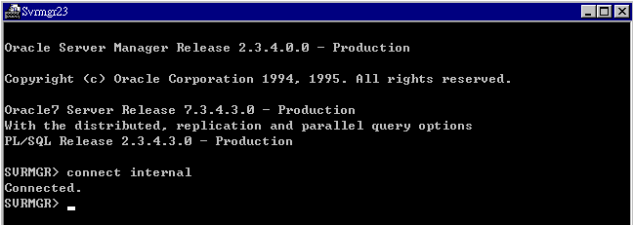

Starting up/Shutting Down the Oracle Database
- Log onto Oracle using svrmgr23 (see Logging into Oracle with SVRMGR23).
- Enter startup or shutdown to startup or shutdown the database. These commands will produce output like:
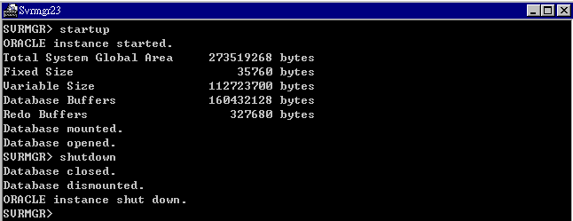

Stopping Oracle (emergency)
- Log onto Oracle using svrmgr23 (see Logging into Oracle with SVRMGR23). Use the shutdown immediate command to shut down the database.
- If the computer hangs after the shutdown immediate command, use the shutdown abort command. After using shutdown abort, you should startup the database again (this initiates an automatic recover), and then shut down normally.

Starting SAP
- Start the SAP Manager from Start >> Programs >> SAP R/3 >> SAP ManagerXXX
- Click the START button to start the dispatcher and message server. The lights on the display panel will turn green.

Stopping SAP (normal)
- Handle background, transport, and other jobs that may be running.
- Start the SAP Manager from Start >> Programs >> SAP R/3 >> SAP Service Manager
- Click the STOP button to stop the message server and dispatcher. The lights on the display panel will turn gray.
- Log onto Oracle using svrmgr23 (see Logging into Oracle with SVRMGR23). Use the shutdown command to shut down the database.

Backup

Using DLT vs. DAT
SAPDBA distinguishes different tape drives by the parameters in the file specified in the sapdba backup parameter “Parameter File”. By default, this file is
D:\Orant\Database\initSID.sap.

Set the parameters in this file as shown to change the tape device used:
DLT | DAT (DDS/2)
Tape_size = 350000  Tape_address = /dev/nmt1  Tape_address_rew = /dev/nmt1 | tape_size = 3600  tape_address = /dev/nmt0  tape_address_rew = /dev/nmt0

Initialize the backup tapes
The backup tapes must be initialized before use with the SAP backup tools. Suggested volume names are in the file initSID.sap, and are of the pattern SIDBXX or SIDAXX for backup or archive volumes. To initialize,
- Make sure the tape to be initialized is in the tape drive
- Check the tape header to make sure the tape was not recently used (see Check tape header information)
- Start sapdba and go to “h – backup database”
- Choose “a – backup function”, then “b – initialize BRBACKUP tape”, then “q – Return”. The sapdba menu should now look like:
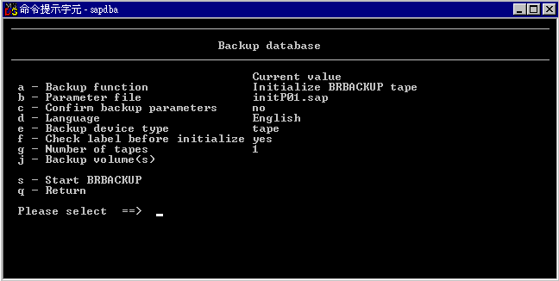

- Enter ‘f’ and press return, so that “Check label before initialize” is set to “no”.
- Enter ‘j’ and press return, and enter the name (e.g. P01B13) to initialize the tape to.
- Enter ‘s’ and press return to start initializing the tape.

Check tape header information
- Make sure the tape to check is in the tape drive
- Start sapdba and go to “h – backup database”
- Choose “a – backup function”, then “c – show information in tape header”, then “q – Return”. The sapdba menu should now look like:
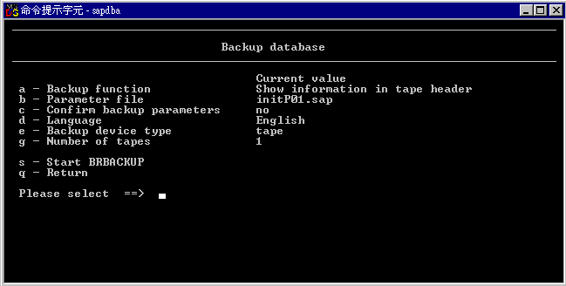

- Enter ‘s’ and press return to start reading the tape header.

Full Backup from SAPDBA
- Make sure the tape to be used for backup is in the tape drive
- Start sapdba and go to “h – backup database”
- Choose “j – backup volume(s)” and enter the name(s) of the volume(s) to use for backup (e.g. P01B13). The name(s) must match the name in the header of the tape in the tape drive (see Check tape header information).
- Set the other parameters appropriately (e.g. “l – Verification after backup”, “k – Compress”)
- Press ‘s’, then Enter, to start the backup procedure.

Scheduling a Backup Job from SAP GUI front end
- Log into SAP and go to transaction DB13. The screen will show a calendar.
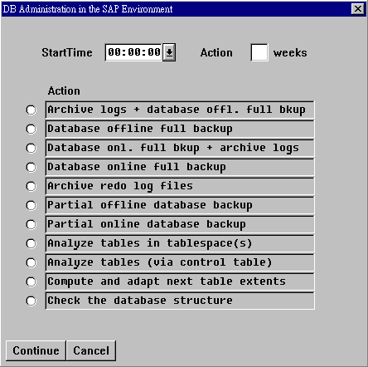
- Double-click on the day you want to schedule a backup. A menu will appear as shown to the right here; choose the backup scheme you want to use, and enter the time of day you want to begin the backup job.
- Press “Continue”
- Enter the name(s) of the volume(s) to use for backup (e.g. P01B13). The name(s) must match the name in the header of the tape in the tape drive (see Check tape header information).
- Press “Continue”
- SAP will prompt for additional parameter information. Enter this information until the screen returns to the calendar. There will be an entry on the day the job was scheduled
- Make sure the first tape to be used for backup is in the tape drive when the job starts

Changing a Scheduled Backup job from SAP GUI front end
- Log into SAP and go to transaction DB13. The screen will show a calendar.
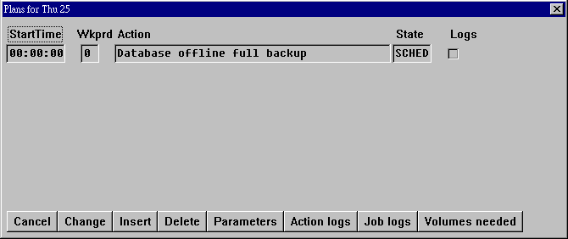
- Double-click on the top line (for example, line “Thu 25”) of the day for which the backup job is scheduled. A popup box will show a list of jobs for that day:
- Click on the job for which you want to check volumes needed.
- Press “Change” and enter the new job parameters.

Checking the Volumes Needed from the SAP GUI front end
- Log into SAP and go to transaction DB13. The screen will show a calendar.
- Double-click on the top line (for example, line “Thu 25”) of the day for which the backup job is scheduled. A popup box will show a list of jobs for that day:
- Click on the job for which you want to check volumes needed.
- Press “Volumes Needed”. The system will check the space required and the volumes entered in the job.
- Respond to any error messages by changing the parameters of the job (see Changing a Scheduled Backup job from SAP GUI front end)

Database Restore/Recovery from Backup Tape

Full Restore from Offline or Online SAPDBA backup
- Make sure the database is shut down and the Oracle service is stopped.
- Insert the most recent backup DLT into the tape drive.
- Open a command prompt and go to F:\oracle\SID\sapbackup. The sapbackup log files must be present in this directory. If they are not, or if you are restoring a PROD backup into the STBY machine, you must copy the files from PROD’s F:\oracle\SID\sapbackup to STBY’s F:\oracle\SID\sapbackup.
- Enter the command brrestore and follow the online instructions
- After the restore is finished, check logs to make sure no errors occurred. If errors occurred, either fix the errors, or restore from a different tape
- Restart the Oracle service.
- If archive logs need to be applied, or if the database was restored from an online backup, follow the steps in “Performing Database Recovery.” Otherwise, open the database now.

Performing Database Recovery
- Make sure all archive log files from the time of the backup are in the directory F:\oracle\SID\saparch.
- Make sure the backup control file script is ready (see below).
- Start svrmgr23 and issue the following commands:
SVRMGR> connect internal
SVRMGR> startup nomount
SVRMGR> @<path_of_create_backup_controlfile_script>
SVRMGR> alter database mount;
SVRMGR> set autorecovery on
SVRMGR> recover database using backup controlfile
SVRMGR> alter database open resetlogs;
The control file script should look like:
The data and log files can be listed by querying the tables V$DBFILE and V$LOGFILE.
CREATE CONTROLFILE REUSE DATABASE 'P01' RESETLOGS ARCHIVELOG
MAXLOGFILES 255
MAXLOGMEMBERS 3
MAXDATAFILES 254
MAXINSTANCES 50
MAXLOGHISTORY 1000
LOGFILE
GROUP 11 (
'D:\ORACLE\P01\ORIGLOGA\LOG_TG101_M1.DBF',
'G:\ORACLE\P01\MIRRLOGA\LOG_TG101_M2.DBF'
) SIZE 20M,
GROUP 12 (
'G:\ORACLE\P01\ORIGLOGB\LOG_TG102_M1.DBF',
'D:\ORACLE\P01\MIRRLOGB\LOG_TG102_M2.DBF'
) SIZE 20M,
GROUP 13 (
'D:\ORACLE\P01\ORIGLOGA\LOG_TG103_M1.DBF',
'G:\ORACLE\P01\MIRRLOGA\LOG_TG103_M2.DBF'
) SIZE 20M,
GROUP 14 (
'G:\ORACLE\P01\ORIGLOGB\LOG_TG104_M1.DBF',
'D:\ORACLE\P01\MIRRLOGB\LOG_TG104_M2.DBF'
) SIZE 20M
DATAFILE
'G:\ORACLE\P01\SAPDATA1\SYSTEM_1\SYSTEM.DATA1',
·
·
·
'G:\ORACLE\P01\SAPDATA3\PROTI_2\PROTI.DATA2'
;

Restore a Single File or Tablespace (Using SAPDBA)
This procedure can be used to restore individual files (control files, data files, etc) from a backup tape.
- Open a command prompt and go to F:\oracle\SID\sapbackup. The sapbackup log files must be present in this directory. If they are not, or if you are restoring a PROD backup into the STBY machine, you must copy the files from PROD’s
- Start sapdba
- Choose menu item “k – Restore/Recovery”
- Choose the appropriate menu item and enter the parameters

RAID Management

View, Test, Change RAID Configuration
RAID configuration can be displayed using the Mylex DAC960 SCSI RAID Controllder Administration Utility (dacadm.exe). To start the utility, log on as SIDadm user, and double-click the Dacadm icon on the desktop. It can be changed using the Mylex DAC 960 configuration tool at startup. This requires a boot from a floppy or from the internal hard drive.

Boot System Tools from the Internal Hard Drive
- If possible, shut down the database and back it up before proceeding.
- Reboot the machine and enter F2 for setup. In setup, go to Hard Drives and configure the first hard drive type to Auto. Press F10 to save changes, exit, and reboot.
- Press F2 for setup again. Change the boot disk to the new IDE hard drive added in step 2. Press F10 to save changes, exit, and reboot.
- The machine should now boot from the internal drive, and a tools menu will appear.

Standby Server With Oracle Standby Functions
Oracle provides standby database functionality that allows a database copy to be designated as a standby database until it needs to be open. Probably the only advantage to using this method is that the standby database won’t accidentally be opened; it requires a special command to open.

Set Up the Standby Server
- Make a full backup of the PROD database (online or offline)
- Restore all files from the backup to the STBY.
- Create the standby database control file. Start svrmgr23 on the PROD system:
SVRMGR> connect internal
SVRMGR> startup (if database is not already open)
SVRMGR> alter database create standby controlfile as ‘filename’;
SVRMGR> alter system archive log current;
- Copy the standby control file and archived log files to STBY:
control files: D:\oracle\P01\origlogA\ctrlP01.ctl
F:\oracle\P01\saparch\ctrlP01.ctl,
G:\oracle\P01\sapdata1\ctrlP01.ctl)
archived log files: F:\oracle\P01\saparch
- Start the STBY database. Start svrmgr23 on the STBY system:
SVRMGR> connect internal
SVRMGR> startup nomount
SVRMGR> alter database mount standby database;
- Follow the procedure in “Maintain the Standby Server” to update the standby database.

Refresh the Standby Database Control File
Use this procedure to update the standby database control file.
- Make sure archive log files are copied PROD to STBY (F:\oracle\P01\saparch). This step is not necessary when creating a new standby database. Start svrmgr23 on STBY:
SVRMGR> cancel standby database
- Create the standby database control file. Start svrmgr23 on the PROD system:
SVRMGR> connect internal
SVRMGR> startup (if database is not already open)
SVRMGR> alter database create standby controlfile as ‘filename’;
SVRMGR> alter system archive log current;
- Copy the standby control file and archived log files to STBY:
control files: D:\oracle\P01\origlogA\ctrlP01.ctl
F:\oracle\P01\saparch\ctrlP01.ctl,
G:\oracle\P01\sapdata1\ctrlP01.ctl)
archived log files: F:\oracle\P01\saparch

Maintain the Standby Database
Use this procedure to update the standby database.
- Make sure archive log files are copied PROD to STBY (F:\oracle\P01\saparch). Start svrmgr23 on STBY:
SVRMGR> recover standby database

Switchover to Standby Server (Productive Server Crash)
- Shutdown the productive server
- If possible, archive the current redo logs on the PROD system. Start svrmgr23 on the PROD system:
SVRMGR> connect internal
SVRMGR> startup (if database is not already open)
SVRMGR> alter system archive log current
- Copy any unapplied archive logs to the STBY’s archive log directory (F:\oracle\P01\saparch)
- Follow the procedure in “Maintain the Standby Server” to update the standby database.
- Activate the standby database. Start svrmgr23 on the STBY system:
SVRMGR> alter database activate standby database

Standby Server Without Standby Function

Set Up the Standby Server
- Perform a full restore and recovery of the productive database into the standby system (see Database Restore/Recovery from Backup Tape), but do NOT open the database after the recovery

Maintain the Standby Database
- Make sure archive log files are copied PROD to STBY (F:\oracle\P01\saparch). Start svrmgr23 on STBY:
SVRMGR> recover database using backup controlfile until cancel

Switchover to Standby Server (Productive Server Crash)
- Shutdown the productive server
- If possible, archive the current redo logs on the PROD system. Start svrmgr23 on the PROD system:
SVRMGR> connect internal
SVRMGR> startup (if database is not already open)
SVRMGR> alter system archive log current
- Copy any unapplied archive logs to the STBY’s archive log directory (F:\oracle\P01\saparch)
- Follow the procedure in “Maintain the Standby Server” to update the standby database.
- Open the standby database. Start svrmgr23 on the STBY system:
SVRMGR> alter database open resetlogs;

Weekly/Monthly Administrative Tasks
Please see the monthly and daily checklists for task lists. This documentation describes some of these tasks.

Test Restores
Test the restore procedure by restoring a tablespace and/or a complete system.

Cleanup: Backup and Delete
Backup the SAP directories under F:\oracle\SID (saparch, sapbackup, sapcheck, sapreorg, sapstat, and saptrace) and D:\usr\sap (put and trans). These directories are generally small, and can be backed up to DAT, ZIP disk, CD, or even diskette. After backup, the contents of these directories can be deleted (recent files in sapbackup and sapreorg should not be deleted).

Check File Systems
Check the space/growth of file systems and hard disk volumes, to make sure that the database is not growing too large for the systems to handle.

Check the alert monitor (AL01) or the Freespace Problems in transaction DB02 for tablespace size problems. Tablespaces can be extended using either SAPDBA (add datafile) or Oracle Storage Manager (resize or add datafile).

Some tablespaces may grow very slowly, and these can be allowed to be almost full. You can change the alert threshhold so that these tables do not trigger an alert

Check Boot from Backup Partition
Reboot the machine. At the menu prompt, choose “NT 4.0 (Backup Partition)”. Run and test primary services/applications for the server (see MIS Service Overview).

Update Backup Boot Partition
- Stop all SAP and Oracle services
- Start the NT Disk Administrator
- Delete the backup partition (K). You may have to close windows and stop several services before the system lets you delete this partition
- Click on the boot partition (C), then hold down the Ctrl key and click the backup partition
- From the menu, choose “Create Mirror”
- Exit the Disk Administrator. You will be prompted to reboot the machine
- After reboot, wait several minutes and start the NT Disk Administrator
- Click on the mirrored partition. The status in the bottom of the window should read “HEALTHY”
- From the menu, choose “Break mirror”
- Exit the Disk Administrator. You will be prompted to reboot the machine
- If you need to edit the startup menu, edit the file C:\boot.ini. The entries will look something like:
multi(0)disk(0)rdisk(0)partition(1)\WINNT="Windows NT Server Version 4.00" /NoSerialMice:COM2
multi(0)disk(0)rdisk(0)partition(1)\WINNT="Windows NT Server Version 4.00 [VGA mode]" /basevideo /sos /NoSerialMice:COM2
multi(0)disk(0)rdisk(1)partition(2)\WINNT="NT 4 from backup partition" /NoSerialMice:COM2
The third entry is for the backup partition. Note that rdisk(1)partition(2) indicates that the backup partition is on system disk number 1 (the normal backup partition is system disk 0), partition 2.

Client Copy and Deletion

General
- During client copy, the source and target clients should not be used. The target client is automatically locked; however, the source client is not always locked. For this reason, client copy between systems should involve only STBY and DEV, not PROD. Also, it is best to either manually lock the users from the source client, or to perform the copy at night.
- Client administration on the STBY machine requires opening the STBY database, which will change its status from a standby database to a normal database. To restore this status, it will then be necessary to re-setup the standby database (see “Setting Up the Standby Database”).
- If performing a local client copy, it is usually to run a test run of the client copy.
- To avoid tablespace problems, you can use the Oracle Storage Manager to monitor tablespace usage, adjust tablespaces, and adjust rollspaces. It is also very useful to set the datafiles of problematic tablespaces to autoextend
- During client import, if a termination occurs, you can fix the error and restart the im
- Delete any superflous clients (including the target client) before beginning a client copy.
- Do not copy client-independent data, unless you want to reset the DEV database repository to the same state as the STBY database repository.
- Back up the system before performing a client copy.
- To speed up client deletion, first run report YKDELCLS from the client to be deleted. This report deletes records from transparent tables that are the source data for cluster tables (without going through the clustered table expansion/compression), or execute the delete statements directly from SVRMGR23. Be careful!
- For the productive client,
client deletion takes roughly 4 hours,
local client copy takes roughly 6 hours,
client export/import/post-processing takes roughly 2/4/4 hours (total 10 hours)

Adjusting the Rollspace
You probably will need to adjust the rollspace before client copy, because SAP needs to be able to fit the largest table into the rollspace. You may need to
- Using Oracle Storage Manager or SVRMGR23, add a datafile (size 1000M), to the tablespace PSAPROLL.
- Add a rollspace BIGROLL (initial 10M, next 10M, optimal 20M, maxextents 200) to the PSAPROLL tablespace.
- Take all rollspaces offline, except BIGROLL and SYSTEM.
- You may temporarily change the initSID.ora parameter:
rollback_segments = (BIGROLL)
- You can also add an additional rollspace (BIGROLL2), and/or set the datafiles in PSAPROLL to autoextend (next 40M maximum 50). This is necessary for copying the productive client.
- Make sure to change these settings back after the client copy is finished.

Local Client Copy
- Adjust the rollspace on the system
- Log onto the target client
- Go to transaction SCC0, or use the menu path Tools→Administration→Administration→Client→Client Admin→Client Copy→Local Client Copy

Remote Client Copy
- Adjust the rollspace
- Log onto the target client
- Go to transaction SCC0, or use the menu path Tools→Administration→Administration→Client→Client Admin→Client Copy→Local Client Copy

Copying the Productive Client to the Development System (with Client Export/Import)
- Make sure the source client is locked or no one is using it.
- Log into the source client.
- Export the source client using transaction SCC8.
- Choose the target system D01.
- Choose profile ZSAP_ALL.
- Check/change the profile parameters as necessary, using the menu command Profile→ Change/Display
- Schedule the export to run in the background
- After export, check the job log (SM37) to make sure the export was successful.
- Check to make sure the exported files exist in \\dev\sapmnt\trans\data and \\dev\sapmnt\trans\cofiles. The files should have a name of the form
Sxnnnnn.sid, Ronnnnn.sid, and/or Rtnnnnn.sid where nnnnn is the transport request number, and sid is the SID of the source client. The file Ronnnnn.sid contains client-independent data.
- Adjust the rollspace (see above) of the target database.
- Import the request SIDKOnnnnn if it exists, using the u248 options. For instance, if the request is P01KO00011, and you are importing to system D01 client 100, you would execute the commands:
tp addtobuffer P01KO00011 D01
tp import P01KO00011 D01 client=100 u248
- Check the transport logs to make sure the import was successful.
- Import the request SIDKTnnnnn, using the u248 options. For instance, if the request is P01KT00011, and you are importing to system D01 client 100, you would execute the commands:
tp addtobuffer P01KT00011 D01
tp import P01KT00011 D01 client=100 u248
- Check to make sure the import was successful
- After tp import is finished, use transaction SCC7 to start post-import processing. Check the job with SM37 to make sure it finishes successfully.
- After SCC7 has finished (about 4 hrs), shut down and restart SAP and Oracle
- Return the rollspace to its normal configuration

Deleting Client
- Make sure that all rollspaces are online (not just BIGROLL).
- Log onto the client to be deleted.
- Go to transaction SCC5, or use the menu path Tools→Administration→Administration→Client→Client Admin→Special Functions → Delete Client
- Schedule the deletion as a background job.

Common Problems with Client Copy or Deletion
- Termination with Oracle error 1562 or 1555 during client copy: rollspace problem. Make sure you have adjusted the rollspace (see above).
- Deletion stops at large tables with a rollspace problem, even though I have adjusted the rollspace: Make sure all rollspaces are online (not just BIGROLL), and restart SAP. You can also manually delete the table with an SQL command (see below). Note that for client copy or import, only the BIGROLL rollspace should be online.
- Could not extend table because either table reached maximum number of extents, or could not allocate space in a tablespace. If the table has reached the maximum number of extents, reorganize the table and/or change its NEXT and/or MAXEXTENTS values. If a tablespace is out of space, add or adjust the tablespace datafiles.
- Object does not exist in target system: this only occurs when importing client-independent data. A table exists in the source system, but not in the target system. Either transport the table to the target system, or create it in the target system. This error indicates that your system repositories are not consistent.
- For other problems and solutions, please see notes 68896, 10146, 60233, 102034, 65594, and 107152.
- If you are deleting a large client, you can improve performance by first deleting large cluster tables CDCLS and RFBLG (see report YKDELCLS). You can do this with the SQL command
SVRMGR> connect sapr3/sap
SVRMGR> delete table_name where mandt = 'client_number';
SVRMGR> commit;
If you are deleting all clients in the system, you can improve performance by deleting large transparent tables such as ACCTIT, BSEG, BKPF, and MSEG with the truncate command, which does not write transactions to the roll space (be careful! This command will delete all data in a table, so if the table is client-dependent, all data for all clients in this table will be deleted!):
SVRMGR> connect sapr3/sap
SVRMGR> truncate table_name;

