 System Landscape
The system landscape contains all the SAP Systems that you have installed. It can consist of several system groups, whose SAP Systems are linked by transport routes.
After you decide which clients you need and which roles you want them to have, you need to decide how to distribute them amongst the different SAP Systems. You can set up multiple clients independently of one another in a single SAP System. However, when you configure the data, you must remember that cross-client Customizing settings and Repository objects are identical for all clients in a single SAP System. Changes made in one client apply immediately to all clients in the system.
Three-System Landscape
We recommend a three-system landscape in which each of the central clients has its own SAP System.
This consists of a development system DEV, a quality assurance system QAS and a production system PRD. The development system contains the Customizing client CUST, the quality assurance system contains the quality assurance client QTST and the production system contains the production client PROD.
Make all changes to Customizing data and Repository objects in the Customizing client. When you release the corresponding change requests, they are transported into the quality assurance client. This means that changes to cross-client data only appear in the quality assurance client after the transport. In the quality assurance client you can test whether the transports are complete, or whether any linked changes are missing and are still in unreleased change requests. If the test is successful, the change requests are transported into the production client. The production client is completely separate from the other clients as regards cross-client data.
If you need other clients with additional roles you can set them up in one of the three systems. Set up the development test client (TEST) and the prototype client (SAND) in the development system. Set up the training client (TRNG) in the quality assurance system.
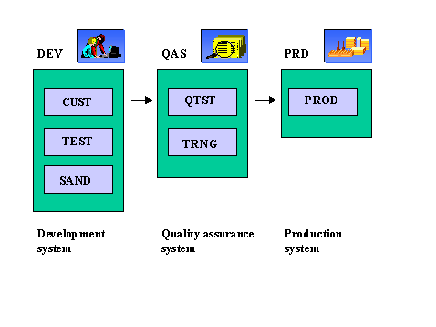
Two-System Landscape
A two-system landscape is an alternative for smaller SAP implementations where little Workbench development takes place.
The two-system landscape does not include a separate quality assurance system QAS. The quality assurance client is also in the development system DEV.
As in the three-system landscape, the production client is completely separate from the other clients. The disadvantage of a two-system landscape is that cross-client data is used in both the Customizing and quality assurance clients. This means that any changes that are made to cross-client data in the Customizing client can affect the tests in the quality assurance client. You can also not guarantee that transports from the Customizing client will be complete. Although all tests in the quality assurance client were successful, errors could still occur after the transport into the production client. This problem is caused by changes being made to cross-client data and then not being transported.

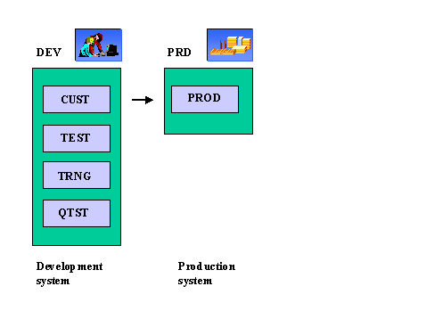
One-System Landscape
We do not recommend a one-system landscape containing all central clients in a single SAP System. Joint usage of hardware resources and cross-client data places serious restrictions on how a single system operates. In particular, once the system is used productively, you can no longer develop in it, unless you stop productive operation for the development and test phases.

