SAP Content Server
Purpose
The SAP Content Server is based on the SAP DB and is available on Windows NT Server and Windows 2000 Server from release 4.6.
Therefore, besides the SAP DB, an external content server is always available in every SAP system installation. In this way, the necessary technical infrastructure is provided for all document-centric applications and business scenarios that do not require a long-term archiving solution. Since the SAP Content Server is also integrated via the HTTP interface (see SAP HTTP Content Server 4.5 Interface), the actual storage medium used remains completely transparent to SAP applications. This means that the storage medium can be changed at any time.
For OLTP documentation and information on the SAP DB tools, see the documentation under mySAP Technology Components → SAP DB:
Database Manager GUI: SAP DB 7.3
Database Manager CLI: SAP DB 7.3
SQL Studio: SAP DB 7.3
Reference Manual: SAPDB 7.2 and 7.3
Replication Manager: SAP DB
Applications that can use the technical infrastructure of the SAP Content Server include the SAP Business Workplace, SAP ArchiveLink, the Document Management System (DMS), and the Knowledge Warehouse.
Implementation Considerations
The installation procedure for the SAP Content Server is described in the SAP Content Server Installation Guide, which is also available in both English and German as a PDF document on the SAP Server Components2 CD.
Constraints
The SAP Content Server is not intended to replace optical storage systems and other storage media for long-term archiving of documents.

 Integrating the SAP Content Server
Content Server Administration
The Content Server can be administrated directly from the SAP system. Special tools have been developed for monitoring and administrating the SAP DB underlying the SAP Content Server.
For more information, see the SAP Library under Knowledge Provider in the section SAP Content Server Administration.

Monitoring
The Knowledge Provider’s Content Management Service (CMS) is used to monitor the Content Server. The CMS is a service of the IT infrastructure provided by Knowledge Provider within the framework of SAP Web Application Server. The central feature of the CMS is that it is designed to be compatible with different types of storage media. In other words, the CMS functions as an interface between content servers and the SAP system.
For further information see Content Server and Cache Server Monitoring.
Content Servers and Cache Servers
Any number of content servers can be installed in different locations. The contents are transferred directly between the client and content server. If the content servers are accessed from different locations that are linked only via a wide area network (WAN), cache servers should be used. Network traffic across the WAN can be reduced to a minimum and performance enhanced by installing at least one cache server at each location.
A client cache is also available on the user's front-end computer.
For further information see Knowledge Provider and Caching.

Architecture of the SAP Content Server
The SAP Content Server consists of the following components:
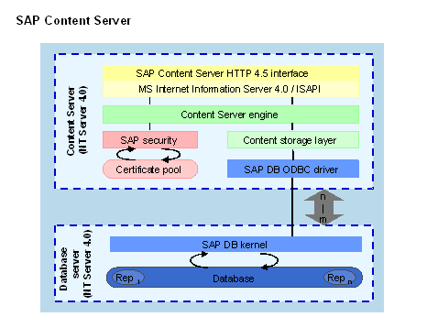
The basis of the SAP Content Server is the Content Server Engine. The engine is implemented as an ISAPI extension in Microsoft Internet Information Server.
The engine receives all URLs, checks their validity, and triggers the processing of requests.
The SAP Content Server saves data to the SAP database (SAP DB). However, the Content Server engine does not communicate directly with the SAP DB. It uses an adapter known as the content storage layer. The storage layer hides the specific access mechanisms of the storage medium behind a consistent, bytestream-oriented interface. This means that one server engine can support several storage media. Only the storage layer has to be implemented every time.
In the case of the SAP Content Server, the storage layer uses the SAP DB client driver to access the database server. The SAP DB administrates the individual repository tables in which the documents are stored.
Advantages of the SAP Content Server
- The SAP Content Server provides a flexible and scalable architecture. You can enhance the capacity and performance of the SAP Content Server even further by using a number of servers and by decoupling the database server from the HTTP server.
- The database is much better suited than a file system to the administration of large amounts of data. Internally at SAP, the SAP Content Server has been used for several release cycles to administrate all documentation and training content.
- The SAP DB version is independent of the SAP release. SAP DB version 7.2 is included in the SAP release 4.6C package. This version of the SAP DB has a capacity of 64 terabytes (maximum). In the unlikely event of this space being used up, another database can be installed.
- Easy-to-use and stable SAP DB administration tools are shipped with the SAP Content Server. These can be used to make automatic backups, for example.
- The interface, which is based on the HTTP protocol, decouples the storage systems involved. Several well-known providers of storage systems have successfully implemented the certification procedure.
Security Mechanisms of the SAP Content Server
Internet security mechanisms are intended to prevent data from being intercepted during transfer by unauthorized persons, and from being used for purposes for which it was not intended. In the Knowledge Provider, there are two potential security risks:
- URLs may be forged, allowing the forger unauthorized access to data
- The data stream may be "tapped" or forged
The following security mechanisms counteract these risks:
- Secure URLs
- Encoded Data Transfer
- Security Mechanisms Against Data Loss
- Access Protection for Administration
Secure URLs
Protection Against Unauthorized Access to Stored Content
To prevent unauthorized access to stored content on the SAP Content Server, the SAP system carries out an authorization check. However, the SAP Content Server is accessed by means of the open SAP Content Server interface (see also SAP Content Server HTTP 4.5 Interface). URLs must be secure so that they allow only authorized access to stored content and, correspondingly, so that forged requests are rejected. To make a URL secure, it is given a characteristic (like a watermark on a banknote) which allows the receiver to detect whether or not the URL has been tampered with (like if the watermark is missing from a banknote).
In the case of a Content Server URL, the characteristic in question is the signature. The signature is an encoded copy of the URL itself and is transferred to the content server as part of the URL. A signed URL contains the additional parameters expiration (see also Parameters and Keywords) and secKey (digital signature). A signed URL is only valid if the expiration time has not been exceeded and if it contains a valid signature.
The content server decodes the signature and compares it with the URL it received. The content server only executes the request if the URL and the signature match. If an intruder changes the plaintext in the URL, the signature will not match the URL. The content server will accordingly reject the request.
The signature is based on the RSA procedure and MD5 hashing.
The RSA procedure is also known as the public key procedure. This procedure is based on a private and a public key. You need the private key to create the signature. You need the public key to check the validity of the signature. For a description of the technical details of this procedure, see the documentation Secure Store & Forward / Digital Signatures (BC-SEC-SSF).
As the main partner in the three-way relationship of client – SAP system – content server, the SAP system is the only partner that may send request URLs to the client. Because of this, the SAP system has to create the URL signature using a private key.
The public key (Certificate) of the SAP system must be stored on the content server, and the relevant repository must have access to it (see also Content Repositories). Transactions OAHT, OAC0 (from release 4.6C) and CSADMIN (from release 4.6C for SAP Content Server, see also Content Server and Cache Server Administration) are used to transfer the certificate. The certificate has to be activated on the content server for the repository in question. This is done using transaction CSADMIN (for SAP Content Server).
Every SAP system must have its own unique certificate, so that the SAP system’s digital signature can be used properly.
See the section Creating a System-Specific Certificate for Content Server Access.

Protection Against Tapping and Forging of the Data Stream
Data transfer must also be encoded, so that a potential intruder cannot access the data while it is in transit between client and server. Standard procedures exist for this, such as secure HTTP (HTTPS). HTTPS encoding is usually implemented between the client and the server and is not part of the SAP HTTP Content Server interface.
Signed URLs can slow down performance, as it takes increased processing power to create the signature.
Security Mechanisms Against Data Loss
SAP Content Server is based on the SAP DB (see also SAP Content Server). To avoid data loss, take the usual measures against data loss in databases. These measures could include the following:
- Redundant hardware
Mirror disks, RAID systems, and so on
- Regular standard security measures
Log files, backups
Note when making a backup that in addition to the database, the file ContentServer.ini and the directory Security must also be backed up. See also note 319332 (Content Server Backup Strategies).
 Creating a System-Specific Certificate for Content Server Access
Use
To ensure that every SAP system has its own certificate (system-specific certificate), a Personal Security Environment (PSE) (see also Personal Security Environment) must be created on every SAP system when it is installed. This only needs to be done once for every system. You set up the PSE in the Trust Manager (transaction STRUST, see also Trust Manager).
As a rule, the SAP system PSE is used to create and verify signed URLs in the SAP system. From SAP Web Application Server release 6.10, you can also use your own PSE.
Two different scenarios are possible here:
- If the SAP system is functioning as a client and is using an external content server as a repository, once you create your own PSE, URLs are from then on signed with your PSE and not with the system PSE. In this case, only private and public key are relevant; the certificate list is irrelevant.
- If the SAP system is functioning as a Content Server and is using HTTP via SAP Web Application Server, the PSE then also has the effect that all public keys needed for checking signatures are stored in the certificate list.
Content Server Administration is used for the checking process itself (see also Content Server and Cache Server Administration). This takes place in transaction CSADMIN, on the tab page Certificates.
Carry out the procedure described below for creating a certificate for Content Server access before creating repositories.
If you do this after you create repositories, you will have to re-send the certificates to all HTTP repositories and reactivate all the certificates. This is because the certificate changes when you create a new PSE.
If you are accessing the database via HTTP (see also HTTP Access for Repositories on the SAP Web Application Server), you also have to redistribute and reactivate the certificates.
Procedure
Take the following steps to create your own PSE:
- Call transaction STRUST.
The Trust Manager opens.
- Choose Applications.
- Choose New Entries.
- Use F4 Help to select HTTP Content Server and confirm this by choosing Enter.
Additional fields for application-specific Secure Store & Forward (SSF) parameters and standard values for empty fields are grayed out.
- Make the following entries:
  - In the field Security/Product, enter SAPSECULIB.
  - In the field SSF Format, choose International standard PKCS#7.
  - In the field Priv. add. book, enter SAPHTTPCS.pse.
  - In the field SSF profile, also enter SAPHTTPCS.pse.
  - In the field SSF ProfileID, enter CN=<Common name>,OU=<Organization Unit>,O=<Organization>,C=<Country>.
For example: CN=BCECS,OU=DEV,O=SAP-AG,C=DE
  - Check Distribute PSE (Only SAPSECULIB).
- Save your entries.
- Call transaction STRUST again.
- Select HTTP Content Server.
- Choose Replace from the context menu.
- Confirm this at the confirmation prompt.
- Confirm your entries by choosing in the next popup (Replace PSE).
Example
The HTTP Content Server PSE links to a system-specific PSE. This means that you can specify that you no longer want to use a specific certificate, for example. In this case, you have to open Content Server Administration and delete the certificate in all repositories. You also have to delete it from the certificate list.
Access Protection for Administration
Administration for the SAP Content Server is carried out partly inside the SAP System (see Content Server and Cache Server Administration), and partly outside (see Reference Manual: SAPDB 7.2 and 7.3). Note the following security considerations in relation to administration on the Content Server:
- Make sure that only authorized persons have (administrative) access to the computer on which the SAP Content Server is running.
- Make sure that (administrative) access to the database is appropriately restricted.
To ensure that only authorized persons have administrative access to the SAP Content Server from the SAP system, you need to set the parameter AdminSecurity in the file ContentServer.ini on the SAP Content Server to 1: AdminSecurity=1.
For more information, see the section CSADMIN, and the installation documentation SAP Content Server Installation Guide.

 Content Server for Business Workplace Documents

Purpose
For the Knowledge Provider to be able to store documents on the content server, a class for these documents must be created. In the Knowledge Provider the class SOFFPHIO is provided for Business Workplace documents. Storage categories are assigned to this class with content repositories.

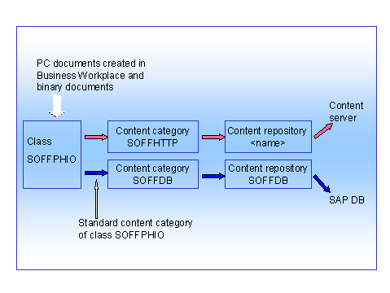

As shown in the graphic, SOFFDB is the default content category assigned to the SOFFPHIO class. This means the documents are stored on the SAP DB. To use the SAP Content Server or an external content server, you have to make some settings. Then you can store Business Workplace documents on the content server.

Process Flow
Process Flow | Procedure
1. Creation of content repository for connecting to the content server | a. In the Implementation Guide (IMG) (transaction SPRO) choose Basis → Basis Services → Knowledge Provider → Content Management Service → Define Content Repositories .  b. Create a content repository for the storage category HTTP content server. This content repository will contain the connection details to your content server. To do this follow the IMG documentation for this activity.
2. Assignment of content category SOFFHTTP to the content repository you have created. | a. In the Implementation Guide (transaction SPRO) choose Basis → Basis Services → Knowledge Provider → Content Management Service → Define Content Categories .  b. Select the entry SOFFHTTP by double-clicking on it.  c. In the Content Repository field enter the name of the content repository that you created for your content server.  d. Choose .
3. Assignment of SOFFPHIO class to content category SOFFHTTP | a. Enter transaction SKPR08.  b. The previous memory category SOFFDB is already specified for the class SOFFPHIO. In the New Category field enter SOFFHTTP.  c. Choose .

Result
Once you have completed the settings, new PC documents created in the Business Workplace and binary documents will be stored on the content server you defined. Documents stored in the Business Workplace before this time point, will remain in the database used up to now.
The content category SOFFDB establishes the connection to this database and must not be changed or deleted.
Cache Servers
Purpose
The purpose of the Cache Server is to provide the following benefits:
- Seamless, transparent integration into existing content server landscapes
- Significant reduction in client response times
- As little administration work as possible
Cache servers are used to speed up access to document content. This is particularly useful if the content is required for display in a Web browser, for example. Cache servers can also reduce the network load and thereby enhance performance. It is therefore also a task of the cache to provide the client with documents from a physically close location, even if the content server is located on a different continent.
Caches are used in many areas. For example, MS Internet Explorer uses a local cache on the user's hard disk.
Cache servers are similar to content servers, but require less administration with the same level of access protection.
The Cache Server only uses HTTP. To make this possible, SAP Content Server HTTP Interface has been extended (see SAP Content Server HTTP 4.5 Interface). By using cache servers, you are simply extending your existing infrastructure in a transparent way. There is no need to re-structure the existing content server landscape.
Implementation Considerations
The cache server is installed from the SAP Server Components2 CD-ROM as part of the installation of the SAP Content Server. Installation instructions in PDF format are provided in both English and German on this CD-ROM, in the directory \CONTSERV\DOCU.
Architecture of the Cache Server
Despite their similar architecture, the Cache Server and the Content Server have some basic differences. The cache server can set up its own HTTP connections to other servers and can forward incoming client requests. The "other servers" can be content servers or other cache servers. If the server in question is another cache server, this architecture is known as cascaded or multi-layer caching (see also Cascaded Caches).
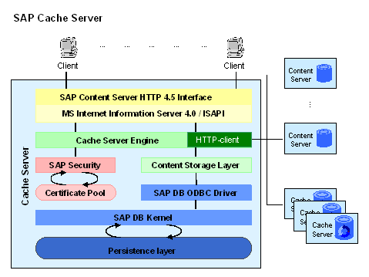
A notable feature of the cache is its almost complete freedom in terms of administration. As soon as the cache is integrated into the server topology, it can start performing its services without the need for log monitoring or backups.
Caches are always used for read access to documents. "Lazy write" is not supported. In other words, a client that wants to store documents must always be directly connected to the corresponding cache server.
As already described (see Content Management Service), SAP HTTP Content Server interface supports signed URLs. Cache URLs can of course alse be signed. However, it would be very inconvenient if the cache had to rely on the Content Server to carry out signature checks every time. It therefore makes sense for the cache to check the signatures itself. To this end, the cache contains all the necessary SAP certificates, or else it gets them from the appropriate content server.
The Cache Server has the same security mechanisms as the Content Server.
Deletion Strategy and Performance
Deletion
A characteristic of cache servers is the pre-set limit on the amount of memory available for storing objects. Unlike the content server, this memory space does not "grow" (but the size of the cache can of course be increased at any time).
If the cache server fills up to the level where it does not have enough space to store the next object, it starts deleting "old" objects from the memory. To facilitate this, the cache carries out a statistical analysis of accesses to cached objects. It then deletes the documents that have been unaccessed the longest, until there is enough space in the memory to store the current document. This method is also called the least recently used (LRU) mechanism.
Performance Considerations
SAP’s own analyses have shown that the cache provides a consistent, significant advantage in terms of speed, taking into account both the frequency and size of requests. In the diagram below, this is shown in the comparison of the response times of the cache server and the content server. From the diagram, it is clear that both curves run parallel, regardless of the request size, and that the response times of the content server exceed those of the cache server by a factor of 10. This result is, of course, independent of the bandwidth available to the content server. For example, SAP has a high-bandwidth connection between Walldorf and Palo Alto. In a customer environment, much higher improvements on speed can be expected.
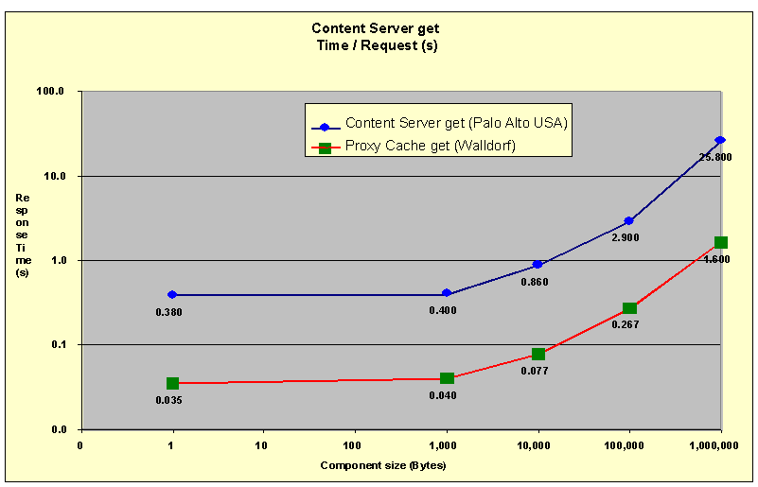
The relationship between cache hits and cache misses is an essential criteria in cache efficiency. When the hit rate is near 100%, cache performance is at optimum level. If the misses are in the majority, or if misses make up 20-30% of the total number of requests, you should consider taking performance optimization measures.
What causes a sharp increase in cache misses?
- An almost full cache
- A large number of widely dispersed requests; that is, documents that are not located in the cache are being constantly requested
Both factors cause the cache to behave in the following ways.
Stored documents are deleted to make way for new objects. The lack of space in the cache and the non-homogenous nature of the requests means that deletion continually takes place.
In extreme cases, the cache content is in a constant state of flux (also known as "thrashing"). This greatly degrades cache performance.
The only solution to this problem is to extend the cache space, so that the maximum occupancy of the cache can be maintained at 75%. Backbone caches are particularly susceptible to thrashing, as these serve as concentrators for other caches.

Optimal Access Path for Client Requests
The SAP system knows the locations of the content server, cache server, and client attached to it. This knowledge enables it to establish an optimal content access path.
The cache is selected as follows:
- The SAP system establishes the location of the client.
- The SAP system then establishes the location of the content server.
- If the client and the content server are at the same location, no caching is necessary and the requested URL can be retrieved directly from the content server. In other words, the content is displayed directly from the content server.
If the client and content server are not at the same location, the SAP system finds out the identity of the cache server at the client location.
- If no cache server is available, the URLs are displayed on the client directly from the content server.
If one or more cache servers are available, one of these is selected to display the content.

