Sap Router Certificate Renewal Process

- In the following document SAP Router was installed in C:\SAProuter\SAProuter

This is the process to check for the validity of the saprouter certificate and re-apply this.

- From command prompt, give this command:
sapgenpse get_my_name -n validity

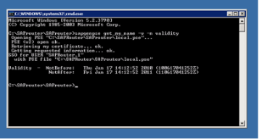

This will show the validity. Please see screenshot highlighted. It is showing validity
expired on Jun 17, 2011.

When the validity is showing as expired, proceed as follows:

- Stop the Saprouter from the services panel.
- Make a backup of the folder: C:\SAProuter\SAProuter.This folder contains the saprouter files and might be needed for a restore if any issues
- Then check the following environment variables as shown below:
SECUDIR
SNC_LIB

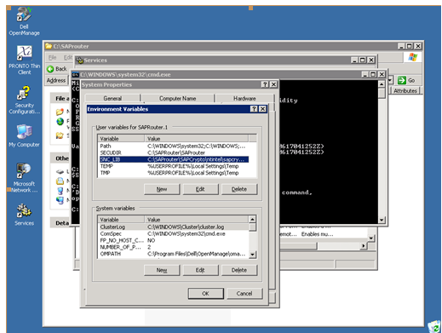
- Delete these 4 files in C:\SAProuter\SAProuter ( Ensure that you have taken the backup in the previous steps )
certreq
cred_V2
localpse
srcert

- The distinguish name is available from the command:
sapgenspe get_my_name

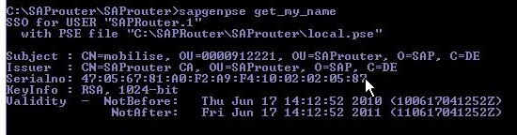

The distinguish name in this case is the entire details following Subject.

- Generate the certificate request using the following command
sapgenpse get_pse –v –r certreq –p local.pse "your distinguish name"

It will ask for entering the PIN. Enter any 4 digit number. Please remember and save the same. This pin will be needed for access to the PSE.

Once the request is created, it creates the file certreq under location: C:\SAProuter\SAProuter

- Then Login to service marketplace under:
http://www.service.sap.com/saprouter-sncadd a Apply Certificate

This opens the form below.
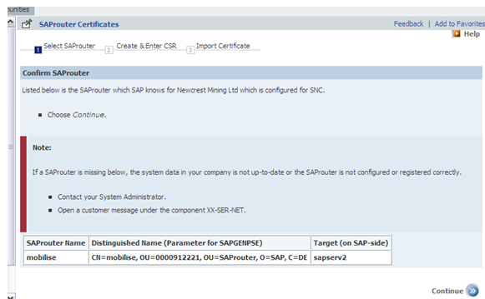

Select Continue

- Paste the contents of the certreq file generated above as below, and then “Request Certificate”. See below
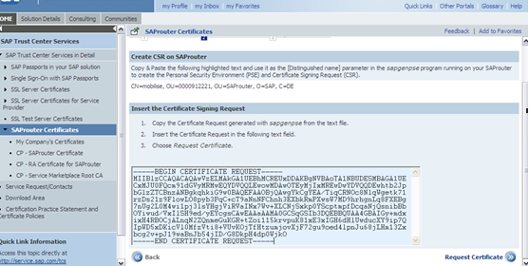

- Copy the details of the new certificate generated and then paste it in a new file srcert in the location C:\SAProuter\SAProuter.

- Then import the new certificate using:
C:\SAProuter\SAProuter>sapgenpse import_own_cert –c “C:\SAProuter\SAProuter\srcert” –p local.pse
Please enter PIN:
CA-Response successfully imported into PSE "C:\SAPRouter\SAProuter\local.pse"

- Then run this command to generate the file cred_V2 in the saprouter directory.

sapgenpse seclogin –p local.pse

- Check if the certificate has been loaded correctly by using the following command

sapgenpse get_my_name –v –n Issuer

C:\SAProuter\SAProuter>sapgenpse get_my_name -v -n Issuer
SSO for USER "SAPRouter.1"
with PSE file "C:\SAPRouter\SAProuter\local.pse"
Subject : CN=mobilise, OU=0000912221, OU=SAProuter, O=SAP, C=DE
Issuer : CN=SAProuter CA, OU=SAProuter, O=SAP, C=DE
Serialno: BD:43:BA:2D:74:72:35:B0:10:01:02:22:A7
KeyInfo : RSA, 1024-bit
Validity - NotBefore: Mon Jun 20 11:58:38 2011 (110620015838Z)
NotAfter: Wed Jun 20 11:58:38 2012 (120620015838Z)

This shows that the certificate has been renewed.

- The saprouter owner here is the user svc-saprouter and we need to give the saprouter permission to this user:

C:\SAProuter\SAProuter>sapgenpse seclogin -p local.pse -O svc-saprouter
running seclogin with USER="SAPRouter.1"
creating credentials for user "NMLCLAP03\svc-saprouter"...
Please enter PIN:
Adjusting credentials and PSE ACLs to include "NMLCLAP03\svc-saprouter".
C:\SAPRouter\SAProuter\cred_v2 ... ok.
C:\SAPRouter\SAProuter\local.pse ... ok.
C:\SAPRouter\SAProuter\local.pse ... ok.
Added SSO-credentials for PSE "C:\SAPRouter\SAProuter\local.pse"
"CN=mobilise, OU=0000912221, OU=SAProuter, O=SAP, C=DE"

Once it is done, we need to restart the saprouter. And the RFC connection SAP-OSS worked.

