Structural Authorizations
Step by Step, with Gotchas Too
by
Norm and Carl

Structural Authorizations Overview 2
Overview 2
Example 2
About this Document 2
Graphical Overview of Structural Authorization Components and Setup 3
Considerations for Structural Authorization Implementation 3
Considerations for Structural Authorization Implementation 4
Gotchas 4
Overall Design Considerations 4
Steps to Implement Structural Authorizations 5
1. Turn on PD PA Switch 5
2. Turn on Structural Authorizations Main Switches 6
Description 6
3. Create Organizational Plan 7
4. Create Personnel Master Record 11
5. Create User ID’s 16
6. Create Infotype 105 17
7. Create Structural Authorization Profiles 19
8. Create Infotype 1017 22
9. Assign Structural Authorization Profiles to User ID’s 25
10. Setup Regular Security 28
Appendix 1 30
Authorization Main Switches 30
Maintain Authorization Main Switches 30
Standard Settings 30
Further Notes 31
Appendix 2 32
Appendix 3 34
Assign Structural Authorization Profile to User ID Manually 34

Structural Authorizations Overview

Overview
Structural authorizations are used to grant access to view information for personnel where HR has been implemented. Access is granted to a user implicitly by the user’s position on the organizational plan. Structural authorizations are not integrated into the standard authorization concept and structural authorization profiles are not the same as standard authorization profiles.

Example
The use of structural authorizations can be illustrated by the following example. A manager can typically view or maintain information on employees in her organizational unit but not employees in other organizational units. When an employee moves from one unit to another his previous manager will no longer be able to view or maintain information about them. Similarly if a manager moves from one unit to another she will be able to see the employees in her new unit.

About this Document
This document shows how to set up a very simple example of structural authorizations that are assigned to Organizational Units. All the steps of setting up a test environment are documented below so you can try it too. There are some gotchas and design considerations listed up front and some additional information listed in the many appendices at the end.

Graphical Overview of Structural Authorization Components and Setup
The graphic below shows the main components of structural authorizations at a high level. The setup of structural authorizations is more complex than regular security authorizations. None of the main setup steps can be omitted or incomplete. Structural authorizations setup is analogous to an electric circuit. If there is a break anywhere in the circuit structural authorizations it will not work.

Org Unit
Position
Task
Standard Task
Security Role
Profile
Authorizations
User ID
Personnel Master Record
Organizational Plan Node
Structural Authorization Profile
PD PA Switch
ON
HR Main Switch (AUTSW- ORGPD)
ON

Communication Infotype 105
Report
RHPROFLO (daily)
Infotype 1017
Transaction
PPOM_OLD
Key:
Configured in Production
Configured in Development
Configured in All Environments

Considerations for Structural Authorization Implementation

Gotchas
- Setting up structural authorizations has some dependencies so follow the order of the steps in this document for best results.
- Structural authorization profiles are not related to standard security profiles in any way.
- Unassigned Users: User IDs that have been linked to a Personnel Master Record via Infotype 105 MUST be assigned a structural authorization profile regardless of whether they are assigned to a node on the organizational plan or not. (See Appendix 3)
- There is no way to trace structural authorization checks, and structural authorization checks that fail do not show in SU53. The closest thing to a trace is the information available in OOSP by clicking on the Blue I icon next to the profile. This lists the effect of the structural authorization when it is working.
- The HR Main switch: Tolerance time of the authorization check (ADAYS) which is 15 by default did not affect the structural authorizations in this example. In tests where a manger was moved from one organizational unit to another the effect of the structural authorizations was immediate after running report RHPROFL0. The manager can no longer see information for anyone in their old organizational unit.

Overall Design Considerations
- What level of the organizational plan to assign structural authorizations – we use org units in this example. This allows managers in the same org unit and same level to see each other’s information. If this was not acceptable then a hybrid approach of organizational units and positions could be used. It seems most efficient to attach structural authorizations to the highest node on the organizational plan possible. Note that we create profiles with authorization for an organizational unit but we assign these profiles to positions.

- As mentioned in Gotchas above unassigned users linked to personnel master records with access to HR transactions can see personnel data for any user. This has an impact on how you design both standard roles and also procedures for creating roles. One way to make sure that unintended access does not occur is to assign a dummy structural authorization to every user in the system with. The dummy structural authorization should be empty. It is possible to control this using infotype 105 as well. Any user ID that is not associated with a personnel master record will not be able to view other users information with the correct standard authorizations assigned to the User ID.

Steps to Implement Structural Authorizations

1. Turn on PD PA Switch
Tcode: OOPS
Action: Ensure value registered for PLOGI – ORGA is X. No other values need to be checked or changed.

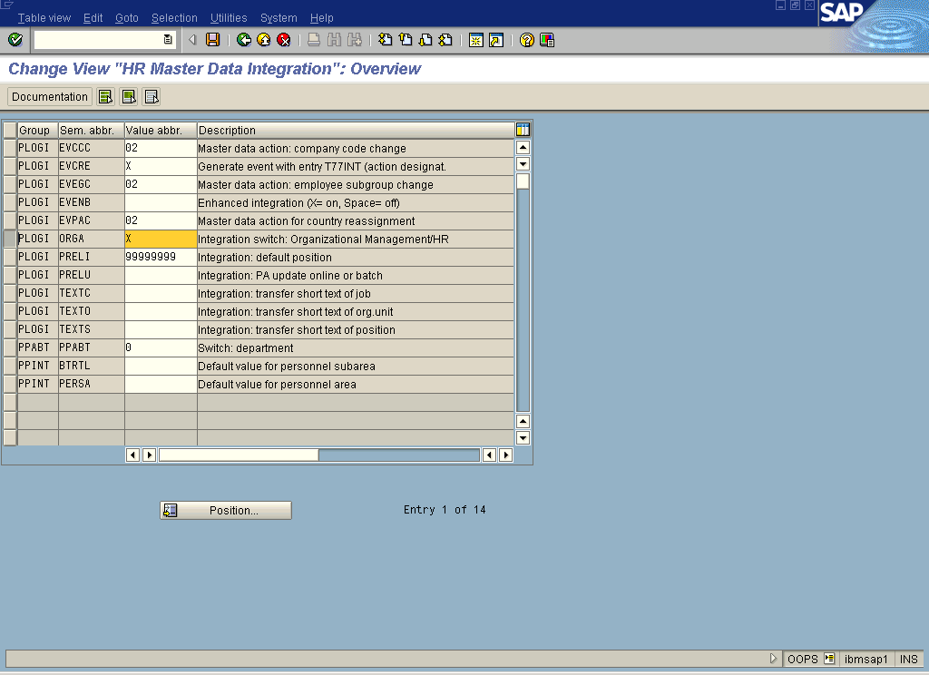

Explanation: PD and PA sub modules of HR are not configured to share data by default in the SAP delivered system. This switch must be on for data to flow between both modules.
Additional Info: None
Gotcha:
- Do not create your Organizational Plan without this switch on.
- If you do, structural authorizations will not work and some org and infotype setup will not work.
- ***You cannot turn the switch on and get structural authorizations on an organizational plan, that was created while it was off, to work.***

2. Turn on Structural Authorizations Main Switches
Tcode: OOAC
Action: Ensure values for the main authorization switches in HR are set to the following Values
Group | Sem. abbr. | Value abbr. | Description
AUTSW | ADAYS | 15 | HR: tolerance time for authorization check
AUTSW | APPRO | 0 | HR: Test procedures
AUTSW | NNNNN | 0 | HR: Customer-specific authorization check
AUTSW | ORGIN | 1 | HR: Master data
AUTSW | ORGPD | 1 | HR: Structural authorization check
AUTSW | ORGXX | 0 | HR: Master data - Extended check
AUTSW | PERNR | 1 | HR: Master data - Personnel number check

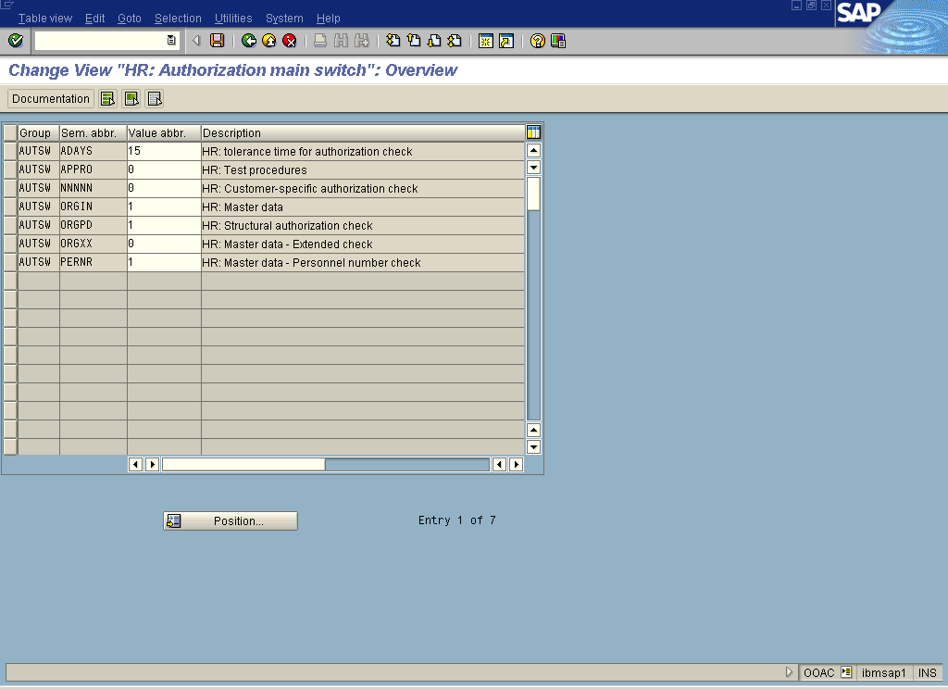

Explanation: The SAP delivered system has similar values as above but PERNR = 0.
Gotcha: Make sure that ORGPD = 1 otherwise structural authorizations will not work.
Additional Info: Appendix 1

3. Create Organizational Plan
Tcode: PPOM_OLD
Action:
1. Create the root of your Organizational Plan
- Organizational Plan > Create
- Enter info and click Create
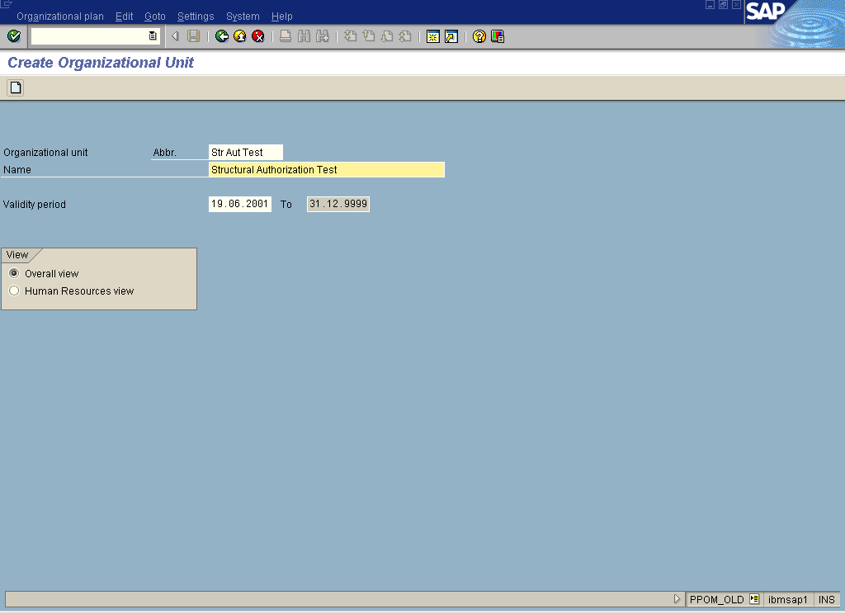

2. Create Organizational Units
- Select the Organizational branch you want to build on and click Create
- Fill in the abbreviations and names of the child structures (one level at a time) in the popup dialog box.

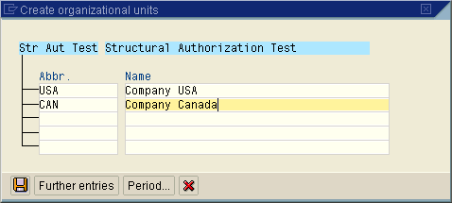

Example of the results:
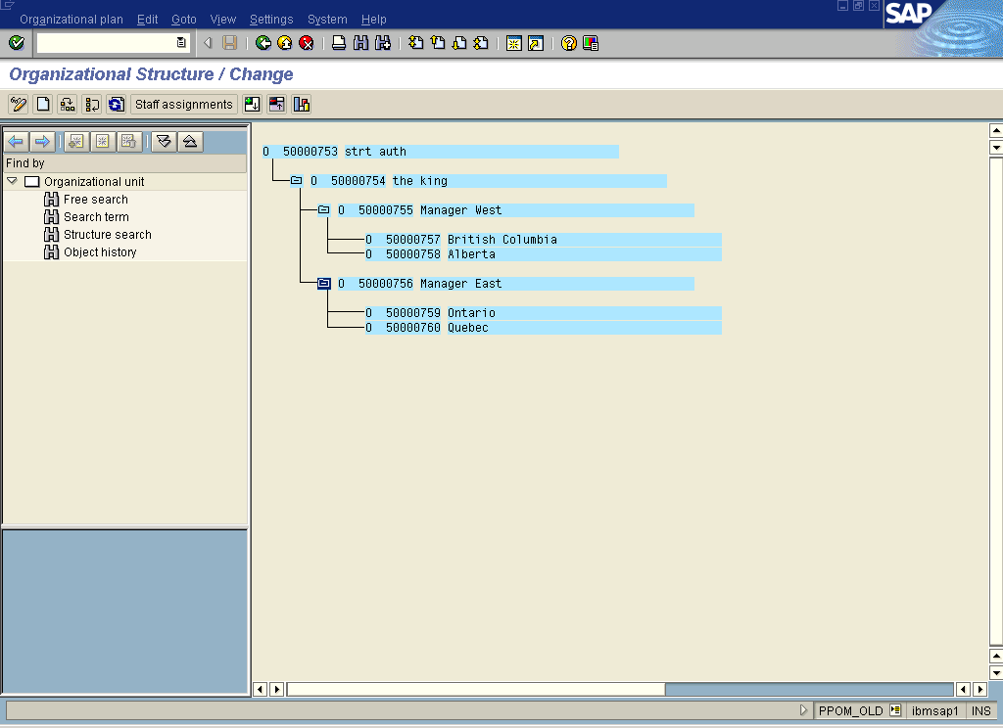

3. Create and assign positions
- Click on Staff Assignments button
- Select the unit that the position will be part of, then click on Create Positions…
- In the popup dialog box select a job description in the Choose Describing Job field group, fill in the fields in the Position field group and save.

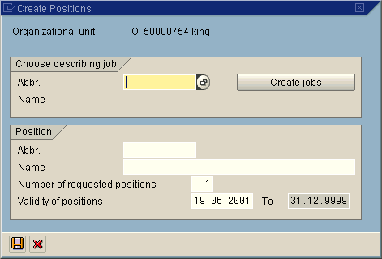

Example of the results:
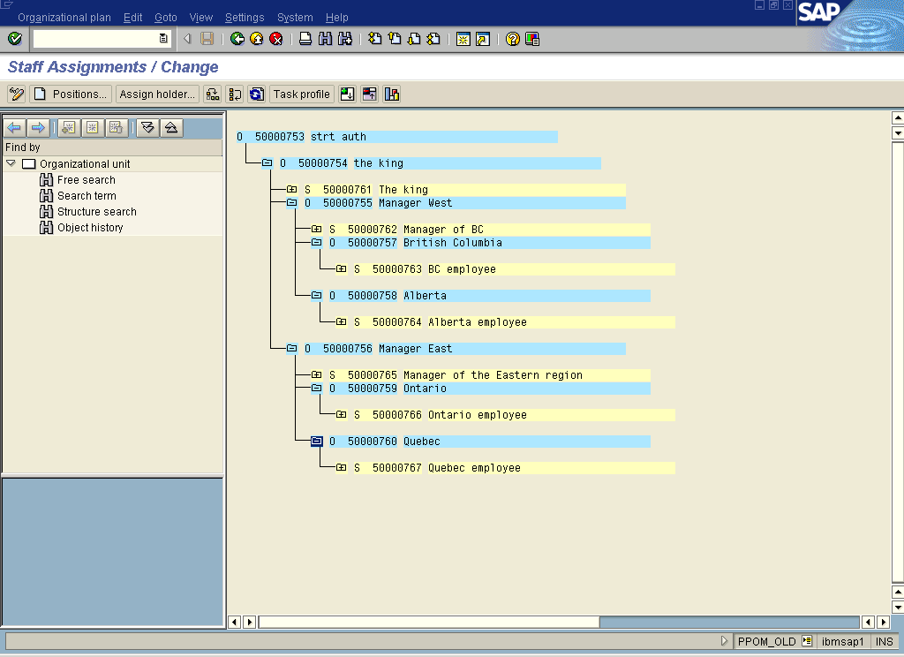

4. Designate Chief Positions
- Select the Position which will be the manager’s position and Select Edit > Chief Position > Create
- Select the position in the Create Chief Position dialog box and click on Save

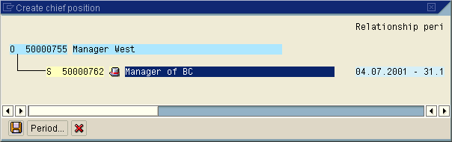

Results:
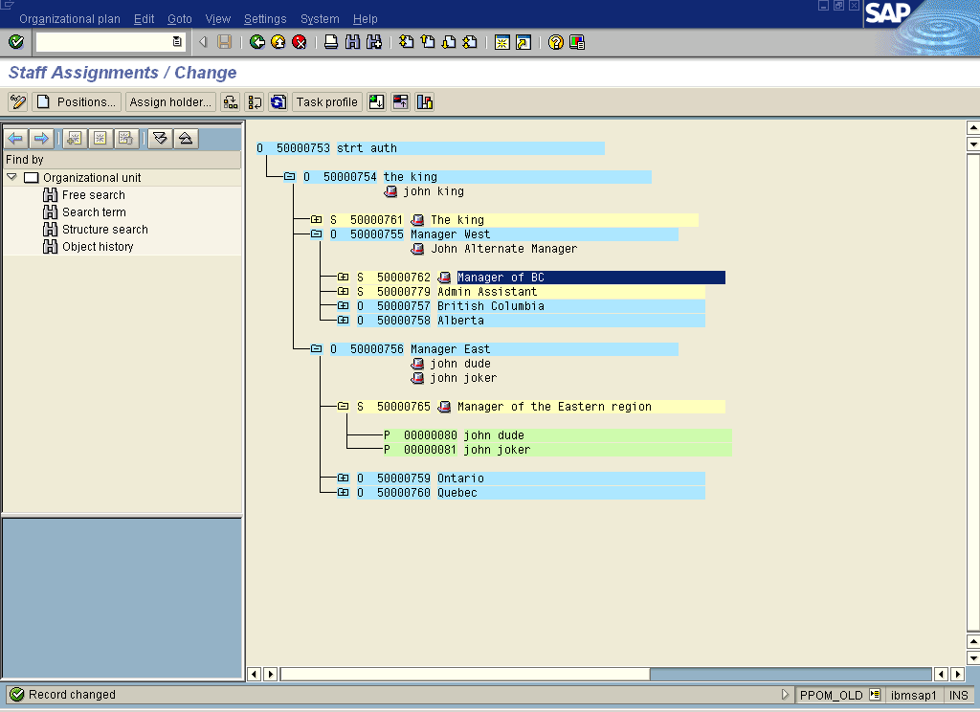
Notice the position Manager of BC now has a Hat next to it and the name of the Chief is listed below the Org Unit.

Explanation: Structural authorizations work based on this hierarchy (the Organizational Plan). This is the ‘structure’ in ‘structural’ authorizations.
Gotcha:
- Don’t start this step without first ensuring the PD PA switch is on (the first step in this document).
- If we want to use Manager’s Desktop we need to designate a position as Chief. The user(s) associated with this position will only be able to access Manager’s Desktop if their position is designated as Chief. Chief positions can have more than one person assigned, i.e. a single business unit can have more than one manager at the same level.
- SAP’s documentation indicates that performance may be adversely affected by the complexity of structural authorizations.
Additional Info: None

4. Create Personnel Master Record
Tcode: PA40
Action: Create a personnel master record and assign it to the organizational plan.
- Ensure that Personnel no. field is empty. Select a hiring action from the bottom of the screen and Click on execute.

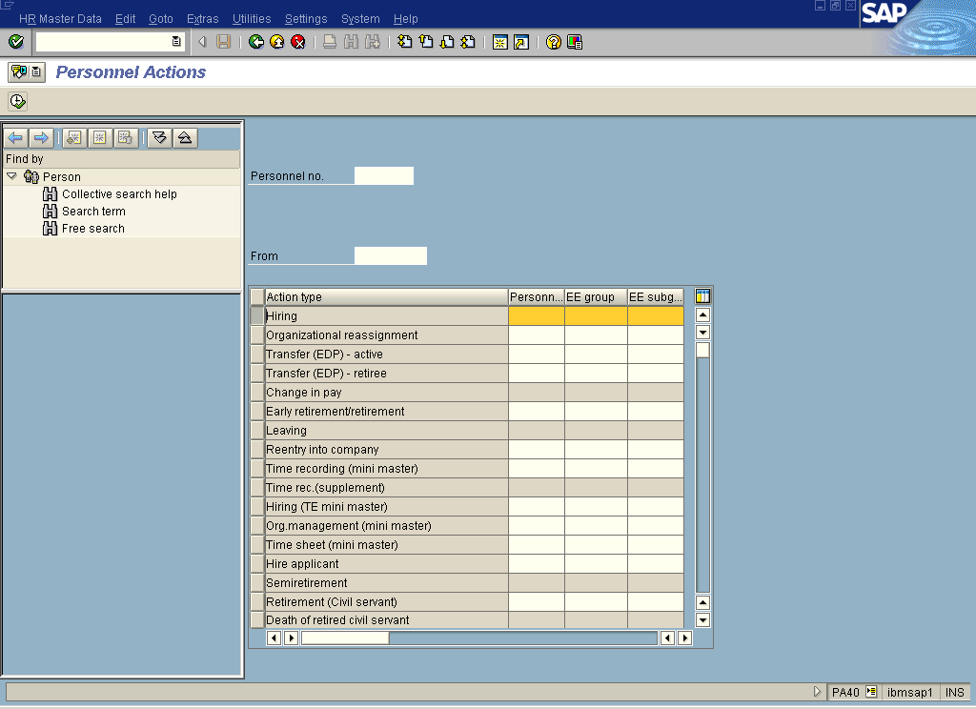

- Enter basic data for the master record.
- Enter a Start Date (current date is fine).
- Enter Personnel Area, Employee Group and Subgroup.
- Enter the Position Number to assign this employee to a node on the organizational plan.
- Save
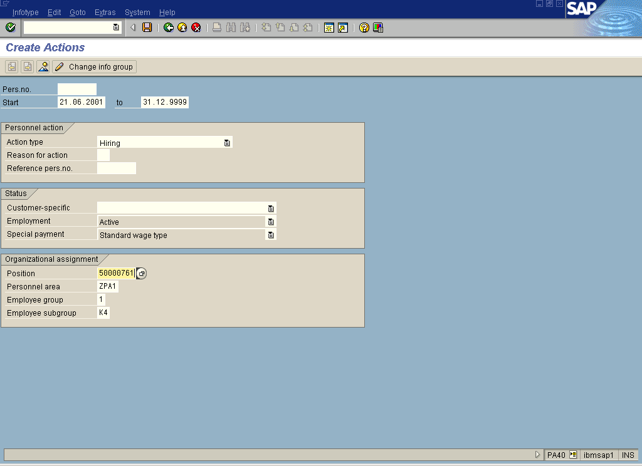

- Enter more personal data.
- Enter First and Last Name
- Select Gender
- Enter SIN number 000000000
- Enter birthday
- Save
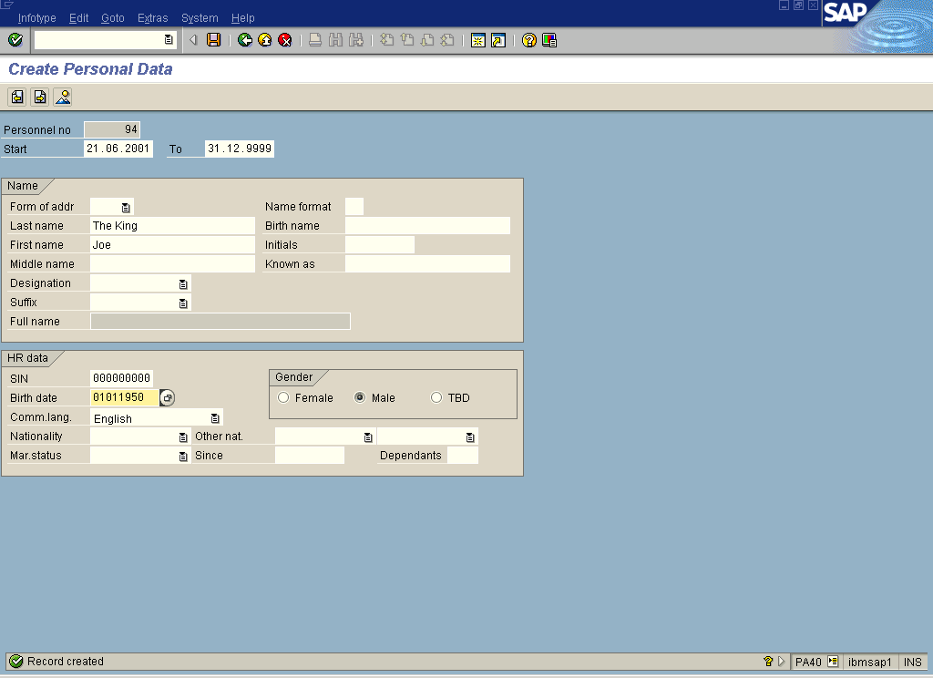

- Enter Information on one more screen.
- Enter the Payer Area and Subarea
- Save.
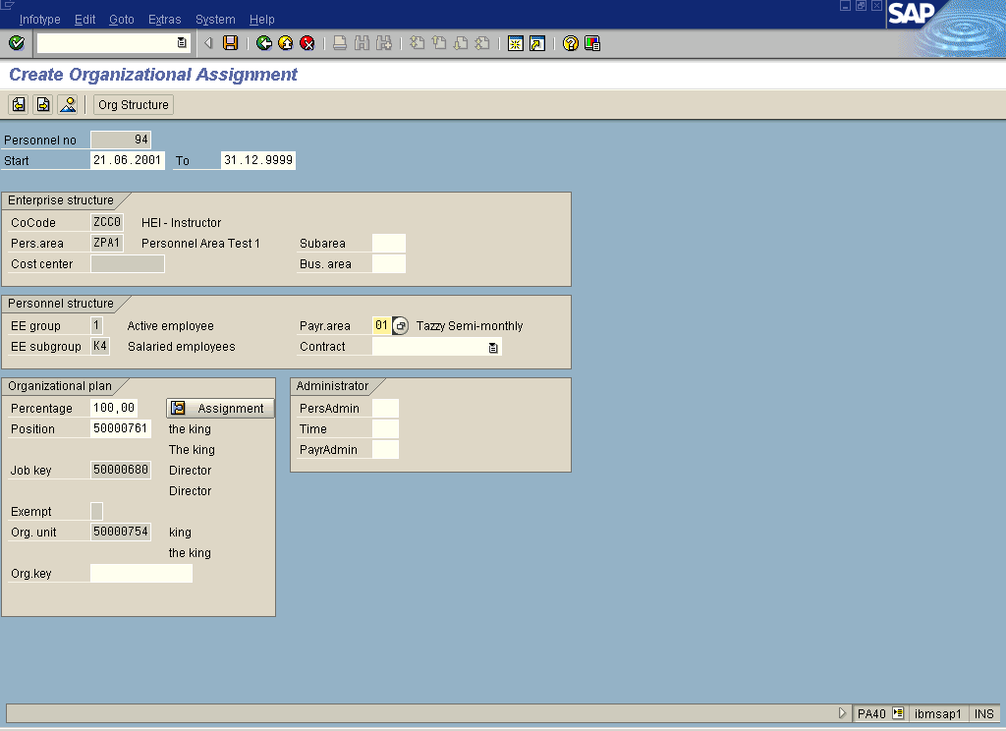

- End maintenance for this action
- Back out of the above screen
- Yes to this message
- Record the Personnel Number on the next screen

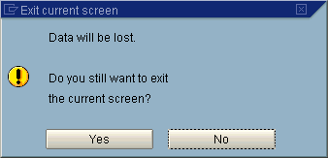

Results:
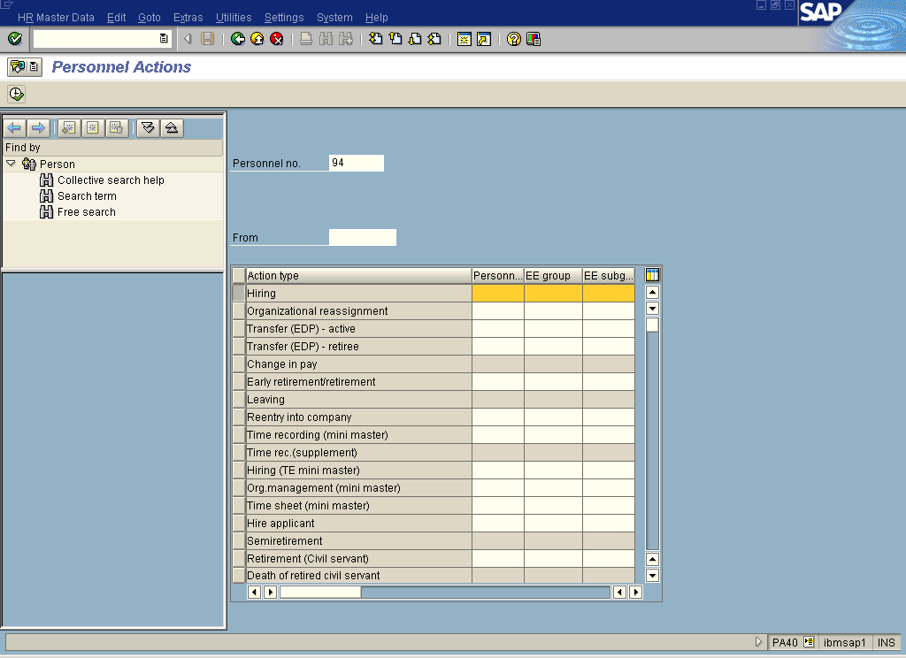

Explanation: User ID’s are not assigned directly to the organizational plan. The User Master Record (User ID) is relatively simple and is mostly used to give access to the SAP system. In SAP a personnel master record is created and assigned to the organizational plan. The Personnel Master Record is then linked to the User ID, which is the next step in building structural authorizations.

Gotcha:
- Ordinarily all personnel master records will be assigned to a node on the Organizational Plan. See Unassigned Users in the Gotchas in the Overview at the beginning of this document for more on this issue.
- The sequence of the screens in this action can vary
Additional Info: None

5. Create User ID’s
Tcode: SU01 or SU10 (Mass Create)
Action: Create users (Suggest creating users with a name similar to the Personnel Master employee name)
Explanation: User master records must exist before you can proceed to the next step.
Gotcha: If you use mass create make sure that request ‘with log’ and print or save the log so you know what the initial password is for each user.
Additional Info: None

6. Create Infotype 105
Tcode: PA30
Action: Create Infotype 105 for each Personnel Master Record
- Enter Personnel ID, Info Type 105 and Subtype 0001.

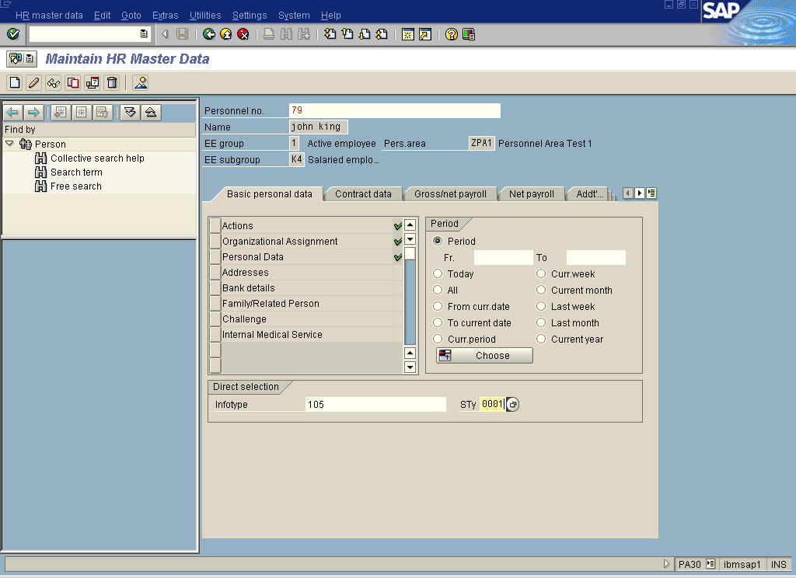

- Enter the User ID in the ID/Number field
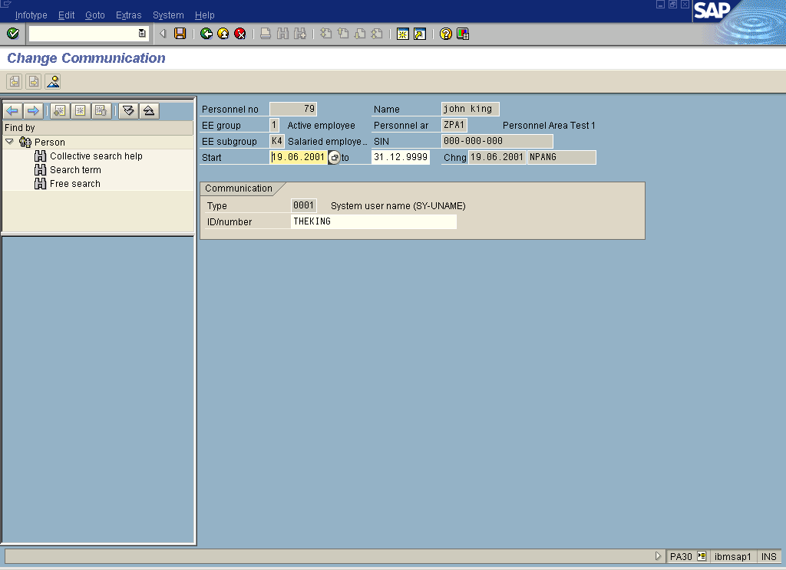

Explanation: The user master record and the personnel number have to be linked because it is the personnel number that is associated with the Organizational Plan. When the user logs on SAP needs to know which personnel number is associated with that user ID in order to grant structural authorizations.
Gotcha: None
Additional Info: None

7. Create Structural Authorization Profiles
Tcode: OOSP
Action: Create structural authorization profiles and then define the details of the authorization profile.
- Click new entry. Enter the authorization profile names, and descriptions. Click Save. (If you don’t save here you won’t be able to see the profile in the selection list of the next step)
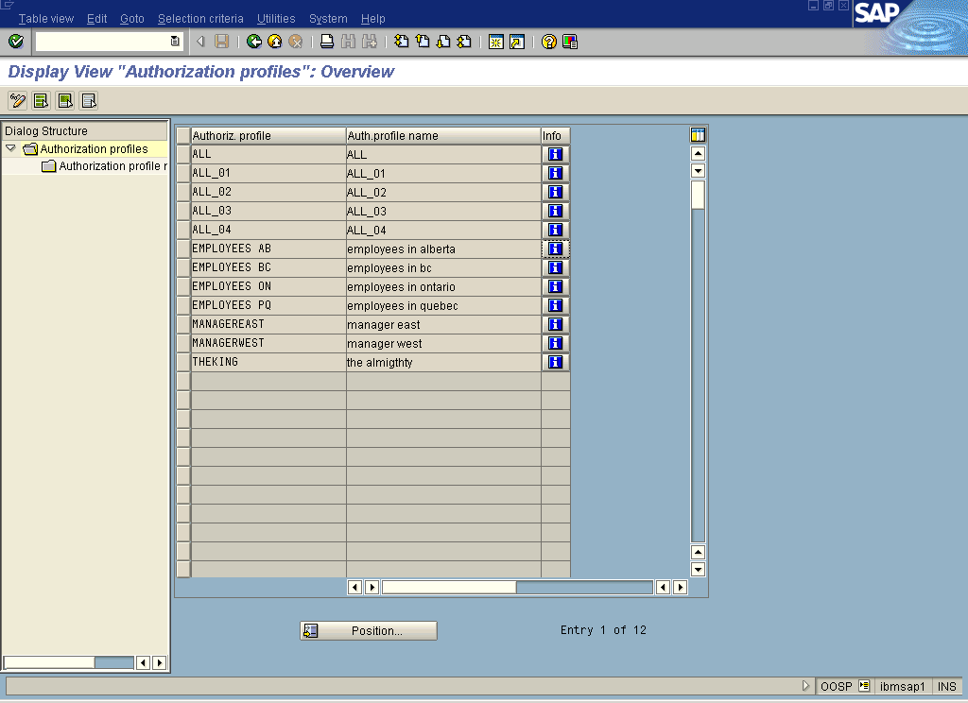
Click here to check information

Check the information for a profile e.g. Manager West.
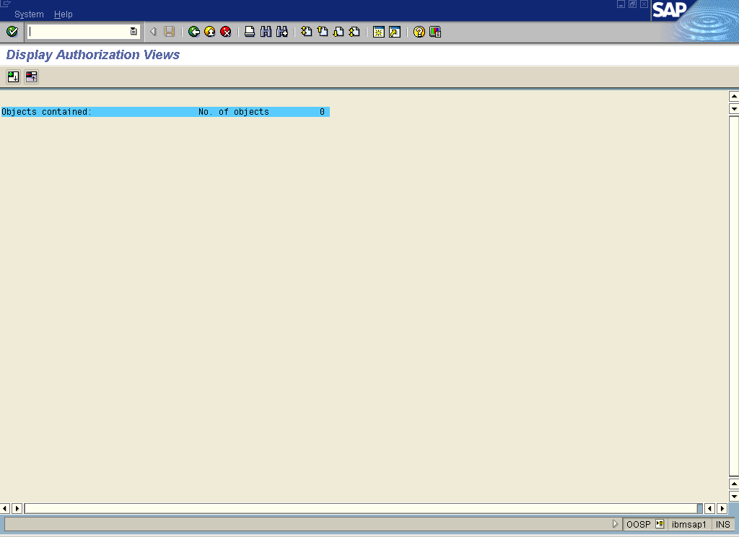
Note: No organizational plan units are shown in the list.

- Define the structural authorization profile.
- Select a profile and click on Authorization Maintenance on the left side
- Click on New Entry
- Enter the following:
Field | Value
Profile: | Select a structural authorization profile
No. | Choose an interval e.g. 10
Plan vers. | Select a plan version probably 01
Obj. type | In this case we are securing by Org unit. Enter O
Object ID | In this case we are securing by Org unit. So enter the Org unit number
Maintenance | Check this on
Eval.path | Recommend O-S-P
Status vec | Recommend 12
Depth | Recommend no entry
Sign | Recommend no entry
Period | Recommend no entry
Function module | Recommend no entry

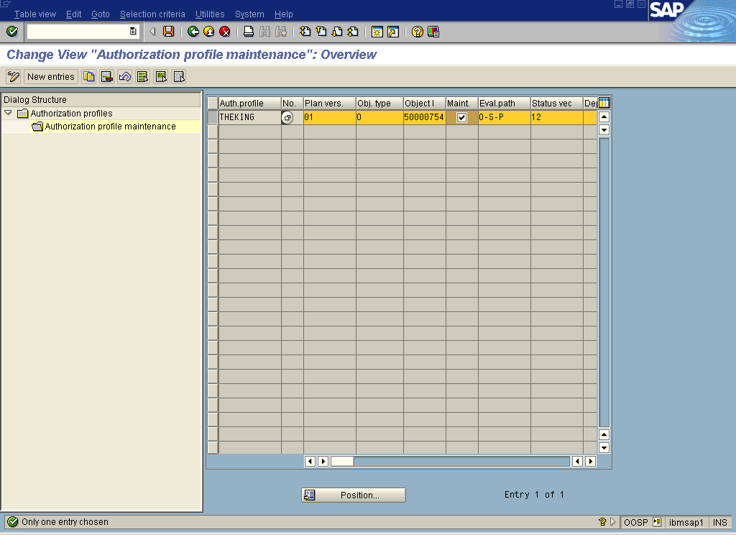

Explanation: We are creating structural authorization profiles here. In order to limit a user’s access to information according to the structure of the organization plan, you must define the place on the organizational structure below which a user can see personnel information.
Gotcha: Check the info button on the profile to make sure that the profile a) gives access to something and b) gives access to the right thing.
Additional Info: Appendix 2

8. Create Infotype 1017
Tcode: PO10 (Organizational Unit) or PO13 (Position)
Action: Create Infotype 1017 for all relevant nodes on the Organizational Plan. In this case all Positions (Tcode PO13)
  - Select the position
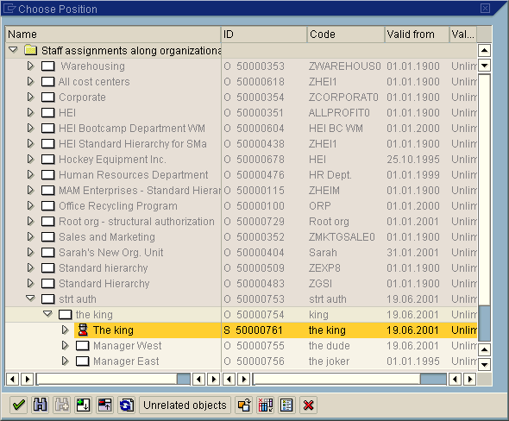

  - Select the PD Profile infotype from the scrollable list and click on Create button
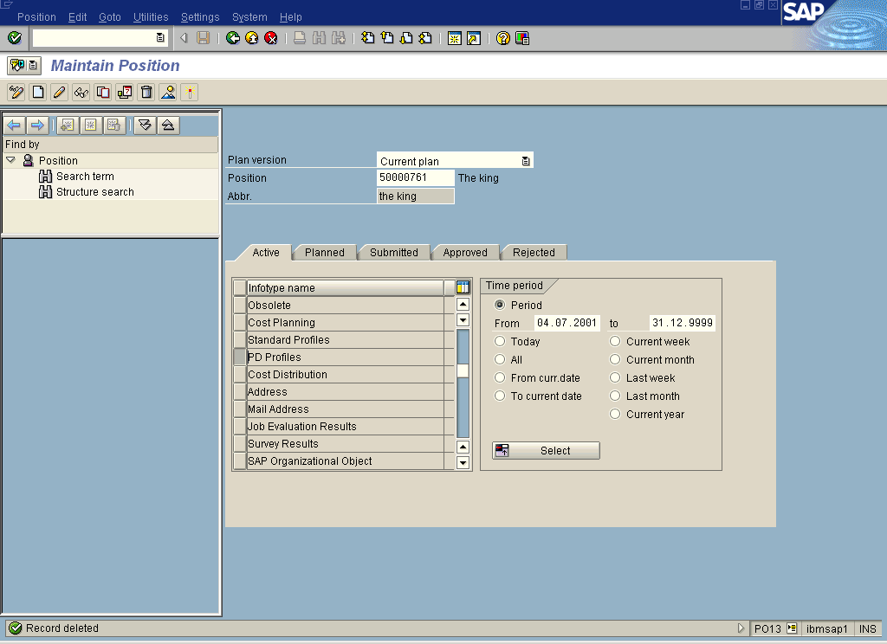

  - Enter the profile name in the Profile field and click on the Save button
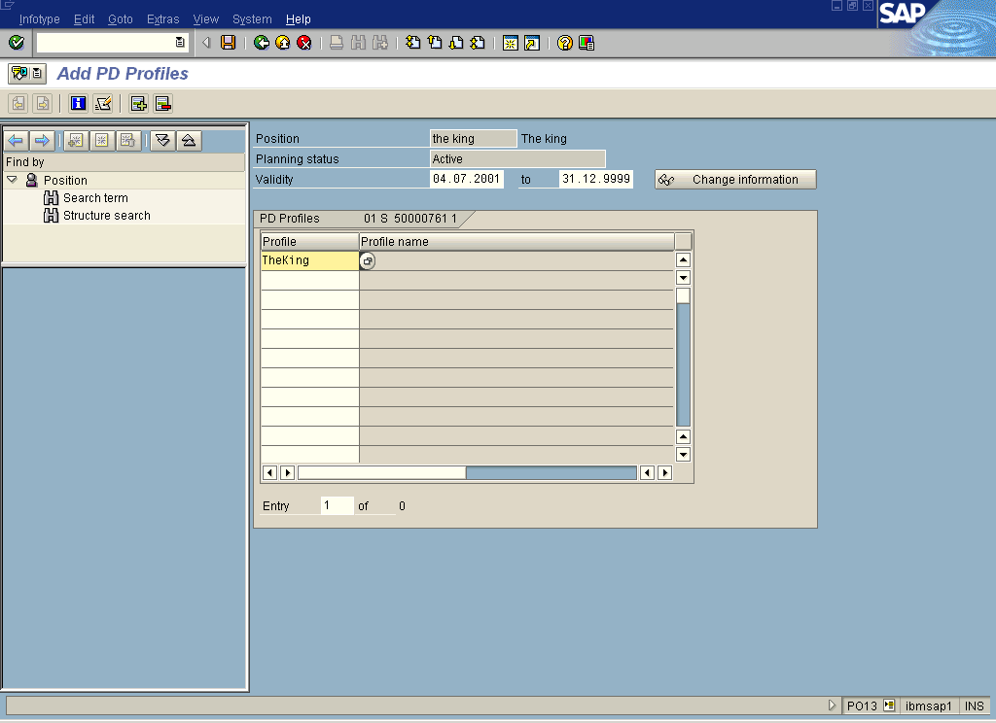

Explanation: This infotype links the structural authorization profile to a node on the organizational plan. In our example we use PO13 to assign the authorization to a Position. Note we can assign the structural authorization profile to other types of nodes e.g. an organizational unit but we must use different transactions for each different node type.
Gotcha: This has to be done manually. SAP documentation may seem to indicate that report RHPROFL0 will do this, it doesn’t, this step must be done manually.
Additional Info: None

9. Assign Structural Authorization Profiles to User ID’s
Tcode: SE38
Action: Use report RHRPROFL0 to automatically assign the appropriate structural authorization profile to each User ID. This program will update the table in transaction OOSB.
- Execute the report
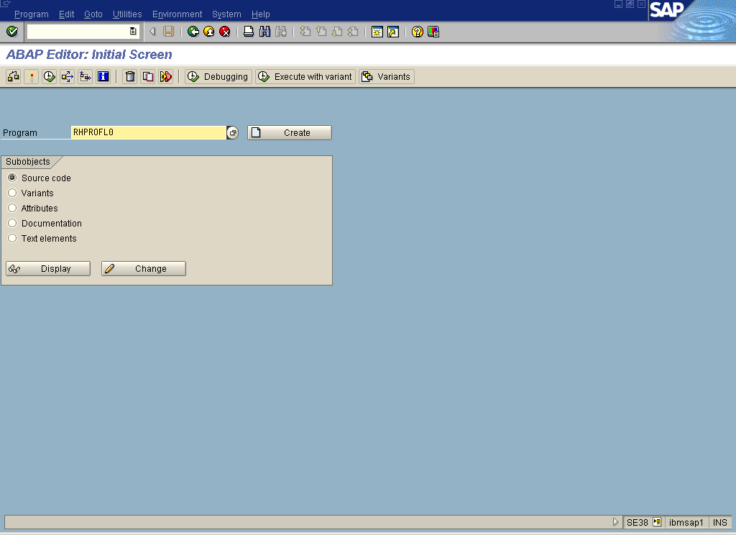

- Enter the following data, the Object ID should be the object ID for the root of the Organizational Plan.
Field | Value
Organizational Unit | O
Object ID | e.g.50000753
Evaluation Path | PROFL0
Test Session | (check on)

Leave all other defaults as they are.
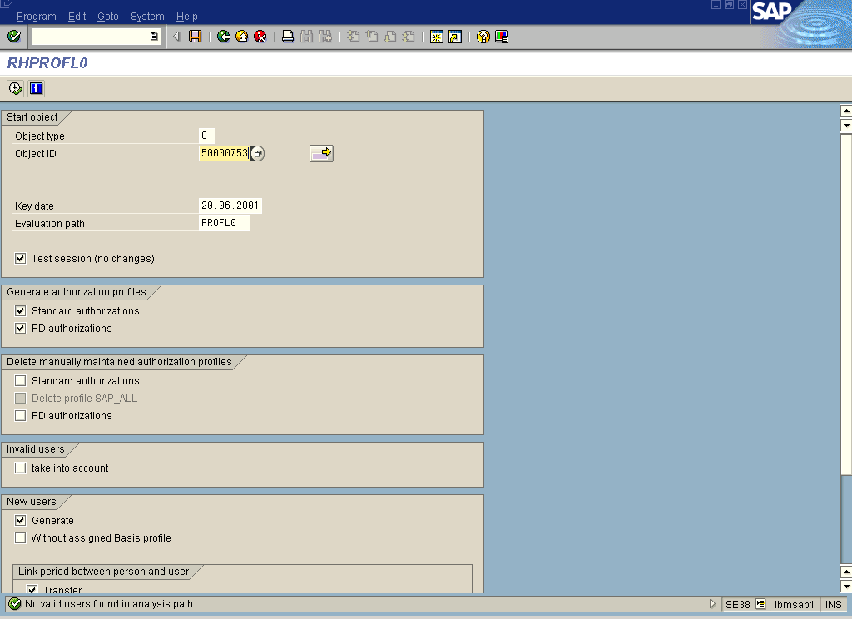

- Execute in test mode
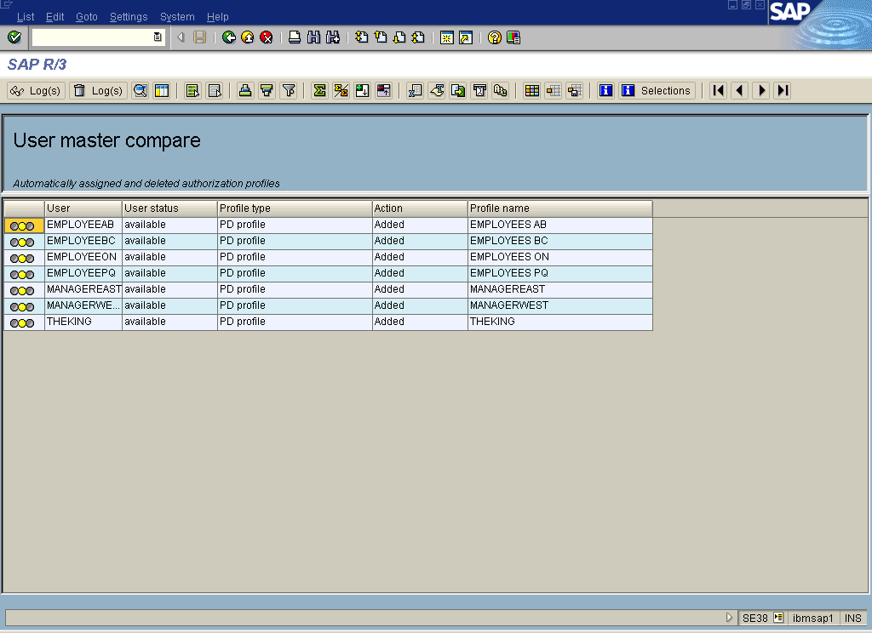
Note: The lights in the left margin of the report are yellow. This is because the assignment has NOT been made yet.

- Back out of this screen. Uncheck Test Session and then Execute to have the changes made.

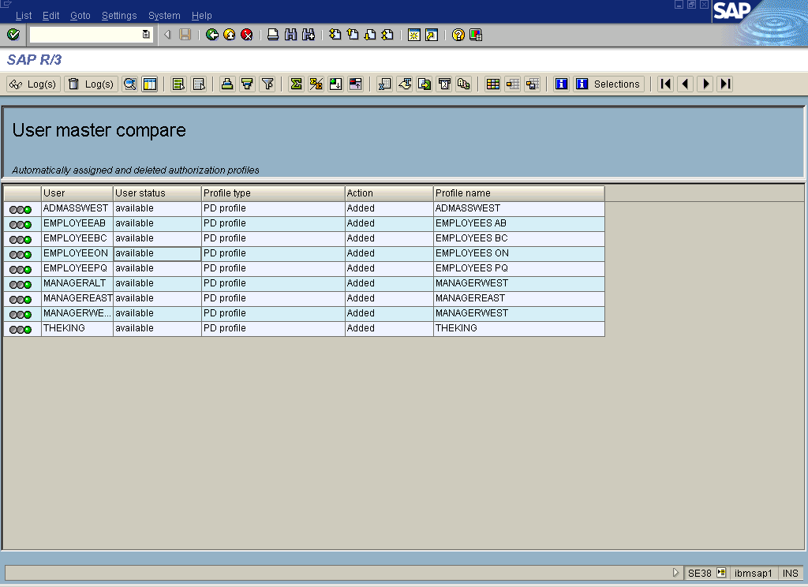
Note: The lights in the left margin of the report are green now. This indicates that the assignment has been made.

Explanation: This report assigns a structural authorization profile to the user ID based on the Organizational Plan. If we had not first completed all the main steps listed above this report would be empty. The report is a positive indicator that some of the steps to setup structural authorizations have been completed successfully. It is possible however, to have results with this report and yet have structural authorizations that do NOT work.
Gotcha:
- Don’t forget to execute the report with Test Session unchecked!
- This report should be run daily to update the authorizations of users based on changed made in the Organizational Plan.
- Ensure that the Infotype 1017 has been populated for all relevant nodes on the Organizational Plan.
Additional Info: None

10. Setup Regular Security
Tcode: PFCG
Action: Create regular security role and assign to User ID
- Create a role that gives access to regular HR transactions for all employees. E.g. Time Entry CAT2, PA20, PR20 Enter expenses
- Create a role that gives access to manager HR transactions. E.g. Time Approval CADO , PPMDT Managers Desktop, PR05 Approve Expenses

Explanation: Structural authorizations are used in addition to standard security. Setup two roles to do positive and negative tests.
Gotcha: None
Additional Info: None

Appendix 1

Authorization Main Switches
Gotcha: This is SAP delivered information. It is not that easy to understand. The bottom line is make sure the Structural authorization switch and the P_PERNR switch are on.

Maintain Authorization Main Switches
In this step you maintain the authorization switch and adapt, if necessary, the profile generator specifications. You must process the profile generator specifications if you intend to make changes to the main switch settings.
You can process the authorization main switch using transaction HR: Authorization main switch (OOAC).
Using the Auth.object check under transactions transaction (SU24) you maintain whether a transaction checks an authorization and/or whether the relevant authorizations are offered in the profile generator for maintenance.
The profile generator recognizes whether authorization objects are used in transactions using the legal check status. You can process this manually, also using the Auth.object check under transactions transaction (SU24). Also check the individual authorization objects under Process check status in all transactions. Ensure that the following check indicators are set:
- When you switch on the HR: Master data (P_ORGIN), HR: Master data - extended check (P_ORGXX) and HR: Master data - personnel number check (P_PERNR) authorization objects, you must set the relevant check/maintain check status in the primary transaction that accesses these objects. You recognize these in the standard system, because the check indicator is set to check/maintain (PP) for the HR: Master data (P_ORGIN) object. In addition to this, please note the example below.
- When you switch off the HR: Master data (P:ORGIN) authorization object, you must reset the check indicator for the HR: Master data (P_ORGIN) authorization object from check/maintain (PP) to check (P).
Example (1):
The HR: Master data (P_ORGIN) object is switched on, the HR: Master data - extended check (P_ORGXX) and Master data - personnel number check (P_PERNR) objects are switched off.
No customer action is necessary.
Example (2):
The HR:Master data - extended check (P_ORGXX) object is switched on, the HR: Master data (P_ORGIN) and HR: Master data - personnel number check (P_PERNR) objects are switched on. You must set the following check status:
For the HR:Master data - extended check (P_ORGXX) object, copy the default check indicator of the HR: Master data (P_ORGIN) object. Then change the check indicator of the HR: Master data (P_ORGIN) object from check/maintain (PP) to check (P). Leave the given check status for the HR: Master data - personnel number check (P_PERNR) object as it is.

Standard Settings
In the standard system the authorization main switches and settings are defined as follows:
Switch Setting
HR: Tolerance time of the authorization check (ADAYS)15
HR: Check procedure (APPRO) 0
HR: Customer authorization check (NNNNN) 0
HR: Master data (ORGIN) 1
HR: Structural authorization check (ORGPD) 1
HR: Master data - extended check (ORDXX) 0
HR: Master data - personnel number check (PERNR) 0

Further Notes
When you use a customer authorization object (P_PNNNN) you must maintain it in the Auth. object check under transactions transaction, analogous to the HR: Master data (P_ORGIN), HR: Master data - extended check (P_ORGXX) and HR: Master data - personnel number check (P_PERNR) objects.
Example:
When the switch is off for the HR: Master data (P_ORGIN) and HR: Master data - extended check (P_ORGXX) objects and is on for the customer object (PNNNN) and HR: Master data - personnel number check (P_PERNR) object, you must reset the check status for these - corresponding to the setting of the HR: Master data object (P_ORGIN) in the standard system - to check/maintain (PP), and for the HR: Master data (P_ORGIN) and HR: Master data - extended check (P_ORGXX) to check.

Appendix 2
PD Authorization configuration fields
Field Name | Description
Auth Profile | Chose an authorization profile. For this example we always selected the authorization profile that we were editing. Gotcha: The profiles that have not been saved will not show in the list.
Line Number | Enter a line number for each authorization. (Each line in this screen is a separate authorization.) This is a unique identifier for the authorization. Choose any number, we chose 10 for our first authorization. The second authorization would be 20…
Plan Version | Specify the current Plan version. Usually 01 (the active plan)
Object Type | Specify object type We used O for Organizational Unit but you can assign authorizations to positions tasks and standard tasks too.
Object ID | Specify the object ID of the object in the Object ID field.
Maintenance | Two types of function codes exist. A function codes with "maintaining" and a code with "non-maintaining" attributes. The maintenance function code is linked to T77FC and is activated by flagging the Maintenance field. If the Maintenance field is flagged, maintenance is possible for the authorized objects defined in the PD Profiles.
Evaluation Path | Select path from the list of delivered evaluation paths. Note: You can create a custom path via the IMG - “Maintain evaluation paths.” (O-S-P).
Status Vector | Select the planning status (1-Active, 2-Planned, etc).
Depth | Leave blank or specify the descending level of organizational units to access.
Sign | Controls access of structure direction. (+) or blank (default) Structure is viewed from root object and down. (-) Structure is viewed in reverse from root object.
Time Period | Use this field if you want to restrict the auth. according to the validity period of the structure. If you select the entry D the authorization is limited to structures valid on the current day. Possible entries:  Blank - All  D – Current Day  M – Current Month  Y – Current Year  P – Past  F - Future
Function Module | This field allows you to specify a function module to determine the root object of the structural authorization. Possible entries:  RH_GET_MANAGER_ASSIGNMENT (Determine organizational units for manager)  This function module finds the root organizational unit with which the user is related via the position and relationship A012 (manages).  RH_GET_ORG_ASSIGNMENT (Organizational assignment)  This function module finds the root organizational unit to which the user is organizationally assigned.

Appendix 3

Assign Structural Authorization Profile to User ID Manually
Unassigned Users: User IDs that have been linked to a Personnel Master Record via Infotype 105 MUST be assigned a structural authorization profile regardless of whether they are assigned to a node on the organizational plan or not.

Why? Users in this situation will be able to see HR data for any Personnel Master Record as long as they have the standard authorization profiles that give access to transactions where HR data can be seen, and which give access to HR data to see other people’s data.

Solution: If the user is not on the Organizational Plan we need to assign the profile manually. If the user is assigned to a node on the Organizational Plan AND that node has a structural authorization profile assigned to it, we need to run report RHPROFL0 and we need to make sure the user does not log on. If the user is assigned to a node AND that node does not have a structural authorization profile assigned to it we need to assign the profile manually.

It is possible to assign a structural authorization directly to a user instead of having the profile assigned indirectly by virtue of the user’s assignment in the Organizational Plan and the structural authorization profile that is assigned to the same node as the user. This is not the recommended approach because it will require increased maintenance. Assigning one or more structural authorizations directly to a User ID means that we are not taking advantage of SAP delivered functionality which allows implicit assignment of HR authorizations. If this approach is used then when the user is promoted for example, maintenance will have to be done on both the Organizational Plan and in Transaction OOSB. Assigning structural authorizations to users may be useful for temporary assignments, or testing.

Tcode: OOSB
Action: Assign structural authorization profile (created in OOSP) to the UserID
- Click on New Entries button and enter the Name of the user, the name of the profile the start date, end date. And save
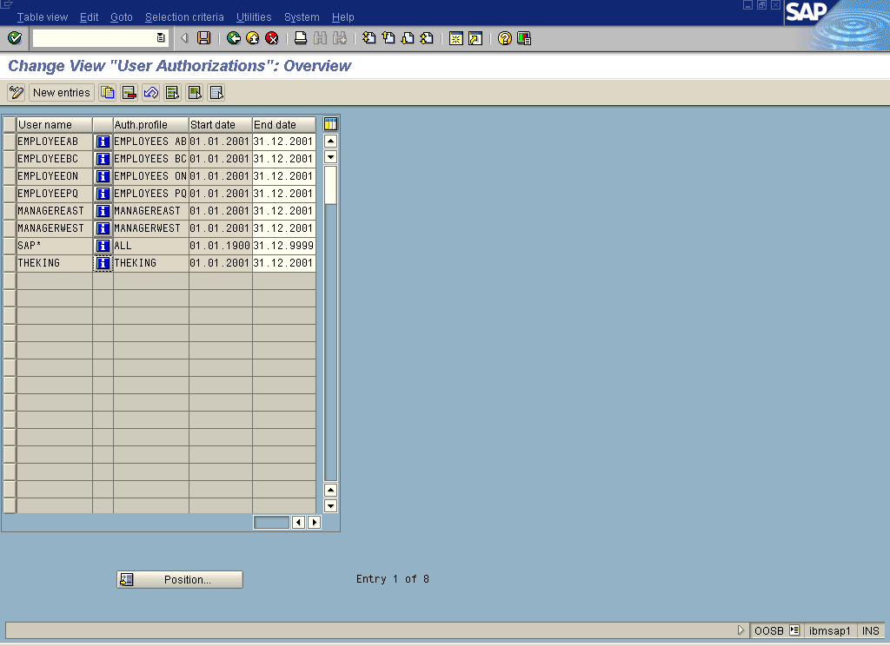

- Check to see that the profile is giving access to the appropriate Organizational units Positions etc…
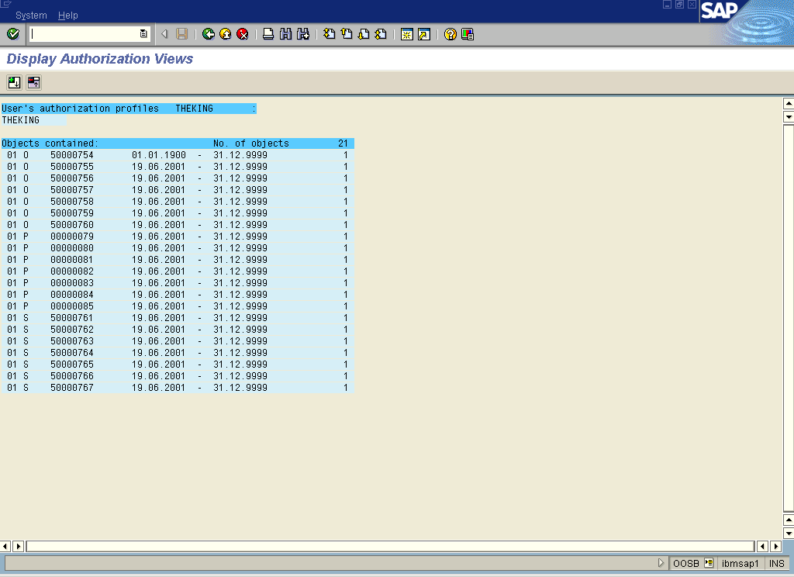

Explanation: This is analogous to assigning a profile generator role to a user ID. SAP needs to know what structural authorization profiles a user takes advantage of .
Gotcha: You need to assign every user in the system at least one structural authorization profile including consultants. Create a dummy authorization profile and assign it. (To be verified by Norm 20.06.2001)
Additional Info: start date, end date limit the validity of the authorization so if the authorization has an end date of June 30 then on July 01 they will no longer be able to see information on their subordinates.

